
For Optimal Health
Stimulating
The Vagus Nerve
Hello.
Thank you for downloading “Stimulating The Vagus Nerve For Optimal Health.”
If you’re looking for practical steps to improve the function of your body, then you’ll want to know about the vagus nerve and what it can do for you.
The good news is there are both foods and exercises you can use to have a healthy vagus nerve. If you’re having some health issues right now, you may notice some improvement. The key is to daily support the vagus nerve either to help you as part of your health protocol or to help prevent health issues.
I am here to help you. I can clarify what you need to do so don’t be afraid to reach out.
If you have any questions, please feel free to contact me at (PHONE NUMBER) or (EMAIL).
Enjoy!

Signature
 (Place HEADSHOT)
Contact info (optional)
(Place LOGO)

Medical Disclaimer
All information contained in this document is for informational purposes only. It is not intended to diagnose, treat, cure or prevent health problems. For all serious health issues, please contact a medical or nutrition practitioner. The information provided in this program is based on the best knowledge of the author at the time of writing, and we do not assume liability for the information within this program, be it direct or indirect, consequential, special, exemplary or other damages. In all circumstances, it is always wise to consult your physician before changing your diet, taking supplements or starting any exercise or health program.
Table of Contents
Understanding The Vagus Nerve 5
The Vagus Nerve 6
Polyvagal Theory 6
What Is Mindfulness? 7
How To Activate The Vagus Nerve 7
Embodied Practices To Stimulate The Vagus Nerve 8
Chanting 8
Pranayama/Breathwork 8
Diaphragmatic Warm-Up 8
Deep Diaphragmatic Breathing 8
Coherence Breathing 9
Kapalabhati 9
Bhramari (Humming) 9
Ujjayi Pranayama 9
Meditation 10
Yoga 10
Your Home Practice This Week 11
Nutrients For The Vagus Nerve 11
Support Gut Health 13
Probiotics For Nerve Health 13
Prebiotics For Nerve Health 13
Phospholipids For Nerve Health 13
Supplements For The Vagus Nerve 14
Recipes For The Vagus Nerve 15
Chia Seed Pudding with Berries and Walnuts 15
Blueberry and Almond Overnight Oats 16
Avocado and Kale Smoothie Bowl 16
Apple Cider Chicken Salad 17
Walnut Apple Quinoa Salad 18
Turmeric Ginger Carrot Soup 18
Lentil Vegetable Soup 19
Salmon and Spinach Stuffed Sweet Potatoes 20
Brown Rice and Broccoli Stir-Fry 21
Sardine and Spinach Stuffed Bell Peppers 22
Mango Avocado Salsa with Grilled Shrimp 23
Tomato and Cumin Chicken Liver Stir-Fry 23
Sweet Potato and Turmeric Hummus 24
Apricot and Sunflower Seed Cookies 24
Berry Granola Yogurt Parfait 25
Pistachio Chocolate Nut Clusters 26

Understanding The Vagus Nerve
Imagine the vagus nerve as a vital communication line in your body, connecting your brain to many important organs like the heart, lungs, stomach, and intestines. It's like a control center that helps regulate various automatic functions you don't consciously think about, such as breathing, digestion, and your heartbeat.
The vagus nerve has two main roles:
Relaxation Response: It's in charge of the “rest and digest” mode. When things are calm, it slows down your heart rate, helps with digestion, and promotes a sense of relaxation.
Inflammatory Control: The vagus nerve also has a say in your body's immune response. It can help calm down inflammation, which is your body's way of reacting to things like injuries or infections.
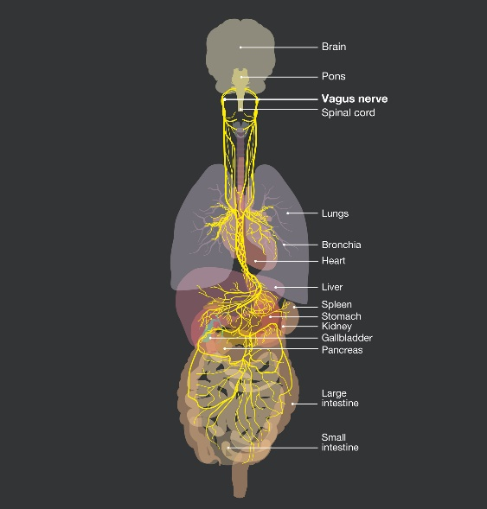
The function of the vagus nerve has to be seen in degrees. It’s not a black-and-white situation. For example, small levels of stress can have a small effect on vagus nerve function, slowing it down. As the stress increases, the more the vagus nerve slows down.
As it slows down, the more symptoms may appear related to other areas in the body. Symptoms may not appear to be all that noticeable at first. However, once a condition has been diagnosed, the more the vagus nerve may not be functioning as it should.
It’s important to understand that the vagus nerve is the major connection between the brain and the gut – affecting their function as well. This means every area in the body can either benefit from good vagus nerve function or have issues due to poor function.
Here are some of the issues associated with low vagus nerve function:
Digestive Hiccups: If the vagus nerve isn't signaling properly, your stomach and intestines might not work as smoothly as they should, causing problems like bloating or stomach aches.
Heartbeat Issues: Since the vagus nerve helps manage your heart rate, issues with it can lead to irregular heartbeats or other heart-related concerns.
Mood Swings: A happy vagus nerve usually means better stress management. If it's not working well, it might contribute to feelings of anxiety or sadness.
Body Overreactions: Sometimes, a glitch in the vagus nerve can make your body overreact, leading to persistent inflammation or contributing to conditions like migraines or epilepsy.
Blood Sugar: The vagus nerve helps regulate both glucose and insulin levels. Low vagus nerve function has been linked to the development of diabetes.
Gut Health Issues: Along with the digestive symptoms mentioned above, issues such as Crohn’s, IBD and IBS have been linked to issues with the vagus nerve.
Immune Function: Autoimmunity, allergies, and other immune-related conditions can be affected by poor vagal nerve function.
The best approach for good health is to develop a daily routine to support the vagus nerve. This can be done through nutrition and supplements.
But special exercises for the vagus nerve is one of the best ways to support its function. And here’s what you need to know:

The Vagus Nerve
The vagus is the tenth cranial nerve, originating in the brain stem and traveling through the face, neck, lungs, heart, diaphragm, and abdomen, including the stomach, spleen, intestines, colon, liver, and kidneys.
Vagus is Latin for “wanderer,” an appropriate name for the longest cranial nerve in the body.
The vagus nerve is intricately connected to mood, immune response, digestion, and heart rate.
The vagus nerve has more than 100,00 nerve fibers and communicates bidirectionally between the brain and the body: 80% body to brain, 20% brain to body.
It is the source of your “gut feelings,” so pay attention!

Polyvagal Theory
Historically, the autonomic nervous system was pictured as a two-part antagonistic system: when the sympathetic nervous system is activated, the parasympathetic nervous system is not; when we can turn on the parasympathetic nervous system calming, there is less sympathetic nervous system activation.

A new theory, coined the Polyvagal Theory by Stephen Porges, identifies a third type of nervous system response that Porges calls the “social engagement system” that operates out of the vagus nerve, which controls a mixture of activation and calming.
Rather than being in balance, the three systems respond sequentially to circumstances – both safe environments and perceived threats.
As Stephen Porges says: “When we are challenged, we start moving down the evolutionary ladder and in evolutionary stages we move from this safety engagement with the face, and with the myelinated vagus. We move to a more defensive system of the sympathetic nervous system.”
The human brain can be trained through practices like mindfulness.

What Is Mindfulness?
- Directing your attention to your experience in the present moment.
- This can be assisted by being aware of the breath and the body, doing one’s best to minimize any other distractions.
- Notice and become aware of “what’s happening now” — without judgment or attachment.
- Mindfulness studies have shown that this practice can:
  - Increase prefrontal activation, thereby increasing attention and working memory

  - Enhance prefrontal mood regulation
  - Decrease stress and amygdalar volume
  - Increase gray matter and thickness/activation in certain areas of the brain.

How To Activate The Vagus Nerve
Must create a safe environment:
- Make eye contact
- Use pleasant facial expressions
- Use a soothing human voice
- Be around familiar people and surroundings
- Develop relationships
Reversing the stress response:
- When you experience stressful thoughts, your body triggers the sympathetic branch of the nervous system to activate the fight-flight-freeze response, giving you a burst of energy to respond to the perceived danger.
- Your breathing becomes shallow and rapid, and you primarily breathe from the chest and not the lower lungs.
- This can make you feel short of breath, which is a common symptom when you feel anxious or frustrated.
- At the same time, your body produces a surge of hormones such as cortisol and epinephrine (also known as adrenaline), which increase your blood pressure and pulse rate and put you in a revved-up state of high alert. This can be helpful during times of actual threat but may be harmful if left chronically in this state.
- Pranayama/Breathwork is a practice that activates the parasympathetic nervous system.
- When you breathe deeply and slowly, it enables you to downshift from the dominant sympathetic system to the parasympathetic system, which is the body's rest and digest system.
- The parasympathetic branch helps you feel calm, centered, and grounded. It reverses the stress response.
- Pranayama also helps to strengthen our digestive power or agni.
- It does this through activation of the parasympathetic nervous system which optimizes the digestive process.

Embodied Practices To Stimulate The Vagus Nerve

Chanting
Vocal activities produce a vibration in the neck, which stimulates the vagus nerve in a beneficial way.
- Chanting, such as “Om”
- Humming
- Gargling
- Playing a wind instrument

Pranayama/Breathwork
- Pranayama is the practice of consciously using the breath to enhance our physical, emotional, and spiritual well-being.
- The word pranayama comes from two Sanskrit terms: prana and ayama.
- Prana is the vital life force or energy that flows through our body and animates all living beings.
- It is the cosmic intelligence within every cell, tissue, and organ.
- The word ayama means “to extend” or “draw out.”

- In pranayama, we use our breath to extend or expand our life-force energy and improve the communication between all parts of our mind/body system.

Benefits of Pranayama
- Improved cognitive functions
- Increased mindful awareness
- Reduced anxiety and depression
- Lower/stabilized blood pressure
- Increased energy levels
- Muscle relaxation
- Decreased feelings of stress and overwhelm
- Studies show breathwork can help treat depression, anxiety, and PTSD by reducing activity in stress parts of the brain and increasing activity in parts of the brain that regulate emotions.
- Reprograms your nervous system, enabling you to experience both immediate and long-term benefits

Diaphragmatic Warm-Up
- Raise your arms up overhead and breathe as deeply as you can through your nose.
- Release the breath and lower your arms – repeat 10 times.
- Then do 10 slow side stretches with breath to each side, feeling the stretch on each side.
- As you do this, your rib cage will move up and your diaphragm will lower, loosening the attachments and creating more flexibility.

Deep Diaphragmatic Breathing
- Breathe through your nose, inhaling deeply into your belly and exhaling slowly. Control your exhale so that it lasts longer than the inhale.
- The movement of the diaphragm during this breath cycle massages the vagus nerve — and during the exhale, the diaphragm releases around the vagus nerve, improving its functioning.

Coherence Breathing
Coherence Breathing is a very simple breathing technique in which the length of your inhalations and exhalations will follow a set ratio.
Whatever the length of your inhale, your exhale is just a little bit longer.
This pranayama technique has been shown to offer a variety of healing benefits, including:
- Reduced inflammation
- Strengthened immune system
- Decreased anxiety and depression
- Improved sleep
- Increased resilience

Kapalabhati
- Use your abdominal muscles to exhale, driving prana into the head. This is called the skull cleansing technique.
- Breathe in through your nose and then you use your abdominal muscles to push the air out; then pause and your body will naturally inhale.
- Put your hand on your belly and use your abdominal muscles to breathe out like a little burst of air. This will force cerebrospinal fluid to force a wave of detoxification to your brain.
- Begin with only a few breaths, stop if you feel lightheaded, and increase over time.
- Kapalabhati lowers blood sugar, reduces abdominal fat, increases the liver lipase enzyme, lowers cholesterol, increases ATP energy and mitochondrial energy in your body, and it boosts immunity.


Bhramari (Humming)
- Plug your ears and hum.
- When you plug your ears, the humming feels really loud in your head and then you're going to feel a vibration in your head and your heart.
- Then as you're humming, take the tongue to the roof of your mouth and all of a sudden, you'll feel the energy go up to your head and you'll bring that bliss from your heart to your head.

Ujjayi Pranayama
Ujjayi means “to be victorious” or “to gain mastery.”
This gentle, rhythmic breath produces a pleasant, soothing sound – similar to the sound of the ocean waves rolling in and out.
Think of exhaling forcefully onto your glasses to clean them—now do the same thing with your mouth closed!
The benefits of Ujjayi include:
- Calms and relaxes the mind
- Heats the core of the body
- Helps release feelings of irritation or frustration
- Stabilizes the cardiorespiratory system
- Balances the nervous system by toning the vagus nerve
- Helps coordinate breath with movement during asana practice

Meditation
- Meditation is a journey from activity to silence. It is a technique that allows you to settle into quieter and quieter levels of awareness until you experience the pure silence within.
- All types of meditation are good for the vagus nerve; for example – compassionate or “Loving Kindness” meditation. Rather than letting your mind wander, you direct your good thoughts to other people. “May all beings be happy, healthy, loved and safe.”
- As positive emotions increase, so does your vagal tone.
- In the process of going within, you start to purify the body, releasing stress, fatigue, and toxins.
Physical Benefits of Meditation
- Stimulation of the body’s self-repair mechanisms and self-regulation
- Lowered blood pressure and heart rate
- Decreased inflammation
- Increased levels of the enzyme telomerase to help slow the aging process
- Better sleep
- Improved immune function
- Downregulation (turning off) of genes that contribute to diseases such as diabetes, Alzheimer’s, autoimmune illnesses, and some types of cancer
- Upregulation (turning on) of genes that are responsible for good health
- Increased production of rejuvenating hormones such as DHEA and growth hormones
- Reverses some of the brain changes that are associated with aging
Mental and Emotional Benefits of Breathwork
- Decreased stress and anxiety and increased feelings of relaxation and peace
- Expanded experience of healing emotions such as love, compassion, joy, equanimity, and gratitude
- Decreased experience of painful emotions that constrict awareness, including anger, hostility, guilt, fear, anxiety, shame, and depression
- The ability to respond consciously rather than reacting in a conditioned, melodramatic way
- Increased focus, memory, and ability to learn

- Decreased addictive behavior
The benefits of meditation are both immediate and long-term. You can begin to experience benefits the first time you sit down to meditate and in the first few days of daily practice. The benefits that are noted will become more sustained with a regular practice.

Yoga
The practice of yoga incorporates diaphragmatic breathing, chanting and meditation, all of which stimulate the vagus nerve and activate the parasympathetic nervous system to help reduce stress.

Your Home Practice This Week
Preparation
- Set up a physical space for breathwork and meditation, away from distractions.
- Take a look at your schedule, and decide when “sitting in silence” for 5 to 10 minutes will work for you, such as:
  - upon rising
  - late afternoon, before dinner
  - before bed
- Let everyone know you're not available at this time!
Pranayama and Meditation
Start any of these practices gently, for a few breaths, or a few minutes, and build up over time as you become accustomed to them.
- Start with the Diaphragmatic Warm-up before any breathing practice, for greatest effect.
- Take a few deep breaths through the nose.
- Kapalabhati: 10–30 respirations followed by breath hold after last exhalation; 3–5 sets; stop if you feel lightheaded; you will be able to increase over time.
- Bhramari (humming breath with ears plugged): 30 respirations.
- Slow Ujjayi (ocean breath): 5–10 second count for each inhale and exhale; 5–10 minutes.
- Meditation: 10–20 minutes – use a recording or an app (such as Calm or Insight Timer) when you’re beginning.
Try to build up a consistent practice – without judgment! Remember, a regular practice will increase the benefits.

Nutrients For The Vagus Nerve
Omega-3 Fatty Acids: Support overall nerve health and may have anti-inflammatory effects
Foods: Fatty fish (such as salmon, cod, mackerel, sardines), flaxseeds, chia seeds, walnuts, hemp seeds
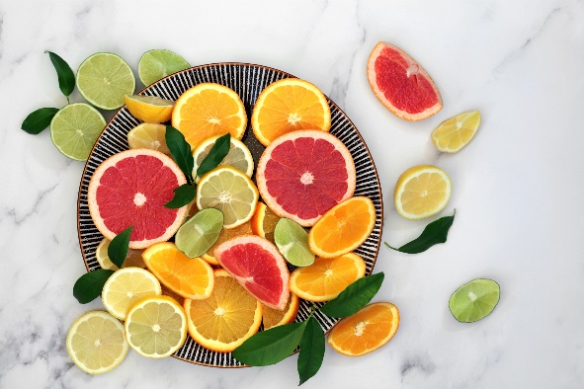
B Vitamins: Important for nerve function and the maintenance of the myelin sheath; involved in the production of neurotransmitters
Foods:
B12 (Cobalamin): Animal products like meat, fish, dairy, eggs
B6 (Pyridoxine): Bananas, poultry, fish, potatoes, chickpeas, fortified cereals
B1 (Thiamine): Whole grains, legumes, pork, nuts, seeds
B2 (Riboflavin): Dairy products, lean meats, green leafy vegetables, almonds
B3 (Niacin): Meat, fish, peanuts, mushrooms, whole grains

Antioxidants: Food and supplements with antioxidant properties may help protect nerves from oxidative stress. Plus, they're involved in nerve function and may have a calming effect on the nervous system.
Foods:
Vitamin C: Citrus fruits, strawberries, bell peppers, kiwi, guava
Vitamin E: Nuts, seeds, vegetable oils, spinach, broccoli
Magnesium: Nuts, seeds, leafy green vegetables, legumes, whole grains, avocados, bananas
Zinc: Important for neurotransmitter regulation and may support overall nerve function
Foods: Meat (beef, pork, lamb), nuts (cashews, almonds, pine nuts), seeds (pumpkin seeds, sesame seeds), legumes (beans, lentils), dairy products (cheese, yogurt)
Potassium: Essential for nerve function
Foods: Bananas, oranges, potatoes, sweet potatoes, spinach, avocados, tomatoes, beans (black beans, kidney beans)
Sodium: Essential for nerve impulse transmission, muscle contractions and maintaining electrolyte balance, supporting overall nerve function, including the vagus nerve. However, it's crucial to consume sodium in moderation to avoid potential health issues associated with excessive intake.
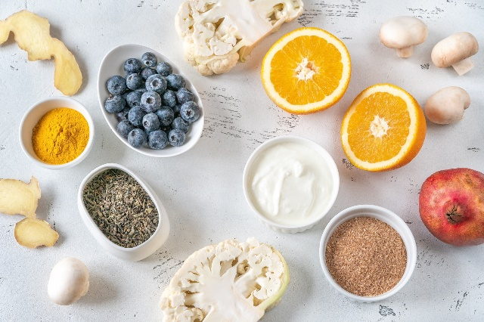
Foods: Most fruits and vegetables have reasonable amounts of sodium. Pink (Himalayan) or gray sea salt and miso are also good sources of sodium.
Polyphenols: Have antioxidant and anti-inflammatory properties that may support nerve health. Plus, they play a role in helping feed good bacteria.
Foods: Berries (blueberries, strawberries, raspberries), green tea, dark chocolate, red grapes, apples, spinach; think of foods that are red, blue, purple, and black
Acetyl-L-Carnitine: May have neuroprotective effects and support nerve function
Foods: Meat (beef, pork, lamb), dairy products (milk, cheese), poultry (chicken, turkey), fish (cod, haddock, salmon)
Choline: A precursor to acetylcholine, a neurotransmitter that plays a role in nerve signaling
Foods: Eggs, meat (beef, chicken, turkey, especially liver meat), fish (salmon, trout), dairy products (milk, cheese), legumes (soybeans, chickpeas, peanuts), broccoli, pistachios, walnuts, cashews, almonds
It's crucial to maintain a well-balanced diet that includes a variety of nutrient-rich foods for overall health, including nerve health. Additionally, lifestyle factors like stress management, regular physical activity, and adequate sleep contribute to overall nerve function and well-being.

Support Gut Health

Probiotics For Nerve Health
Probiotics are beneficial microorganisms that support gut health, and their impact extends to the nervous system through the gut-brain axis. A healthy gut microbiota, aided by probiotics, may positively influence the vagus nerve, potentially enhancing nerve function and communication.
Foods rich in probiotics: Yogurt, kefir, sauerkraut, kimchi, kombucha, apple cider vinegar, miso, tempeh, pickles, traditional buttermilk, natto, fermented aged cheeses

Prebiotics For Nerve Health
Prebiotics are non-digestible fibers that serve as nourishment for beneficial gut bacteria, promoting their growth and activity. By fostering the growth of these bacteria, prebiotics indirectly contribute to nerve health by maintaining a balanced and thriving gut microbiome.
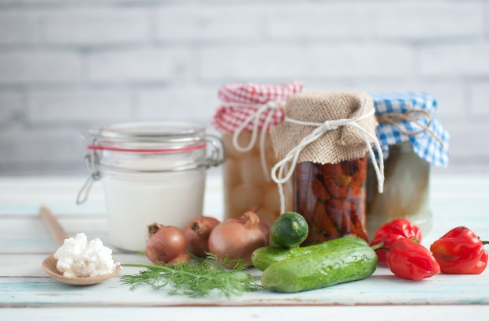
Foods rich in prebiotics: Chicory root and other root vegetables, carrots, Jerusalem artichokes, garlic, onions, leeks, apples, pears, bananas, asparagus, broccoli, cauliflower, tomatoes, berries, citrus fruits, flaxseeds, dandelion greens, barley, potatoes and other tubers, sweet potatoes, whole grains including wheat, brown rice, corn, and oats
Including a variety of probiotic- and prebiotic-rich foods in your diet can contribute to a healthy gut microbiome, supporting not only digestive health but also potential benefits for nerve function.

Phospholipids For Nerve Health
Phospholipids are essential components of cell membranes, including those in nerve cells. They play a crucial role in maintaining the integrity and function of these membranes, influencing the transmission of signals along nerves, including the vagus nerve. They support brain health and play a role in supporting gut health. They can also have anti-inflammatory effects in both areas.
Phosphatidylcholine (PC): Major component of cell membranes, abundant in the brain, precursor to acetylcholine
Foods: Eggs, soybeans, sunflower seeds, certain nuts
Phosphatidylserine (PS): Maintains structure and function of cell membranes, studied for cognitive function
Foods: Organ meats, fish (mackerel, herring), white beans, soy products
Phosphatidylinositol (PI): Involved in cell signaling and plays a role in transmission of signals within nerve cells
Foods: Soybeans, sunflower seeds, nuts (almonds)
Phosphatidylethanolamine (PE): Major phospholipid in cell membranes, involved in membrane fluidity
Foods: Eggs, soybeans, sunflower seeds, certain nuts
Lecithin: Function: Mixture of phospholipids, including PC, PE, PI; studied for potential benefits in supporting nerve function.
Foods: Soybeans and soy products, egg yolks, sunflower seeds, nuts (almonds, peanuts).

Supplements For The Vagus Nerve
The following can be used as teas and are available as supplements with some also available as essential oils:
Adrenal Adaptogens are substances that can support a balanced stress response. This is helpful for the function of the vagus nerve as stress slows its function. There are many adaptogens that may help, but here are three to consider:
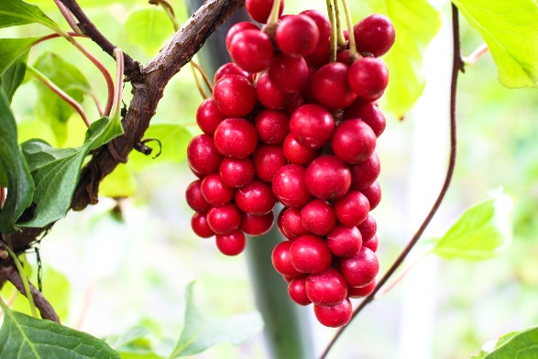
- Schisandra: An adaptogenic herb with a history in traditional Chinese medicine, potentially offering benefits for the nervous system. As an adaptogen, it may help the body adapt to stress and exhibit antioxidant effects, protecting nerve cells from oxidative stress. Some animal studies suggest neuroprotective and anti-inflammatory potential, with some indications of cognitive enhancement.
- Ashwagandha: An adaptogenic herb, ashwagandha is believed to have a balancing effect on the nervous system, which may indirectly influence vagus nerve activity.
- Rhodiola: As an adaptogen, rhodiola is thought to help the body adapt to stress. This adaptogenic property may have a positive impact on the overall balance of the autonomic nervous system, including the vagus nerve.
Other Helpful Herbs
Ginkgo Biloba: Known for potential cognitive benefits, improving blood flow to the brain and possessing antioxidant properties.
Turmeric: The active compound, curcumin, shows anti-inflammatory and antioxidant properties, with potential benefits for cognitive function.
Gotu Kola: Traditionally used for cognitive support, believed to have adaptogenic and neuroprotective effects.
Skullcap: Used for nervous tension and anxiety in traditional herbal medicine, with mild sedative effects.
Chamomile: Usually consumed as tea, it’s known for its calming properties. It contains compounds like apigenin that may interact with brain receptors, promoting relaxation. This calming effect may contribute to easing nerve tension, potentially aiding in anxiety reduction and promoting better sleep.
Valerian: Used traditionally for sleep and anxiety, this contains compounds with sedative effects. Commonly found in herbal teas and supplements, valerian may support relaxation and improve sleep quality, potentially influencing nerve function related to stress and sleep regulation.
Lemon Balm: A member of the mint family, it’s valued for its calming and mood-lifting effects. Rich in rosmarinic acid, it's often used to reduce stress and anxiety, potentially benefiting nerve function by promoting a sense of calm.
Ylang Ylang: An essential oil, with a sweet floral scent, this is used in aromatherapy to calm the nervous system, reduce stress, and promote a sense of well-being. The calming effects of ylang ylang may positively influence nerve function, contributing to overall relaxation.
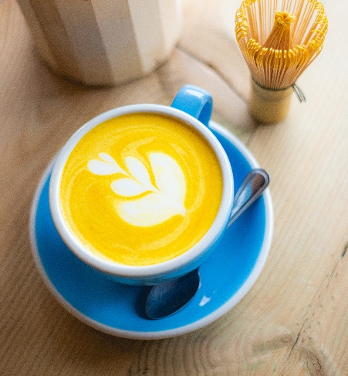

Recipes For The Vagus Nerve
These recipes offer a combination of flavors and textures, incorporating ingredients that are beneficial for the vagus nerve and overall well-being.

Chia Seed Pudding with Berries and Walnuts
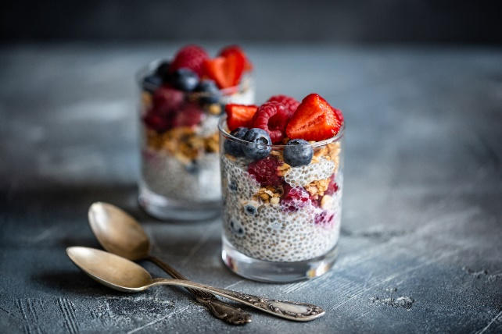
Serves 1
1/4 cup chia seeds
1 cup canned light coconut milk (carrageenan-free) or whole cow’s milk (preferably organic)
1 tsp pure vanilla extract
1 tbsp raw honey
Mixed berries (strawberries, blueberries, raspberries)
1/4 cup raw chopped walnuts

In a medium bowl, whisk together chia seeds, milk, vanilla, and honey.
Cover and refrigerate overnight or for at least 3 hours until the mixture thickens.
Before serving, layer chia seed pudding with mixed berries and top with walnuts.

Blueberry and Almond Overnight Oats
Serves 1
1/2 cup rolled oats
1/2 cup almond milk (carrageenan-free) or whole cow’s milk (preferably organic)
1/4 cup full-fat or coconut yogurt
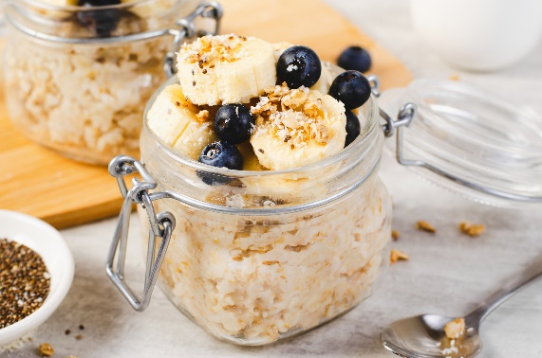
1/2 cup blueberries (fresh or frozen)
2 tbsp natural almond butter
1 tbsp chia seeds
2 tsp maple syrup (optional)
Toppings: sliced almonds, banana slices

Combine oats, milk, yogurt, blueberries, almond butter, chia seeds, and maple syrup (if using) in a jar or container.
Stir well, ensuring the ingredients are evenly distributed.
Cover and refrigerate overnight.
In the morning, give the oats a good stir and top with almonds and banana before serving.
Tip: Add sulfite-free, unsweetened shredded coconut for more prebiotic fiber.

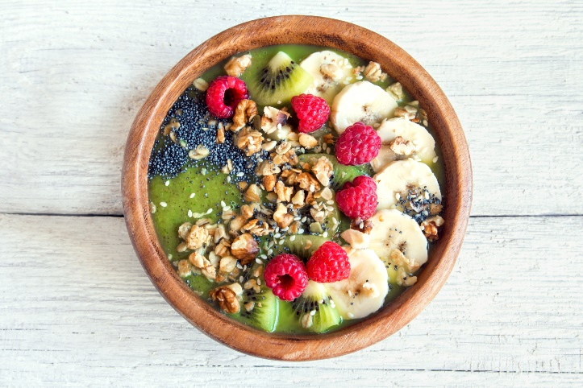
Avocado and Kale Smoothie Bowl
Serves 1
1 avocado, peeled and pitted
1 cup baby kale
1/2 frozen banana
1/2 cup full-fat or coconut yogurt
1 tbsp chia seeds
1/2 cup almond milk (carrageenan-free) or whole cow’s milk (preferably organic)
2 tsp raw honey for sweetness (optional)
Toppings: fresh berries, banana slices, kiwi, nuts and granola

Combine avocado, kale, banana, yogurt, chia seeds, and milk in a blender. Blend until smooth, adding honey for sweetness, if desired.
Pour the smoothie into a bowl and top with fresh berries, banana slices, kiwi, nuts, and granola.

Apple Cider Chicken Salad
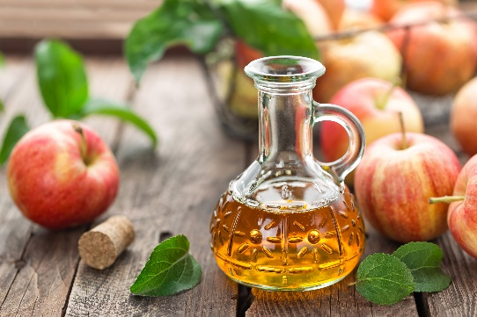
Serves 1–2
2 tbsp cold pressed olive oil
1 tbsp apple cider vinegar
1/2 tsp raw honey
1 small clove garlic, peeled and chopped
1 tbsp chopped fresh basil or 1 tsp dried
Sea salt and black pepper to taste
2 boneless, skinless chicken thighs
4 cups mixed baby greens
6 cherry tomatoes, halved
6 cucumber slices, cut in half
1 avocado, peeled, pitted and sliced

Dressing:
1 tbsp full-fat or coconut yogurt
2 tbsp cold pressed olive oil
1 tbsp apple cider vinegar
1/2 tsp raw honey
1/2 tsp Dijon mustard
Sea salt and black pepper to taste

Mix olive oil, apple cider vinegar, honey, garlic, basil, sea salt, and pepper in a medium bowl to create a marinade.
Cut the chicken thighs into two-inch pieces. Add to the mixture and marinate for 2 hours in the refrigerator.
Heat a medium skillet over medium-high heat. Add the marinated chicken and cook until there’s no pink in each piece of chicken.
Make the dressing by combining all the ingredients in a small bowl.
Place the chicken and dressing on a bed of mixed greens with cherry tomatoes, cucumber, and avocado. Season with sea salt and pepper to taste. Serve.

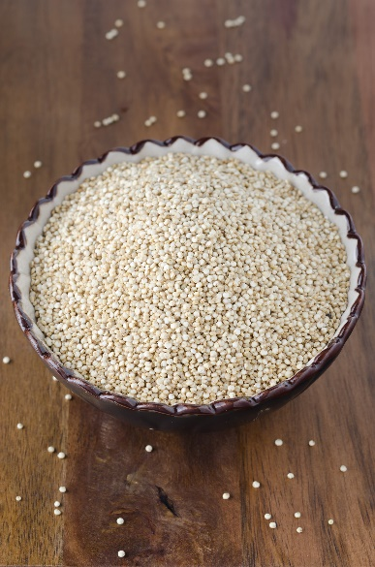
Walnut Apple Quinoa Salad
Serves 2
3 cups cooked quinoa
1 apple, cored, cut into small pieces
1/2 cup chopped walnuts
1/4 cup crumbled feta cheese
2 tbsp cold pressed olive oil
1 tbsp aged balsamic vinegar
Sea salt and black pepper to taste

Combine cooked quinoa, apple pieces, walnuts, and feta cheese in a medium bowl.
Whisk the olive oil, balsamic vinegar, sea salt, and pepper in a small bowl to make the dressing.
Pour the dressing over the quinoa mixture and toss until well combined. Serve.
To cook the quinoa:

Rinse 1 cup of dried quinoa in a sieve.
Place in a pot with 6 cups of water and 1/4 teaspoon of sea salt.
Bring to a boil, lower to simmer, and cook until the quinoa reaches the desired texture. Normal instructions for cooking quinoa would say only use double the amount of water for the quinoa, but for quinoa, time and temperature are key to preventing the quinoa from being crunchy. Adding extra water allows you to cook it to the texture you like best.
Rinse the quinoa after cooking.

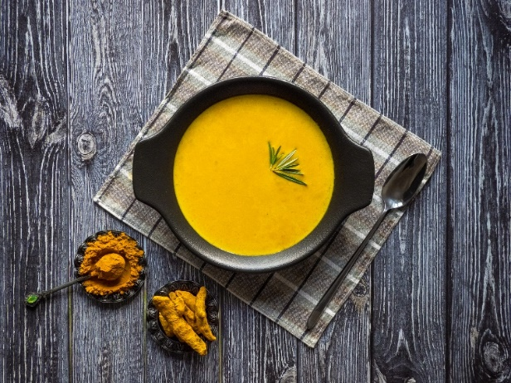
Turmeric Ginger Carrot Soup
Serves 4
2 tbsp butter or coconut oil
1 onion, diced
2 cloves garlic, peeled and minced
1 lb/454 g carrots, peeled and chopped into small pieces
1 tbsp peeled and grated fresh ginger
1 tsp ground turmeric
4 cups vegetable or bone broth (low sodium if purchasing)
1 (14 oz/400 mL) can full-fat coconut milk (carrageenan-free) or 1 1/4 cups whole cow’s milk (preferably organic)
Sea salt and black pepper to taste
Fresh rosemary or cilantro for garnish

Put a large pot on the stove on medium-high heat. Add the butter or coconut oil and melt. Add the onions and garlic and sauté until softened and onions are slightly translucent.
Add carrots, ginger, and turmeric. Cook for an additional 2–3 minutes.
Pour in the broth and bring the mixture to a boil. Reduce to simmer for 15–20 minutes until the carrots are tender.
Puree the soup with a hand blender or transfer to a regular blender and blend until smooth. Transfer back to the pot if using the regular blender.
Stir in the milk and season with sea salt and pepper. Simmer for an additional 5 minutes.
Serve hot, garnished with fresh rosemary or cilantro.
Tip: Serve with kimchi.

Lentil Vegetable Soup
Serves 4
2 tbsp cold pressed olive oil or coconut oil
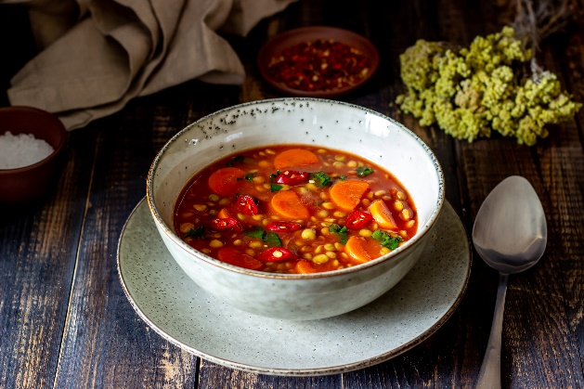
1 onion, diced
2 carrots, diced
2 celery stalks, diced
2 cloves garlic, peeled and chopped
1 tsp ground cumin
1 tsp ground coriander
1 cup dry yellow, green, or brown lentils, rinsed
6 cups vegetable or bone broth (low sodium if purchasing)
1 can (14 oz/400 g) crushed tomatoes
2 cups chopped kale
1/2 red bell pepper, cut into small pieces
Juice of 1 lemon
Sea salt and black pepper to taste

Put a large pot on the stove on medium-high heat. Add the oil, onion, carrots, and celery and sauté until vegetables are soft but still have a bit of crunch left.
Add garlic, cumin, and coriander, and sauté for an additional 2 minutes.
Stir in lentils, broth, and tomatoes. Bring to a boil, then reduce heat and simmer until lentils are tender.
Add kale, red pepper pieces, and lemon juice, and cook until the kale is wilted and the pepper pieces are soft. Season with sea salt and pepper before serving.
Tip: Serve with sauerkraut.

Salmon and Spinach Stuffed Sweet Potatoes
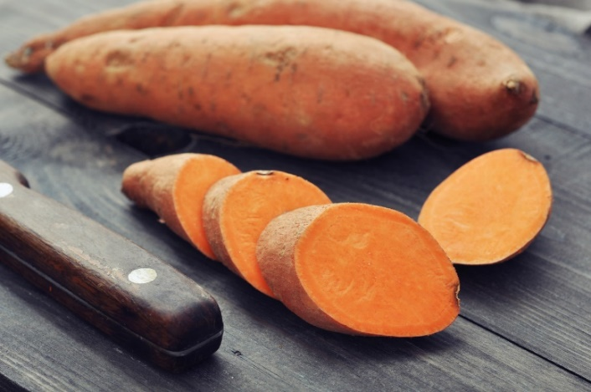
Serves 2

2 medium-sized sweet potatoes
1 tbsp cold pressed olive oil
1 tsp peeled and chopped garlic
2 wild salmon fillets
3 cups fresh baby spinach, chopped
2 tsp lemon juice
1 tbsp chopped dill
Sea salt and black pepper to taste
1 tsp raw honey
2 tbsp thick yogurt or coconut yogurt*

Preheat the oven to 400 degrees F. Wash sweet potatoes if there’s any visible dirt on the surface. Pierce the potatoes with a fork in multiple spots and place in the oven. Bake for 45–60 minutes. Potatoes should be soft on the inside which can be determined by poking with a fork.
Heat a medium skillet on medium-high heat. Add the olive oil and garlic and stir for a minute. Add salmon fillets to the skillet, cooking for 3–4 minutes per side or until cooked through. It should flake with a fork.
In the last minute of cooking, add spinach to the skillet and sauté until wilted.
Flake the salmon and mix it with the sautéed spinach. Add lemon juice, dill, sea salt, and pepper to taste.
Cut open the baked sweet potatoes and scoop out the inside. Place in a medium bowl. Add the salmon mixture, honey, and yogurt. Mix and spoon the mixture back into the potato skins. There will now be more filling than there is potato skin so mound the mixture into the skins so that it is higher than the edge of the skin. Serve.
*To thicken yogurt: Drain some yogurt by putting it in a sieved lined with a cloth. Put this in a bowl to drain some of the whey from the yogurt. This only works with natural yogurt and not yogurts that have been made with emulsifiers.
Tip: Top with shredded, fermented aged cheddar or vegan alternative.

Brown Rice and Broccoli Stir-Fry
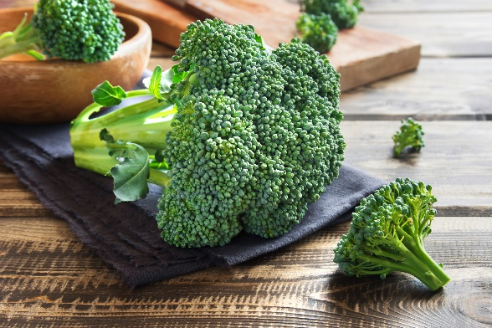
Serves 2

1 cup dry brown rice
2 tbsp sesame oil
2 tbsp chopped white onion
2 cups broccoli florets
1 red bell pepper, thinly sliced
1 cup snap peas, trimmed
2 tbsp tamari or coconut aminos
1 tbsp rice vinegar
1 tsp raw honey
1 tsp peeled and grated ginger
2 cloves garlic, minced
Sea salt and black pepper to taste
Sesame seeds for garnish

To cook brown rice
The traditional method is to prepare 1/2 cup dry brown rice per person. For every cup of rice, you use two cups of water. The problem with this method is that if the cooking temperature is not exactly right, the water absorbs into the rice before it is light and fluffy, and there is a chance that it may burn. A much better way to prepare the rice is to cook it in 6 cups of water. Instead of cooking it until the water is absorbed, it’s cooked as long as it takes to reach the texture you like.
Method for 1 cup of dry brown rice
Fill a large pot with 6 cups of water and place on the stove on high heat.
Rinse the rice and add to the water along with some sea salt. Bring to a boil and lower to simmer. Usually a setting of “3” is good on most stoves.
Cover and cook for about 40 minutes, or until the rice is light and fluffy.
Drain off the excess water by pouring through a sieve. Rinse the rice to remove any excess starch to prevent it from being sticky.

Heat sesame oil over medium-high heat in a large pan or wok. Add the onion and sauté for 2 minutes.
Add broccoli, bell pepper, and snap peas. Stir-fry for 4–5 minutes or until vegetables are tender.
Whisk together tamari or coconut aminos, rice vinegar, honey, ginger, and garlic in a small bowl.
Add the cooked rice to the pan, pour the sauce over the mixture, and toss until well combined. Season with sea salt and pepper to taste.
Garnish with sesame seeds before serving.

Sardine and Spinach Stuffed Bell Peppers
Serves 4
1 cup cooked quinoa
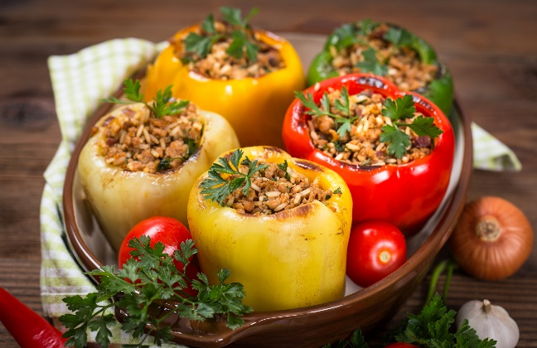
2 cans (3.75 oz/106 g each) sardines in olive oil, drained
1/3 cup chopped white onion
1 clove garlic, peeled and chopped
4 cups fresh baby spinach, chopped
1/4 cup crumbled feta cheese or vegan cheese
1 tbsp lemon juice
1 tbsp maple syrup
1/2 chili pepper, finely chopped or 1 tsp dried chili flakes (optional)
Handful of fresh parsley, chopped
Sea salt and black pepper to taste
4 bell peppers, halved vertically and seeds removed

Preheat the oven to 375 degrees F.
Combine quinoa, sardines, onion, garlic, spinach, feta cheese or vegan cheese, lemon juice, maple syrup, chili pepper or chili flakes (if using), parsley, sea salt, and pepper in a medium bowl.
Stuff each halved bell pepper with the sardine and spinach mixture.
Place the stuffed peppers in a baking dish and bake for 25–30 minutes or until the peppers are tender.

To cook the quinoa:

Rinse 1/3 cup of dried quinoa in a sieve.
Place in a pot with 2 cups of water and 1/8 teaspoon of sea salt.
Bring to a boil, lower to simmer, and cook until the quinoa reaches the desired texture. Normal instructions for cooking quinoa would say only use double the amount of water for the quinoa, but for quinoa, time and temperature are key to preventing the quinoa from being crunchy. Adding extra water allows you to cook it to the texture you like best.
Rinse the quinoa after cooking.

Mango Avocado Salsa with Grilled Shrimp
Serves 4
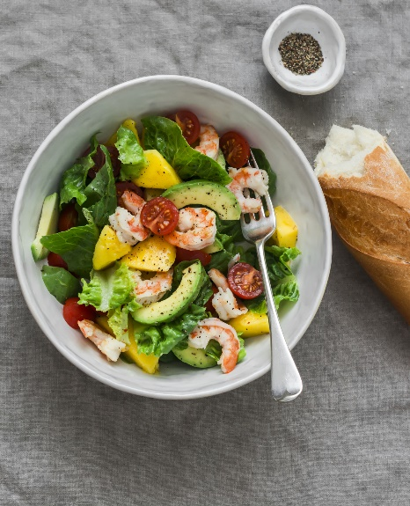
2 tbsp cold pressed olive oil
1 clove garlic, peeled and chopped
1 tsp ground cumin
Juice of 1/2 lime
Sea salt and black pepper to taste
1 lb/454 g large shrimp, peeled and deveined

Salsa
2 ripe mangos, diced
1 avocado, peeled, pitted and sliced
1/2 red onion, finely chopped
1/2 seeded jalapeño, chopped
Juice of 1 1/2 limes
2 tbsp chopped fresh cilantro
Sea salt and black pepper to taste
3 cups romaine lettuce pieces
8 cherry tomatoes, cut in half

Combine the olive oil, garlic, cumin, lime juice, sea salt and pepper in a medium bowl. Add the shrimp and marinate for 1 hour in the refrigerator. Grill for 2 minutes each side until cooked through.
To make the salsa, combine the diced mangos, avocado, onion, jalapeño, lime juice, and cilantro in a medium bowl. Season with sea salt and pepper.
Serve grilled shrimp over a bed of lettuce pieces, tomatoes, and the salsa.

Tomato and Cumin Chicken Liver Stir-Fry
Serves 4
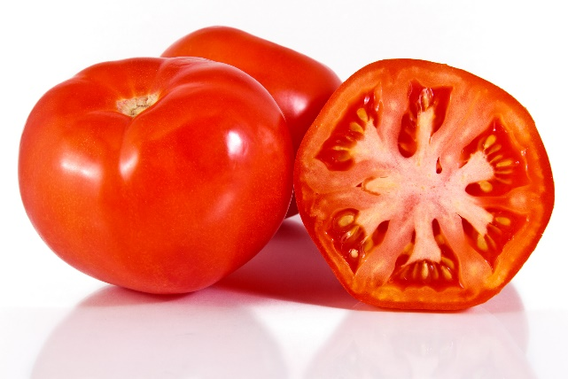
2 tbsp cold pressed olive oil
1 onion, thinly sliced
2 cloves garlic, peeled and chopped
1 lb/454 g chicken livers, trimmed and halved
1 tsp ground cumin
1 tsp smoked paprika
1/2 tsp ground coriander
1 can (14 oz/398 mL) diced tomatoes, drained
Sea salt and black pepper to taste
Fresh cilantro for garnish

Heat olive oil in a large skillet over medium heat. Add onions and garlic, sautéing until softened.
Add chicken livers to the skillet and cook for 3–4 minutes on each side or until browned and cooked through. Sprinkle cumin, paprika, and coriander over the chicken livers, stirring to coat evenly.
Pour in the tomatoes, stirring to combine. Cook for an additional 2–3 minutes until the tomatoes are heated through.
Season with sea salt and pepper to taste. Garnish with fresh cilantro before serving.

Sweet Potato and Turmeric Hummus
2 medium sweet potatoes, peeled and cubed
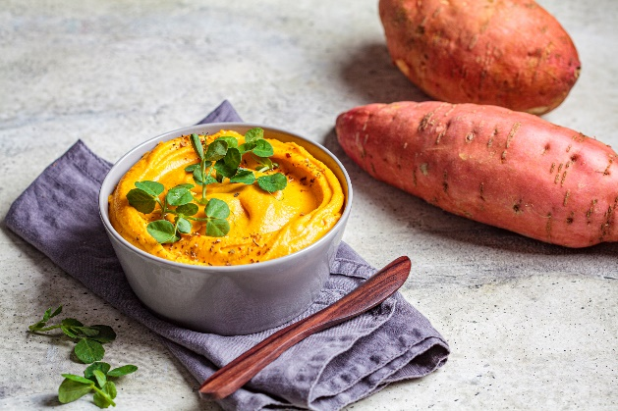
1 can (14 oz/398 mL) canned chickpeas, drained and rinsed
3 tbsp tahini
2 tbsp cold pressed olive oil
1 tsp ground turmeric
1 clove garlic, peeled and chopped
Juice of 1 lemon
1 tbsp raw honey
2 tbsp fresh oregano or 2 tsp dried
Sea salt and black pepper to taste
Carrot, celery, and cucumber sticks for dipping

Rest a colander in a pot with two inches of water. Cover. Bring to a boil. Add sweet potato cubes and steam for 12 minutes. Poke with a fork to make sure they're soft.
Combine sweet potatoes, chickpeas, tahini, olive oil, turmeric, garlic, lemon juice, honey, oregano, sea salt, and pepper in a food processor. Blend until smooth and creamy.
Serve with carrot, celery, and cucumber sticks.

Apricot and Sunflower Seed Cookies
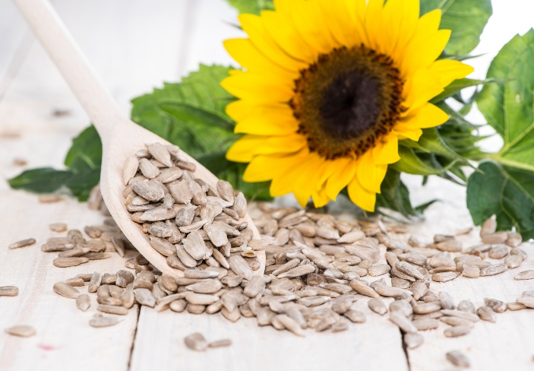
Makes 12–16 cookies
1 cup rolled oats
1/2 cup almond flour
1/2 cup whole wheat flour or brown rice flour
1/2 tsp baking soda
1/2 tsp ground cinnamon
1/4 tsp sea salt
1/2 cup coconut oil or butter, melted
1/2 cup maple syrup
1 large egg
1 tsp pure vanilla extract
1/2 cup raw sunflower seeds
1/2 cup chopped dried unsulfured apricots
1/4 cup hemp seeds

Preheat the oven to 350 degrees F and line a baking sheet with parchment paper.
Combine the rolled oats, flours, baking soda, cinnamon, and sea salt in a large bowl.
In a separate medium bowl, whisk together melted the coconut oil or butter, maple syrup, egg, and vanilla.
Add the wet ingredients to the dry ingredients, stirring until well combined.
Fold in the sunflower seeds, apricots, and hemp seeds.
Using a tablespoon, drop 12–16 spoonfuls of dough onto the prepared baking sheet, spacing them about 2 inches apart.
Bake for 10–12 minutes or until the edges are golden brown.
Allow the cookies to cool on the baking sheet for a few minutes before transferring them to a wire rack to cool completely. Put cookies in a container with a lid. They will keep for one week at room temperature. They also can be frozen for longer storage.

Berry Granola Yogurt Parfait
Serves 1
1 cup full-fat or coconut yogurt
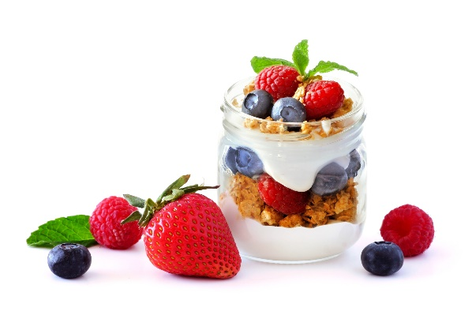
1/2 cup mixed berries (blueberries, strawberries, raspberries)
2 tbsp chopped raw walnuts
1 tbsp chia seeds
1 tbsp raw honey
1/4 tsp ground cinnamon
Fresh mint leaves for garnish (optional)

Layer half of the yogurt at the bottom of a cup.
Add half of the mixed berries on top of the yogurt.
Sprinkle half of the walnuts and half of the chia seeds over the berries.
Drizzle half of the honey over the layers and sprinkle with a pinch of ground cinnamon.
Repeat the layers with the remaining yogurt, berries, walnuts, chia seeds, honey, and cinnamon.
Garnish with fresh mint leaves if desired.
Serve.

Pistachio Chocolate Nut Clusters
Makes 8-12 (depends on size)
1/2 cup shelled pistachios, roughly chopped
1/4 cup unsweetened shredded coconut, sulfite-free
1/4 cup brown rice crisps
1 cup dark chocolate chips or chopped dark chocolate
1 tbsp butter or coconut oil
1/8 tsp pure vanilla extract
Pinch sea salt (optional)
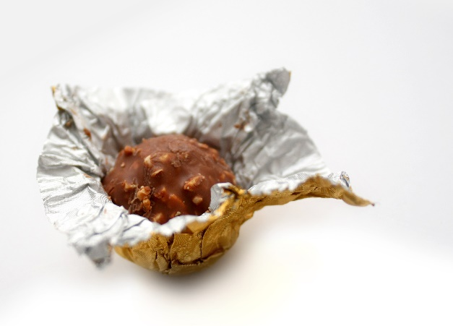
Line a mini muffin tray with small muffin cups. Combine the pistachios, coconut, and brown rice crisps in a medium bowl.
Create a double boiler by placing a bowl in a pot with 2 inches of water. Bring the water to a boil. Place the chocolate and butter or coconut oil in the double boiler. Once melted, mix. Add to the pistachio mixture and stir until the ingredients are evenly coated in chocolate.
Using a spoon, drop the mixture into the muffin cups, dividing the mixture evenly into cups. If desired, sprinkle a few grains of sea salt on top of each cluster for a sweet and salty flavor.
Put the clusters in the refrigerator for 30 minutes until the chocolate hardens.
Once set, peel the clusters off from the muffin cups and transfer them to a plate. Serve. These can also be stored in an airtight container in the refrigerator. They will keep for 1 week.

