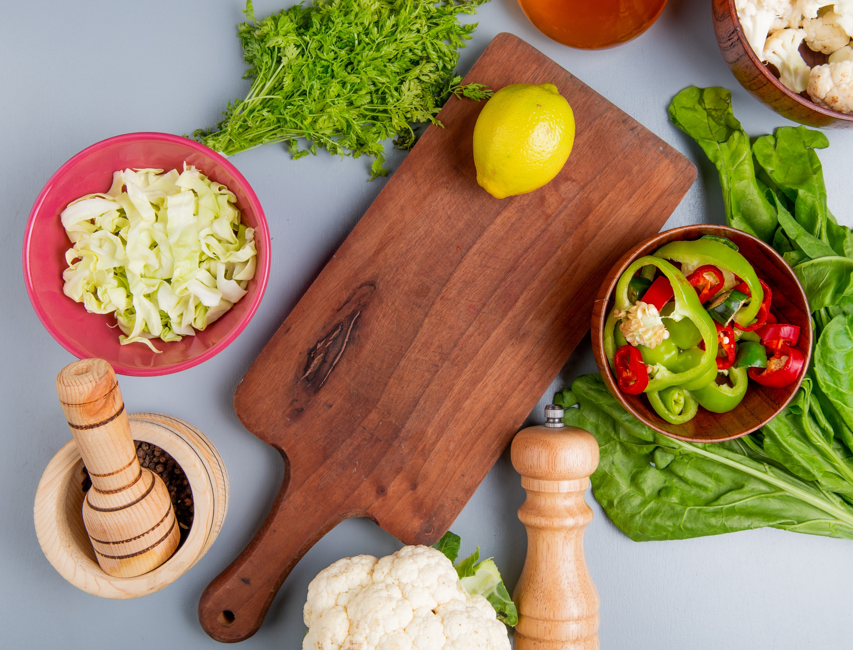
Combinations
Cooking with Food
Hello,
I'm happy to share these simple yet powerful strategies for improving your health and aging well! Combining and preparing our foods plays a key role in enhancing digestion, boosting nutrient absorption, and supporting longevity.
As a (INSERT YOUR TITLE), I'm here to help you explore how smart food pairings and traditional cooking techniques can transform your meals into tools for vitality. Whether nourishing your gut, protecting your skin, or improving overall energy, small, consistent steps make a big difference.
Achieving optimal health and longevity is a journey, and I'm here to guide and support you every step of the way. If you have questions or want to learn more, feel free to reach out at (PHONE NUMBER) or (EMAIL).
Let's work together to unlock your health's full potential and help you age well, one meal at a time!

Signature
 (Place HEADSHOT)

Contact info (optional)
(Place LOGO)

Medical Disclaimer
All information contained in the Healthy Gut program is for informational purposes only. It is not intended to diagnose, treat, cure, or prevent health problems. For all serious health issues, please contact a medical or nutrition practitioner. The information provided in this program is based on the author's best knowledge at the time of writing, and we do not assume liability for the information within this program, be it direct or indirect, consequentially, special exemplary, or other damages. It is always wise to consult your physician before changing your diet, taking supplements, or starting any exercise or health program.

Transform Your Meals For Better Health and Longevity

What if your meals could do more than fill you up? By pairing foods wisely and embracing traditional cooking techniques, you can unlock nutrients, boost digestion, and even promote graceful aging. This guide will show you how simple choices in the kitchen can enhance your health, support longevity, and keep you feeling vibrant for years to come. These are just a few examples that can make a difference.

1. Iron + Vitamin C = Vital Energy for Active Aging

Iron supports energy production, while vitamin C boosts its absorption. Together, they combat fatigue and maintain vitality.

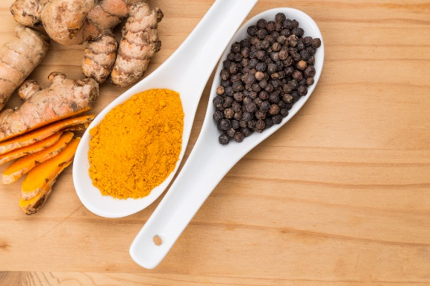
Try This: Toss spinach, bell peppers, and citrus fruits into a refreshing salad.

2. Turmeric + Black Pepper = Anti-Inflammatory Allies

Chronic inflammation is a key driver of aging. Combining turmeric with black pepper supercharges its anti-inflammatory effects, helping to protect your joints and overall health.

Try This: Stir turmeric and black pepper into a golden milk latte or hearty soup.

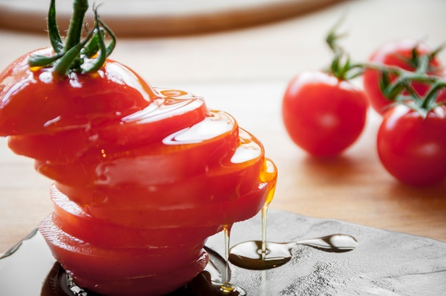
3. Tomatoes + Olive Oil = Youthful Skin and Heart Health

Lycopene in tomatoes protects your skin from UV damage and supports heart health. Pairing it with olive oil ensures better absorption and amplifies these benefits.

Try This: Simmer a tomato sauce with olive oil, garlic, and fresh herbs.

4. Green Tea + Lemon = Brain and Heart Boost

Lemon enhances the absorption of catechins in green tea, potent antioxidants that support heart health and brain function and are key to aging well.

Try This: Add lemon juice to your green tea for a refreshing antioxidant kick.

Traditional Cooking Techniques for Healthy Aging

1. Fermentation for Gut and Immune Health

As we age, gut health plays a more significant role in overall well-being. Fermented foods like sauerkraut and yogurt introduce probiotics that support digestion, immunity, and nutrient absorption.

Tip: Include a small serving of fermented veggies with your meals.

2. Soaking and Sprouting for Nutrient Absorption
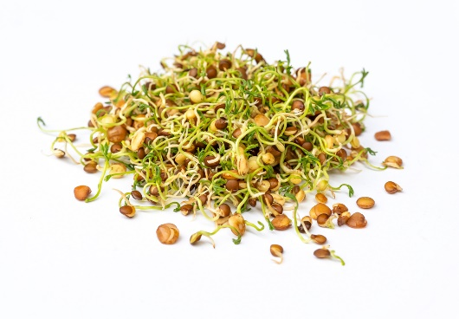
Aging can impact digestion, making nutrient absorption more difficult. Soaking and sprouting grains, legumes, and seeds reduces antinutrients and increases vitamin content, making these foods easier to digest and more nutritious.

Tip: Sprout lentils or quinoa to add to salads or soups.

3. Cooking with Healthy Fats for Cellular Health

Fat-soluble vitamins like A, D, E, and K are essential for skin elasticity, bone strength, and cell protection. Cooking veggies with olive oil enhances absorption and adds flavor.

Tip: Sauté kale or carrots in olive oil for a nutrient-packed side dish.

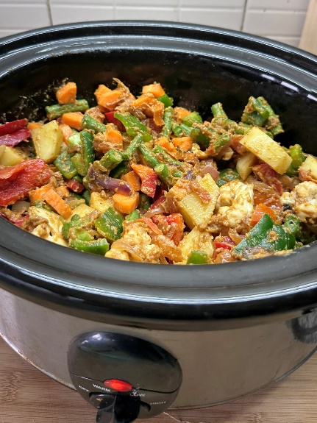
4. Slow Cooking for Nutrient Retention and Digestibility

Slow cooking retains nutrients and makes tough fibers and proteins easier to digest, supporting optimal gut health and nutrient availability as you age.

Tip: Prepare slow-cooked stews with lean meats, beans, and vegetables for a balanced meal.

How This Supports Aging Well

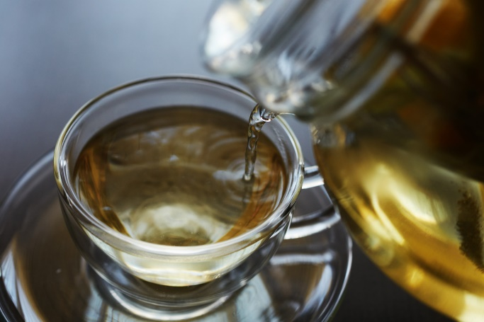
1. Reducing Inflammation: Chronic inflammation accelerates aging and increases the risk of diseases. Food pairings like turmeric and black pepper can help combat inflammation.

2. Supporting Skin Health: Lycopene from tomatoes and healthy fats protect skin from environmental damage and promote elasticity, keeping it youthful.

3. Boosting Brain Function: Antioxidants like catechins in green tea help protect the brain, supporting memory and cognition as you age.

4. Enhancing Digestion: Fermentation and sprouting improve gut health, which becomes crucial for nutrient absorption and immune function in later years.

Start Cooking Your Way to Longevity Today

Simple shifts in preparing and pairing food can enhance your health, boost energy, and promote graceful aging. These timeless strategies support vitality from the inside out.

Ready to Learn More?
