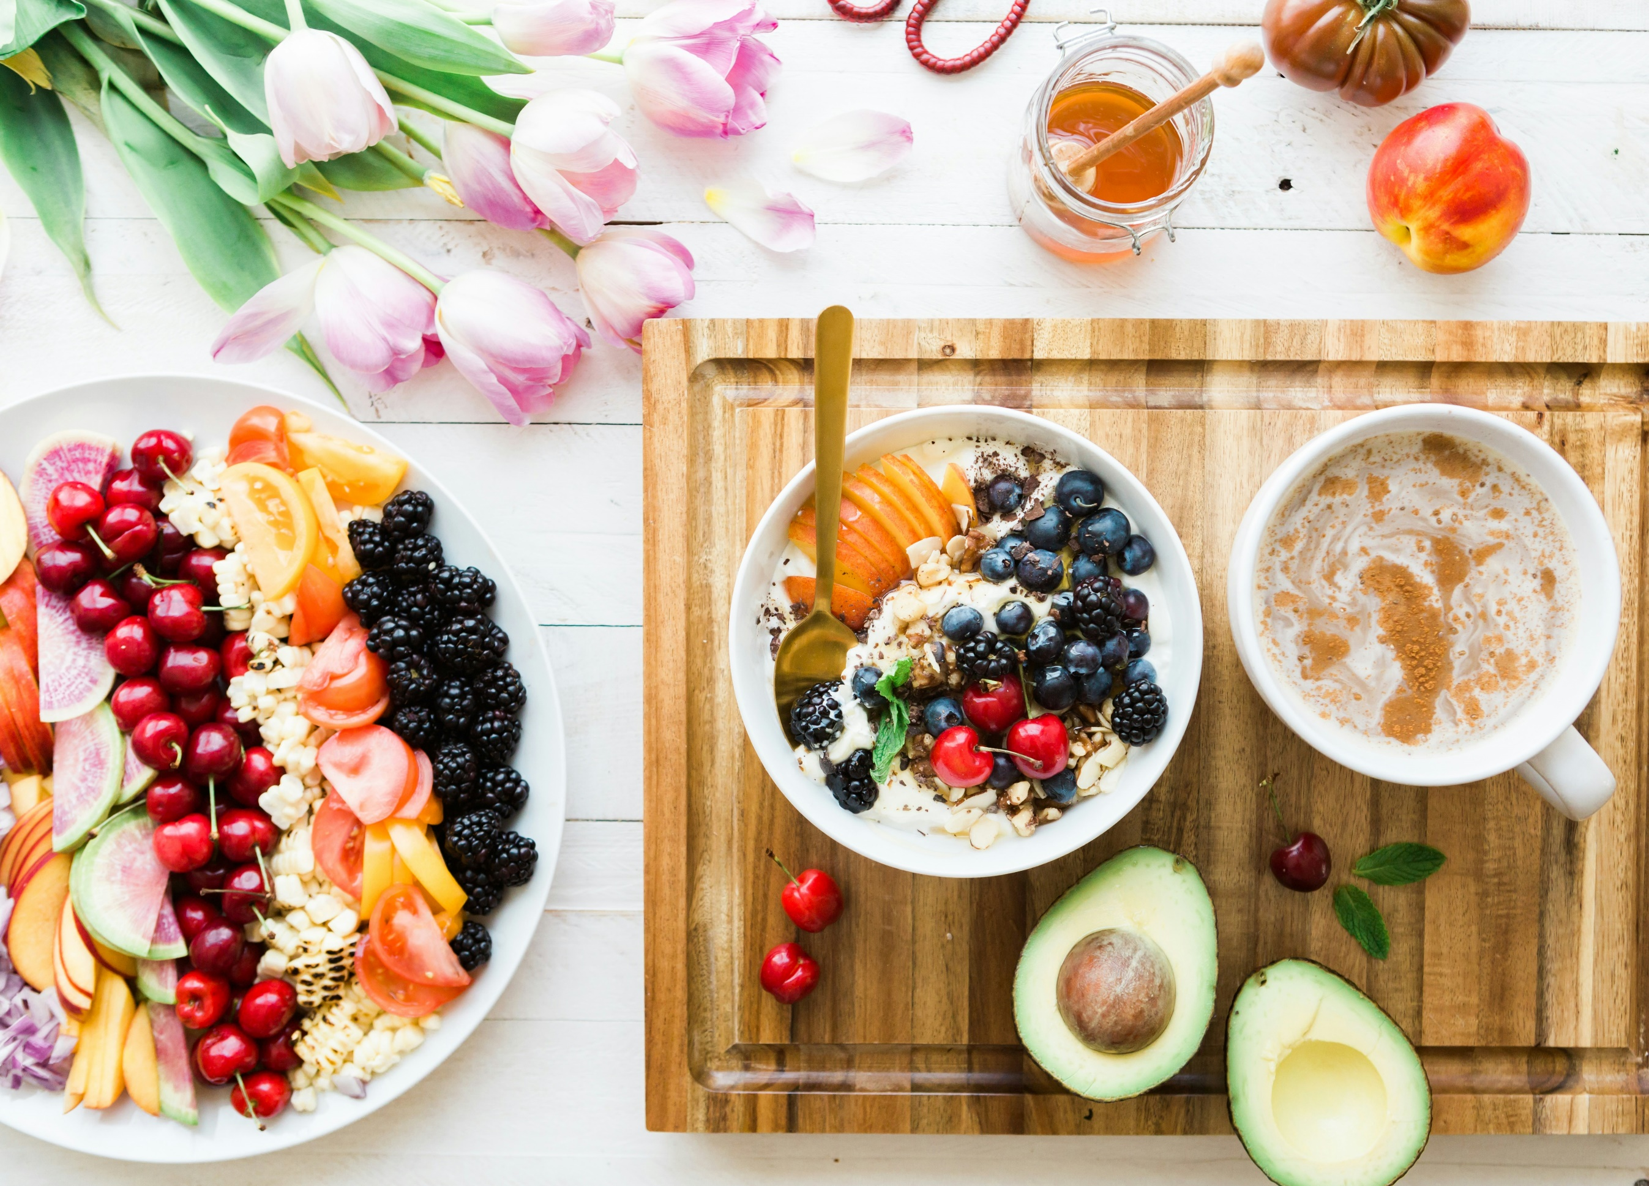
The Cook Smart, Age Well:
Traditional Recipe Guide
Hello,
Welcome to your new food journey. This is your guide to exploring the rich synergy of flavor and health in traditional recipes. Food is much more than nourishment—it is a powerful way to connect with cultural traditions, enhance health, and create joy in everyday life.
Inside, you’ll find recipes that showcase how ancient culinary wisdom and aligns with modern nutrition science. These dishes are more than delicious; they are crafted with ingredient combinations and techniques that naturally promote wellness.
As we dive into these recipes, you’ll discover how traditional foods can support holistic well-being, from reducing inflammation to improving digestion and balancing energy. Along the way, you’ll gain practical tips and insights to help you adapt these recipes to suit your needs while honoring their cultural roots.
If you have any questions or need additional guidance, please feel free to contact me at [your email address] or [your phone number].
I am excited to be a part of your journey and success.

Signature
 (Place HEADSHOT)
Contact info (optional)
(Place LOGO)

Medical Disclaimer
All information contained in the Stress Busters program is for informational purposes only. It is not intended to diagnose, treat, cure, or prevent health problems. For all serious health issues, please contact a medical or nutrition practitioner. The information provided in this program is based on the best knowledge of the author at the time of writing, and we do not assume liability for the information within this program, be it direct or indirect, consequential, special, exemplary, or other damages. In all circumstances, it is always wise to consult your physician before changing your diet, taking supplements, or starting any exercise or health program.

Table of Contents
Traditional French Ratatouille Recipe 6
Nutritional Highlights 7
Food Combinations and Their Benefits 7
Chicken Mole Recipe 9
Vegetarian Mole 10
Nutritional Highlights 11
Food Combinations and Their Benefits 11
Traditional Chinese Recipe: Mapo Tofu (Vegetarian Version) 13
Mapo Tofu Recipe 13
Nutritional Highlights: 14
Food Combinations and Their Benefits 14
Mediterranean Lentil Salad 18
Nutritional Highlights 18
Food Combinations and Their Benefits 19
Traditional Japanese Miso Soup Recipe 23
Nutritional Highlights 23
Food Combinations and Their Benefits 23
Traditional Dosa Recipe 26
Nutritional Highlights 27
Food Combinations and Benefits 27
Coconut Tomato Chutney Recipe 29
Nutritional Highlights 30
Food Combinations and Benefits 30
Traditional Indian Palak Paneer Recipe 32
Nutritional Highlights 32
Food Combinations and Their Benefits 33
West African Peanut Stew Recipe 35
Nutritional Highlights 35
Food Combinations and Their Benefits 36
Traditional Italian Risotto alla Milanese 38
Nutritional Highlights 39
Food Combinations and Their Benefits 39
French Coq au Vin Recipe 43
Nutritional Highlights 44
Food Combinations and Their Benefits 45
Mushroom and White Bean Coq au Vin 46
Traditional Hummus Recipe 48
Nutritional Highlights 48
Food Combinations and Their Benefits 48
Traditional Russian Borscht Recipe 50
Nutritional Highlights 50
Food Combinations and Their Benefits 51
Traditional Chocolate Nut Clusters Recipe 53
Nutritional Highlights 53
Food Combinations and Their Benefits 54

The Synergy of Flavor and Health in Traditional Recipes

Food is more than just nourishment—it's a powerful tool for enhancing our health, connecting with cultural traditions, and creating a sensory experience that brings joy and comfort. When we look closely at traditional recipes like West African Peanut Stew, Italian Risotto alla Milanese, or Japanese Miso Soup, we discover that they are not only delicious but also rich in ingredients that work synergistically to promote wellness. Understanding these recipes from a health-focused perspective reveals how ancient culinary wisdom aligns with modern nutrition science.

By exploring the nutritional benefits, ingredient combinations, and cooking techniques behind these dishes, we gain valuable insights into how traditional foods can support holistic well-being. For instance, the use of anti-inflammatory spices, nutrient-dense vegetables, or cooking methods that preserve antioxidants demonstrates how cultural cuisines naturally prioritize health.

This perspective is particularly helpful today, as it empowers us to:

Make Informed Choices: Recognizing the health benefits of specific ingredients allows us to adapt traditional recipes to suit dietary needs or enhance their nutritional value.

Celebrate Diversity in Food: Understanding the functional role of ingredients helps us appreciate the balance of flavor, nutrition, and tradition in global cuisines.

Support Preventive Health: By incorporating these time-tested recipes into our diets, we can address modern health concerns like inflammation, digestion, and energy management.

Each recipe in this collection combines culinary heritage with evidence-based health benefits, showing how food can be both a medicine and a delight. By understanding the science behind these recipes, we can savor the richness of their flavors while supporting our long-term well-being.

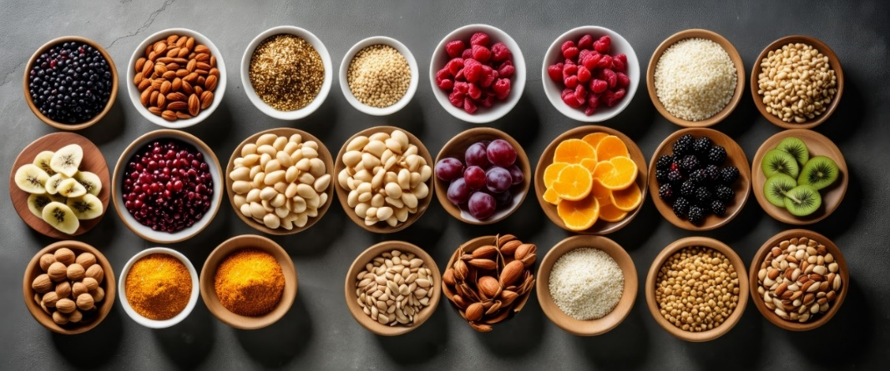

Recipes

Traditional French Ratatouille Recipe

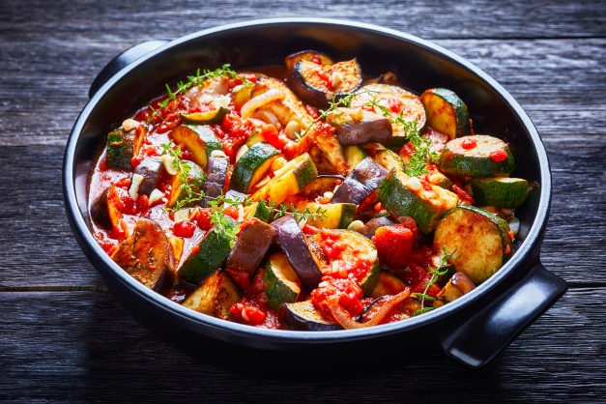
- 2 large tomatoes, diced
- 1 medium eggplant, diced
- 1 zucchini, sliced into rounds
- 1 red bell pepper, diced
- 1 yellow bell pepper, diced
- 1 large onion, finely chopped
- 3 cloves garlic, minced
- 1/4 cup extra virgin olive oil
- 1/2 tsp salt (or to taste)
- 1/4 tsp black pepper
- 1 tsp fresh thyme (or 1/2 tsp dried thyme)
- 1 tsp fresh rosemary, chopped (or 1/2 tsp dried rosemary)
- 1 bay leaf
- Fresh basil leaves for garnish (optional)

Wash and chop all the vegetables into similar-sized pieces to ensure even cooking. Keep them separate. Heat 2 tablespoons of olive oil in a large skillet or heavy-bottomed pot over medium heat. Add the onion and cook until translucent, about 3–4 minutes. Stir in the minced garlic and cook for 1 more minute until fragrant.
Add the diced eggplant to the pan with another drizzle of olive oil. Cook for 5–7 minutes until softened, stirring occasionally. Stir in the bell peppers and zucchini, and cook for another 5 minutes until they soften. Add the diced tomatoes, thyme, rosemary, bay leaf, salt, and black pepper. Mix well to coat all the vegetables with the seasoning.

Reduce the heat to low, cover the skillet or pot, and let the ratatouille simmer gently for 30–40 minutes. Stir occasionally to prevent sticking, and adjust seasoning if necessary. Remove the bay leaf. Drizzle the remaining olive oil over the dish for added flavor and health benefits. Garnish with fresh basil leaves if desired. Serve warm as a side dish with crusty sourdough bread or over brown rice or quinoa.

It can be paired with grilled fish, roasted chicken, a fried egg on top, or 2 tbsp hemp seeds for more protein.

Nutritional Highlights

- Rich in Antioxidants: Lycopene from tomatoes, flavonoids from onions, and beta-carotene from bell peppers.
- Supports Gut Health: Vegetables, onions, and garlic are all prebiotic and promote a healthy gut microbiome.
- Heart-Healthy Fats: Olive oil enhances the absorption of fat-soluble nutrients and protects against inflammation.

Food Combinations and Their Benefits

1. Tomatoes + Olive Oil (Lycopene Absorption)

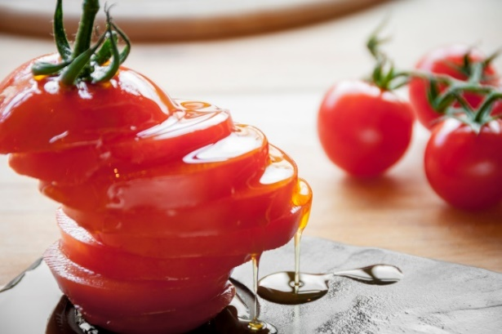
Combination: Tomatoes are rich in lycopene, a potent antioxidant, and olive oil is a healthy fat that enhances lycopene absorption.

Health Benefit: Reduces oxidative stress, supports heart health, and may lower cancer risk.

Science: Studies confirm that consuming lycopene with fats significantly improves its bioavailability and protective effects.

2. Eggplant + Garlic (Gut Health and Immunity)

Combination: Eggplant provides fiber and antioxidants, while garlic contributes allicin, a sulfur compound with antimicrobial properties.

Health Benefit: Supports gut microbiota diversity, improves digestion, and enhances immune function.

Science: Research highlights garlic's role in modulating gut microbiota and reducing inflammation, while eggplant's polyphenols combat oxidative stress.

3. Zucchini + Thyme (Vitamin C and Anti-Inflammatory Synergy)

Combination: Zucchini offers vitamin C, enhanced by thyme's anti-inflammatory properties.

Health Benefit: Reduces inflammation, supports collagen production for healthy skin, and bolsters the immune system.

Science: Thyme contains thymol, an antioxidant that complements vitamin C in reducing free radical damage.

4. Bell Peppers + Onions (Vitamin C and Flavonoids)

Combination: Bell peppers are high in vitamin C, while onions provide quercetin, a flavonoid with anti-inflammatory properties.

Health Benefit: Supports cardiovascular health, reduces inflammation, and enhances immunity.

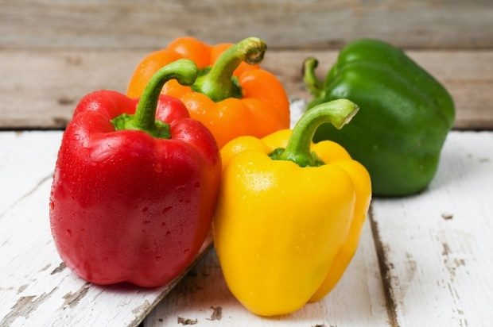
Science: Combining vitamin C and flavonoids strengthens antioxidant defenses and protects against chronic diseases.

Cooking Method and Its Benefits

- Slow Cooking in Olive Oil

Process: Slow cooking allows vegetables to release their natural juices and flavors, blending harmoniously over time. Olive oil ensures even cooking and enhances texture.

Taste Perspective: Deepens vegetable flavors, creating a rich, satisfying dish with natural sweetness and savory complexity. Caramelization adds depth to the taste.

Health Perspective:

- Preserves water-soluble vitamins (like vitamin C) better than high-heat methods.
- Softens vegetable fibers, improving digestibility.
- Enhances absorption of fat-soluble nutrients (A, D, E, K) and antioxidants like lycopene and beta-carotene.

- Minimal Water Use

Benefit: Cooking with minimal water prevents nutrient leaching, ensuring the dish remains nutrient-dense.

- Herb Infusion

Process: Adding thyme, rosemary, or bay leaves during cooking releases essential oils rich in antioxidants.

Benefit: Enhances both flavor and health benefits.

Mexican

Traditional Chicken Mole

Mole is a rich, complex sauce made with chili peppers, spices, nuts, seeds, and chocolate. It's traditionally served over chicken and is a hallmark of Mexican cuisine, combining bold flavors with significant nutritional and health benefits.

Chicken Mole Recipe
Serves 4

- 4 chicken thighs (bone-in with skin)
- 2 dried ancho chili peppers
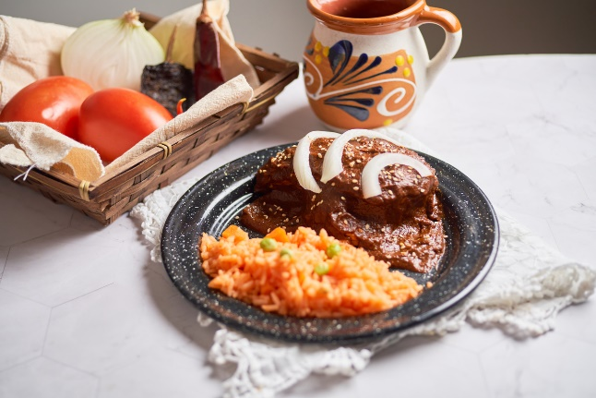
- 2 dried guajillo chili peppers
- 2 medium tomatoes, chopped
- 1 medium onion, chopped
- 3 cloves garlic, minced
- 1/4 cup almonds or peanuts
- 2 tbsp sesame seeds
- 2 tbsp dark chocolate (at least 70% cacao)
- 1/2 tsp cinnamon
- 1/4 tsp ground cloves
- 1/4 tsp cumin
- 1/2 tsp salt
- 2 tbsp olive oil
- 2 cups chicken broth

Heat a dry skillet over medium heat. Toast the chili peppers until fragrant, about 1–2 minutes per side. Toast the almonds (or peanuts) and sesame seeds until golden. Set aside. Place the toasted peppers in a bowl, cover with hot water, and let soak for 10 minutes. Remove the stems and seeds.

To prepare the sauce, heat 1 tablespoon of olive oil in the same skillet. Sauté the onion and garlic until softened, about 5 minutes. Add the chopped tomatoes, cinnamon, cloves, cumin, and salt. Cook for another 5 minutes. Combine the sautéed mixture, rehydrated peppers, toasted nuts, sesame seeds, and chocolate in a blender. Blend with 1 cup of chicken broth until smooth.

Heat the remaining olive oil in a pot. Pour in the blended sauce and cook over low heat, stirring frequently, for 20–30 minutes. Add more chicken broth if the sauce thickens too much.

Cook the Chicken: While the sauce simmers, roast the chicken thighs. Preheat the oven to 375 degrees F. Mix 1-2 tsp olive oil, 1 tsp chopped garlic, 1/2 tsp cumin, sea salt, and pepper to taste in a small bowl. Put the chicken on a rack with a pan underneath. Rub the olive oil mixture over the chicken. Bake for 45-50 minutes or until cooked on the inside.

Transfer the chicken to a plate. Pour the sauce over the cooked chicken. Garnish with additional sesame seeds or chopped nuts if desired.

Vegetarian Mole
Serves 4

- 2 medium sweet potatoes or 1 small butternut squash (peeled and cut into large chunks)
- 2 dried ancho chili peppers
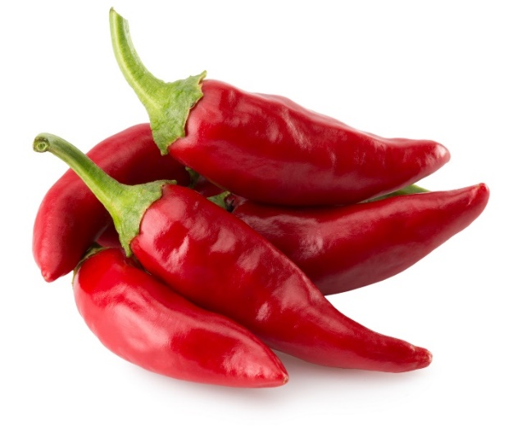
- 2 dried guajillo chili peppers
- 2 medium tomatoes, chopped
- 1 medium onion, chopped
- 3 cloves garlic, minced
- 1/4 cup almonds or peanuts
- 2 tbsp sesame seeds
- 2 tbsp dark chocolate (at least 70% cacao)
- 1/2 tsp cinnamon
- 1/4 tsp ground cloves
- 1/4 tsp cumin
- 1/2 tsp salt
- 2 tbsp olive oil
- 2 cups vegetable broth

Heat a dry skillet over medium heat. Toast the chili peppers until fragrant, about 1–2 minutes per side. Remove and set aside. Toast the almonds (or peanuts) and sesame seeds in the same skillet until golden. Set aside. Place the toasted peppers in a bowl, cover with hot water, and let soak for 10 minutes. In the same skillet, heat 1 tablespoon of olive oil. Sauté the onion and garlic until softened, about 5 minutes. Add the chopped tomatoes, cinnamon, cloves, cumin, and salt, and cook for another 5 minutes.

Combine the sautéed mixture, rehydrated peppers, toasted nuts, sesame seeds, and chocolate in a blender. Blend with 1 cup of vegetable broth until smooth. Heat the remaining olive oil in a pot. Pour in the blended sauce and cook over low heat, stirring frequently, for 20–30 minutes. Add more vegetable broth if the sauce thickens too much.

Preheat the oven to 375°F (190°C). Toss the sweet potato or butternut squash chunks with 1 tablespoon of olive oil, 1/2 tsp cumin, sea salt, and black pepper. Spread on a baking sheet and roast for 30–40 minutes or until tender and slightly caramelized.

Arrange the roasted vegetables on a serving platter. Pour the mole sauce over the top, ensuring everything is well coated. Garnish with additional sesame seeds or chopped nuts if desired.

Nutritional Highlights

- Rich in Antioxidants: Capsaicin from chili peppers, flavonoids from chocolate, and lycopene from tomatoes.
- Supports Heart Health: Healthy fats from nuts and seeds combine with antioxidant-rich ingredients to promote cardiovascular well-being.
- Anti-inflammatory: Spices like cinnamon and cloves reduce inflammation and help regulate blood sugar.

Food Combinations and Their Benefits

1. Chili Peppers + Spices (Capsaicin and Antioxidants)

Combination: Chili peppers provide capsaicin, an anti-inflammatory compound, while spices like cinnamon and cloves add antioxidants.

Health Benefit: Together, they reduce inflammation, improve circulation, and support metabolic health.

Science: Capsaicin reduces pain and inflammation and boosts metabolism, while antioxidants in spices combat oxidative stress.

2. Chocolate + Nuts and Seeds (Flavonoids and Healthy Fats)

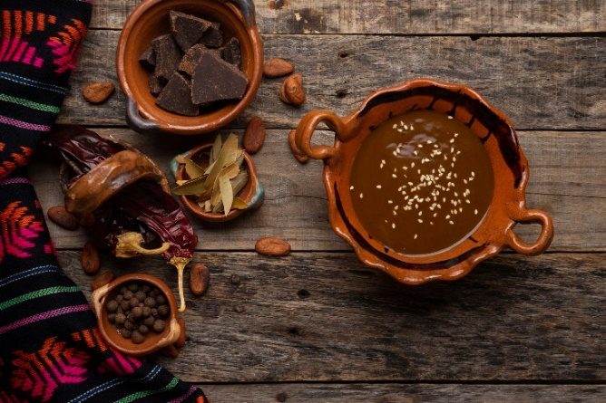
Combination: Dark chocolate, rich in flavonoids, pairs with nuts and seeds (like almonds, sesame seeds, or pumpkin seeds), which provide healthy fats and minerals.

Health Benefit: This pairing supports heart health, reduces inflammation, and boosts brain function.

Science: Flavonoids in chocolate improve blood flow and reduce oxidative damage, while fats from nuts enhance the absorption of fat-soluble nutrients.
3. Tomatoes + Garlic + Onion (Lycopene and Sulfur Compounds)

Combination: Tomatoes contribute lycopene, a powerful antioxidant, while garlic and onions add sulfur compounds that support immune health.

Health Benefit: Together, they enhance immune defense, reduce oxidative stress, and support cardiovascular health.

Science: Lycopene absorption improves when cooked with healthy fats, and sulfur compounds boost glutathione production, the body's master antioxidant.

4. Cinnamon + Cloves (Anti-Inflammatory Power)

Combination: Both spices are rich in bioactive compounds like cinnamaldehyde and eugenol, which reduce inflammation.

Health Benefit: These spices support digestive health and help regulate blood sugar levels.

Science: Studies show that cinnamon helps control blood sugar, while cloves provide antioxidant and antimicrobial effects.

Cooking Method and Its Benefits

- Simmering and Layering Flavors

Process: Mole is made by slowly toasting and blending the ingredients before simmering them to create a rich, complex sauce.

Taste Perspective: Toasting chili peppers, nuts, and seeds brings out their natural flavors and deepens the dish's complexity. Simmering melds the ingredients into a harmonious sauce.

Health Perspective:

- Toasting nuts and seeds releases their oils, improving the absorption of fat-soluble nutrients like vitamin E.
- Simmering preserves and concentrates antioxidants in tomatoes, peppers, and spices.

- Use of Minimal Water

Benefit: Cooking mole with minimal water helps preserve the water-soluble vitamins in tomatoes and onions, keeping the dish nutrient-dense.

- Balancing Fats and Antioxidants

Process: Adding a small amount of oil or fat during cooking enhances the bioavailability of lycopene, carotenoids, and fat-soluble vitamins in the ingredients.

Benefit: Increases the absorption and efficacy of key nutrients, supporting overall health.

Traditional Chinese Recipe: Mapo Tofu (Vegetarian Version)

Mapo Tofu is a beloved Sichuan dish that combines silken tofu with a rich, spicy sauce made from fermented bean paste, chili oil, and aromatics. Traditionally made with ground meat, this vegetarian version uses mushrooms for depth and texture, making it a flavorful and nutritious plant-based option.

Mapo Tofu Recipe
Serves 4

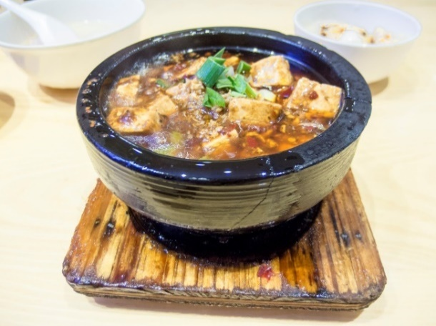
- 1 block (14 oz) silken or firm tofu, cubed
- 1 cup mushrooms (shiitake or cremini), finely chopped
- 2 tbsp fermented bean paste (doubanjiang)
- 1 tbsp chili oil
- 2 cloves garlic, minced
- 1-inch piece of ginger, minced
- 2 green onions, sliced
- 1 tbsp soy sauce
- 1 tsp rice vinegar
- 1 tsp cornstarch or arrowroot, mixed with 2 tbsp water (slurry)
- 1/2 cup vegetable broth
- 1 tbsp sesame oil (optional, for garnish)

Cube the tofu and set aside. Finely chop the mushrooms and green onions. Heat 1 tablespoon of chili oil in a wok or skillet over medium heat. Add garlic, ginger, and the white part of the green onions—stir-fry until fragrant, about 1 minute. Stir in the chopped mushrooms and fermented bean paste. Cook for 2–3 minutes until the mushrooms release their liquid and become tender. Pour in the vegetable broth, soy sauce, and rice vinegar. Bring the mixture to a simmer. Gently place the tofu cubes into the sauce. Let simmer for 5 minutes, allowing the tofu to absorb the flavors.

Add the cornstarch or arrowroot slurry and stir gently until the sauce thickens to a glossy consistency. Sprinkle with the green parts of the green onions and drizzle with sesame oil if desired. Serve hot with steamed rice or noodles.

Nutritional Highlights:

- Rich in plant-based protein: Tofu and mushrooms provide essential amino acids.
- Gut-friendly: Fermented bean paste and aromatics support digestion and immunity.
- Antioxidant-rich: Mushrooms and green onions protect against oxidative stress and inflammation.
- Low-calorie, nutrient-dense: Perfect for heart health and weight management.

Food Combinations and Their Benefits

1. Tofu + Chili Oil (Protein and Capsaicin)

Combination: Tofu provides plant-based protein and essential amino acids, while chili oil contains capsaicin, which supports circulation and metabolism.

Health Benefit: Promotes muscle repair, improves metabolism, and reduces inflammation.

Science: Capsaicin enhances fat oxidation and thermogenesis, while tofu offers high-quality, easily digestible protein.

2. Fermented Bean Paste + Garlic and Ginger (Gut Health and Immunity)

Combination: Fermented bean paste (doubanjiang) supplies probiotics and umami flavor, while garlic and ginger boost immunity and digestion.

Health Benefit: Enhances gut microbiota, supports the immune system, and reduces inflammation.

Science: Fermented foods are rich in beneficial bacteria, while allicin in garlic and gingerol in ginger offer antimicrobial and anti-inflammatory properties.

3. Tofu + Mushrooms (Complete Protein and Antioxidants)
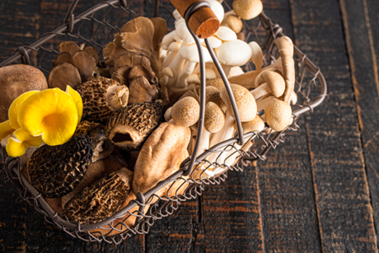
Combination: Tofu is rich in lysine, while mushrooms provide methionine, forming a complete protein profile. Mushrooms also contain antioxidants like ergothioneine.

Health Benefit: Supports muscle growth, immune function, and cellular protection.

Science: Mushrooms provide unique antioxidants that combat oxidative stress, essential for aging and disease prevention.

4. Soy Sauce + Green Onion (Flavonoids and Amino Acids)

Combination: Soy sauce provides amino acids and umami, while green onions contribute quercetin, a flavonoid with anti-inflammatory properties.

Health Benefit: Improves gut health, supports cardiovascular health, and enhances nutrient absorption.

Science: Flavonoids in green onions protect against oxidative damage, while soy sauce contains bioactive peptides beneficial for digestion.

Cooking Method and Its Benefits

- Quick Stir-Frying and Simmering

Process: Ingredients are stir-fried briefly over high heat and then simmered in the sauce, allowing flavors to meld without overcooking.

Taste Perspective: Stir-frying releases aromatic compounds from garlic, ginger, and fermented bean paste, creating bold flavors. Simmering allows the tofu to absorb the rich sauce, enhancing its taste and texture.

Health Perspective:

- Minimal cooking time preserves water-soluble vitamins in aromatics.
- High heat caramelizes sugars in aromatics, deepening flavor without excessive salt or oil.

- Tofu Preparation

Process: Soft tofu is gently simmered to absorb the flavors of the sauce while retaining its delicate texture.

Benefit: Ensures tofu remains nutrient-dense and easily digestible.

- Mushroom Addition

Process: Cooking mushrooms releases natural glutamates, enhancing umami while preserving antioxidants and vitamin D content.

Benefit: Adds depth of flavor and boosts the dish's antioxidant profile.

Substitutes for Cornstarch

Before the introduction of cornstarch in Chinese cooking, traditional thickening agents were commonly used to achieve the same glossy and smooth texture in sauces. Some alternatives include:

1. Arrowroot Powder

What It Is: Arrowroot powder, derived from the roots of tropical plants, has been used for centuries as a natural thickener.
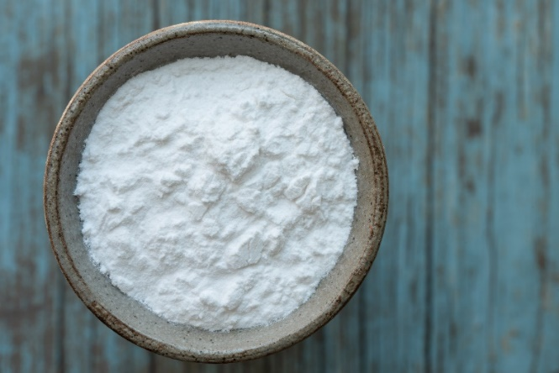
How It Was Used: It is mixed with water to create a slurry similar to cornstarch. This creates a clear, glossy sauce and is excellent for delicate dishes.

2. Potato Starch or Sweet Potato Starch

What It Is: Extracted from potatoes or sweet potatoes, this starch has long been used in Chinese cuisine.

How It Was Used: Potato starch provides a smooth, glossy finish to sauces and soups, ideal for stir-fries and braised dishes.

3. Rice Flour

What It Is: Rice flour is readily available and used as a thickening agent. It is made from finely ground rice.

How It Was Used: It was often mixed with water into a slurry or directly added to soups or stews for mild thickening.

4. Ground White Nuts (Euryale Ferox or Water Caltrop)

What It Is: Pulverized nuts or seeds, like water caltrops, were occasionally used to thicken sauces, particularly in southern China.

How It Was Used: Ground and blended into a paste or powder to add body to sauces.

5. Glutinous Rice Paste

What It Is: Made by grinding glutinous rice into a smooth paste, this thickener was especially popular for sweet dishes but could also be adapted for savory use.

How It Was Used: Slowly added to hot dishes to thicken and stabilize sauces.

6. Kudzu Starch (Pueraria Powder)

What It Is: Extracted from the roots of the kudzu plant, this starch is a traditional thickening agent in East Asia.

How It Was Used: It was mixed with cold water and added to sauces, creating a clear, slightly elastic texture.

7. Ground Sesame or Peanut Paste

What It Is: Ground sesame seeds or peanuts sometimes thicken sauces while imparting a nutty flavor.

How It Was Used: Added directly to hot liquids and stirred to integrate smoothly.

Why Cornstarch Became Popular

While these traditional methods were effective, cornstarch eventually gained favor because of its neutral flavor, consistent results, and convenience. However, these traditional thickeners still hold a place in Chinese culinary heritage and are often preferred for their unique textures and flavors.

Mediterranean Lentil Salad

- 1 cup cooked lentils (green or brown)
- 1 tsp cumin
- 1 cup chopped fresh vegetables (cucumbers, cherry tomatoes, and red onions)
- 1/4 cup crumbled feta cheese (optional for a vegetarian option, omit for vegan)
- 1/4 cup fresh parsley or mint, chopped
- 2 tbsp olive oil
- 1 tbsp fresh lemon juice
- 1 tsp Dijon mustard
- 1 clove garlic, minced
- 1 tsp raw honey
- Salt and black pepper to taste
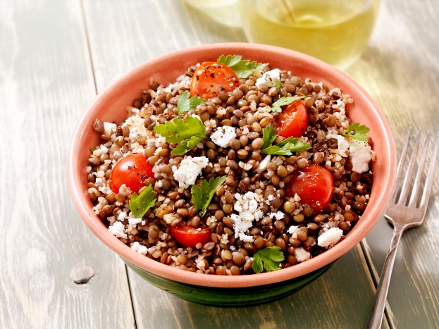

Rinse lentils and boil them until tender but not mushy (15–20 minutes). Drain and let cool. Whisk together olive oil, lemon juice, Dijon mustard, garlic, salt, and pepper in a small bowl. Combine the lentils, vegetables, herbs, and feta cheese in a large bowl. Drizzle the dressing over the top and toss to combine. Garnish with additional herbs or a drizzle of olive oil. Serve immediately or chilled.

Nutritional Highlights

- Rich in Antioxidants: Lycopene from tomatoes, polyphenols in raw honey, and flavonoids from parsley, mint, and cumin.
- Supports Gut Health: Prebiotics from garlic, raw honey, and fiber from lentils and vegetables.
- Improves Digestion and Blood Sugar Balance: Cumin and lentils work together to aid digestion and regulate blood sugar.
- Promotes Skin Health: Olive oil and lemon juice provide skin-supporting nutrients like vitamins E and C, complemented by honey's antibacterial properties.

Food Combinations and Their Benefits

1. Lentils + Lemon Juice (Iron Absorption)

Combination: Lentils are rich in non-heme iron, and lemon juice provides vitamin C, which enhances iron absorption.
Health Benefit: Combats fatigue, supports energy levels, and prevents iron-deficiency anemia.

Science: Vitamin C reduces iron to its more absorbable ferrous form, increasing uptake by the body.

2. Olive Oil + Vegetables (Nutrient Absorption)

Combination: Olive oil, a healthy fat, helps absorb fat-soluble vitamins (A, D, E, and K) from vegetables like cucumbers and tomatoes.

Health Benefit: Enhances antioxidant activity, reduces inflammation, and supports cardiovascular health.

Science: Studies confirm that fats improve the bioavailability of carotenoids and other antioxidants.

3. Garlic + Lentils (Prebiotics and Protein)

Combination: Garlic adds prebiotic fibers that nourish gut bacteria, complementing the plant-based protein in lentils for optimal digestion.
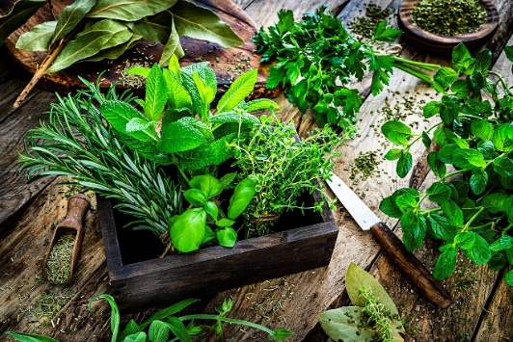
Health Benefit: Supports gut microbiota diversity, improves immunity, and enhances protein
absorption.

Science: Prebiotics improve gut health, which aids digestion and nutrient assimilation.

4. Herbs + Vegetables (Anti-Inflammatory Benefits)

Combination: Fresh parsley and mint provide antioxidants and anti-inflammatory compounds that work synergistically with the vitamins in tomatoes and cucumbers.

Health Benefit: Reduces oxidative stress, supports skin health, and boosts immunity.

Science: Parsley contains apigenin, a flavonoid linked to reduced oxidative stress and enhanced cellular health.

Benefits of Adding Raw Honey

1. Supports Gut Health (Complementing Garlic)

Mechanism: Raw honey contains prebiotics, nourishing beneficial gut bacteria alongside garlic's prebiotic fibers.

Benefit: Improves digestion and immune function by promoting a diverse gut microbiome.

2. Boosts Antioxidant Activity (Complementing Vegetables and Herbs)

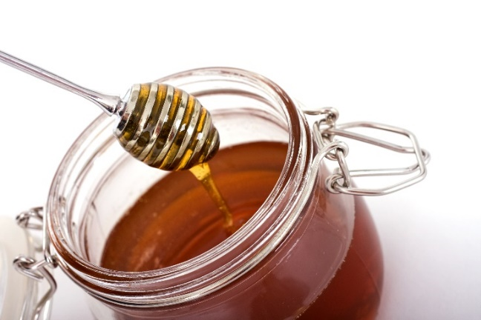
Mechanism: Honey's polyphenols neutralize free radicals and enhance the antioxidant effects of tomatoes, parsley, and mint.

Benefit: Reduces inflammation and supports anti-aging processes.

3. Balances Blood Sugar Spikes (When Paired with Lentils)

Mechanism: Lentils' fiber and protein slow sugar absorption, while honey adds a natural sweetness without causing rapid blood sugar spikes.

Benefit: Provides a stable energy source and enhances satiety.

4. Promotes Skin Health (Complementing Olive Oil and Lemon Juice)

Mechanism: Honey's antibacterial and anti-inflammatory properties complement olive oil's vitamin E and lemon juice's vitamin C for skin repair.

Benefit: Supports elasticity, reduces inflammation, and enhances skin appearance.

5. Improves Flavor (Encouraging Vegetable Intake)

Mechanism: Honey balances the tanginess of lemon juice and mustard, making the salad more palatable.

Benefit: Encourages increased consumption of nutrient-dense vegetables and lentils.

Key Health Benefits of Adding Cumin to Lentils

1. Improves Digestion

Mechanism: Stimulates enzymes that break down carbohydrates and proteins.

Benefit: Reduces bloating, gas, and indigestion.

2. Boosts Iron Absorption

Mechanism: Contains non-heme iron and works with vitamin C (e.g., lemon juice) to enhance absorption.
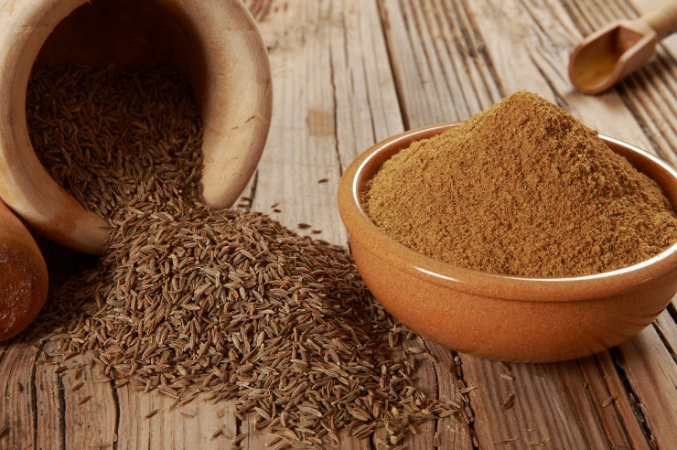
Benefit: Prevents anemia and boosts energy.

3. Reduces Inflammation

Mechanism: Antioxidants combat oxidative stress.

Benefit: Supports heart health and reduces chronic disease risk.

4. Balances Blood Sugar

Mechanism: Improves insulin sensitivity and complements lentils' low glycemic index.

Benefit: Stabilizes blood sugar for better glycemic control.

5. Enhances Antioxidant Activity

Mechanism: Boosts lentils' antioxidant effects.

Benefit: Protects cells and slows aging.

6. Supports Weight Management

Mechanism: Increases metabolism and promotes satiety with lentils' fiber and protein.

Benefit: Aids in weight control
.

7. Adds Essential Minerals

Mechanism: Provides magnesium, calcium, and phosphorus.

Benefit: Supports bone and cardiovascular health.

Practical Cooking Tip: When cooking lentils, add 1–2 teaspoons of cumin or toasted cumin seeds. Toasting enhances flavor and nutrient absorption.

Traditional Japanese Miso Soup Recipe
Serves 4
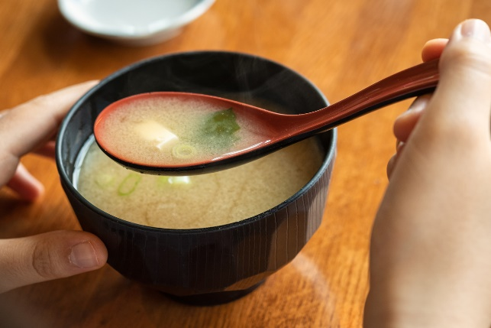
- 4 cups dashi (Japanese soup stock)
- 3 tbsp miso paste (adjust to taste)
- 1 block (200g) silken tofu, diced
- 1/2 cup wakame seaweed (rehydrated, about 1 tbsp dried)
- 1/4 cup green onions, finely sliced
- Optional: 1/4 cup thinly sliced shiitake mushrooms or other seasonal vegetables

Dried wakame seaweed can be rehydrated by soaking it in water for 5 minutes and then draining it. Dice the tofu into small cubes and slice the green onions thinly. Bring the dashi to a gentle simmer in a medium saucepan over medium heat. Lower the heat to prevent boiling. Scoop a small amount of the hot dashi into a small bowl, then dissolve the miso paste. Stir the dissolved miso back into the pot. Avoid boiling after adding miso to preserve its delicate flavors and probiotics. Gently add the tofu cubes, rehydrated wakame, green onions, and other ingredients, such as mushrooms. Simmer for 1–2 minutes to warm the tofu and blend the flavors. Turn off the heat, garnish with sliced green onions, and serve immediately.

Nutritional Highlights

- Rich in Probiotics: Miso paste is fermented, providing gut-friendly bacteria that support digestion.
- Mineral-Rich: Wakame seaweed is a source of iodine, calcium, and magnesium for thyroid and bone health.
- Low in Calories: A light, nutrient-dense dish satisfying without being heavy.
- Complete Protein: Tofu and miso provide a balanced essential amino acid profile.

Food Combinations and Their Benefits

1. Miso + Wakame (Gut Health and Thyroid Support)

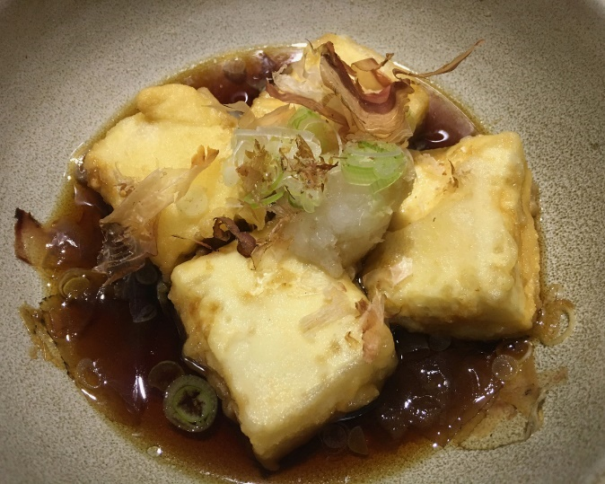
Combination: Miso provides probiotics, while wakame contributes iodine and fucoidan, a compound with anti-inflammatory properties.

Health Benefit: Supports gut microbiota diversity, thyroid function, and immune health.

Science: Studies show miso's fermentation process boosts probiotic content, while wakame enhances iodine intake for thyroid health.

2. Tofu + Dashi (Protein and Umami Synergy)

Combination: Tofu supplies plant-based protein, and dashi offers umami flavor from kombu (seaweed) and katsuobushi (bonito flakes).

Health Benefit: Enhances satiety, improves nutrient absorption, and supports muscle maintenance.

Science: The glutamates in dashi improve the flavor perception of protein-rich foods like tofu, promoting better dietary intake.

3. Green Onions + Miso (Detoxification and Immunity)

Combination: Green onions provide sulfur compounds and vitamin C, while miso adds antioxidants and minerals.

Health Benefit: Supports liver detoxification, strengthens immunity, and reduces oxidative stress.

Science: Sulfur compounds from onions synergize with miso's antioxidants to enhance detox pathways.

Cooking Method and Its Benefits

- Gentle Simmering

Process: Miso soup is prepared over gentle heat to preserve miso's live probiotics and prevent nutrient loss.

Taste Perspective: Preserves the delicate umami flavors of miso and dashi, creating a savory, balanced dish.

Health Perspective:

- Maintains the viability of probiotics in miso paste.
- Prevents degradation of heat-sensitive nutrients like vitamin C in green onions.

- Minimal Cooking Time

Benefit: Quick cooking retains the natural flavors and nutrients of ingredients like tofu and seaweed, making it a nutrient-dense and efficient dish.

Pre-Fermenting Doughs
For Bread:
Make a Pre-Ferment:

Combine equal parts flour and water with a small amount of yeast (or sourdough starter, if using) in a bowl. Cover and let the mixture sit at room temperature for 8–12 hours. This step allows beneficial bacteria and yeast to start breaking down the gluten and starches in the flour.
Incorporate into Bread Dough: Use the pre-ferment as a base when making your bread dough. Adding in the east of the ingredients. This adds a tangy flavor, improves digestibility, and gives the bread a better rise and texture. This is for any bread recipe using yeast.
For Pancakes:
Make a Fermented Batter:
Combine flour in the recipe (e.g., whole wheat, einkorn, spelt, rice, or a mix) with water or milk and a small amount of yogurt, kefir, or buttermilk as a fermenting agent. Add a pinch of salt. For a gluten-free option, use buckwheat or millet flour.
Cover and leave the batter at room temperature for 8–12 hours or overnight. Fermentation breaks down the flour's phytic acid, making minerals like iron and zinc more bioavailable.
Cook as Usual: After fermentation, whisk the batter and adjust consistency with water or milk if needed. Add sweet or savory seasonings and the rest of the ingredients from the recipe, and cook pancakes as you usually would.
For Idli or Dosa (Traditional Indian Fermented Pancakes):
Soak rice and urad dal (split black gram) separately for 4–6 hours. Grind them into a smooth batter, mixing them in a ratio of 2:1 (rice to dal). Add a pinch of salt and mix well.
Cover the batter in a warm place overnight. The natural bacteria in the dal will ferment the batter, making it rise and develop a slightly tangy flavor.
Pour the fermented batter onto a hot pan to make dosas or steam it in molds for idlis.

Benefits of Fermentation:
- Fermentation increases the digestibility of grains and flours by breaking down complex carbohydrates and proteins.
It reduces anti-nutrients like phytic acid, making minerals more accessible to the body.
- The natural tangy flavor adds depth to your recipes and requires less added sugar or salt.

- By using these methods, you’ll enhance both the nutritional value and taste of your homemade breads, pancakes, and other baked goods!

Traditional Dosa Recipe

Dosa is a popular South Indian fermented crepe made from rice and urad dal (black gram lentils). It’s light, crisp, and packed with nutrients from the fermentation process.
Serves 4

- 2 cups rice (raw, any variety such as parboiled or ponni)
- 1/2 cup urad dal (split black gram lentils)
- 1/4 teaspoon fenugreek seeds
- 1 teaspoon salt (or to taste)
- Water (as needed)
- Oil (for greasing the pan)

Rinse the rice in water 2–3 times until the water runs clear. Soak the rice in water for 6–8 hours or overnight. Rinse the urad dal and fenugreek seeds thoroughly. Soak them together in water for 4–6 hours or overnight.
Drain the water from the soaked rice and dal. In a blender or wet grinder, grind the urad dal and fenugreek seeds with water until smooth and fluffy. Transfer to a large mixing bowl. Grind the rice with a small amount of water into a smooth paste. Combine this with the ground dal mixture in the mixing bowl. Mix the two thoroughly, ensuring there are no lumps. The consistency should be like pancake batter—not too thick or too runny.
Fermenting the Batter: Cover the bowl loosely with a lid or cloth and leave the batter to ferment in a warm place for 8–12 hours or until it doubles in size and becomes slightly frothy.
Stir the fermented batter gently and add salt and fenugreek. If it’s too thick, add water to adjust the consistency. Heat a non-stick or cast-iron skillet over medium heat. Lightly grease the skillet with oil. Pour a ladleful of batter onto the center of the skillet. Using the back of the ladle, spread the batter in a circular motion to form a thin crepe. Drizzle a few drops of oil around the edges of the dosa. Cook for 1–2 minutes until the edges start to lift and the bottom turns golden and crisp. Flip the dosa if desired (optional, typically for a softer texture) and cook for another minute.

Nutritional Highlights

- Rice and urad dal together form a complete plant-based protein.
- Fermentation increases B vitamins and enhances mineral absorption.
- Probiotics from fermentation support gut health and digestion.
- The combination of rice and lentils stabilizes blood sugar with a low glycemic index.
- Urad dal provides iron, magnesium, and potassium for energy and heart health.
- Dosa is naturally gluten-free, making it suitable for those with gluten sensitivities.

Food Combinations and Benefits

1. Rice + Urad Dal (Lentils)
Combination: Forms a complete protein, as rice provides methionine (an essential amino acid lacking in lentils) while urad dal provides lysine (lacking in rice). Together, they balance each other's amino acid profiles, making the dosa a great plant-based protein source.
Health Benefit: Enhances muscle repair and overall health by supplying all essential amino acids in one meal.
2. Lentils + Fermentation
Combination: Soaking and fermenting urad dal reduces anti-nutrients like phytic acid, which can inhibit mineral absorption. Fermentation also increases the bioavailability of iron, zinc, and magnesium. The process introduces probiotics that support gut health.
Health Benefit: Improved digestion, better nutrient absorption, and support for a healthy gut microbiome.
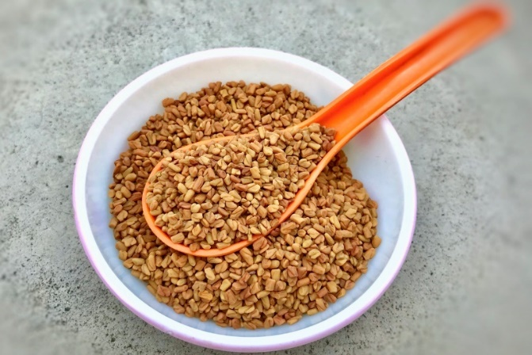
3. Rice + Fermentation
Combination: Fermented rice breaks down starches and fibers, making it easier to digest. It also supports gut health by introducing beneficial bacteria and enhancing the bioavailability of B vitamins.
Health Benefit: Supports energy production, gut health, and improved digestion.
4. Fenugreek Seeds + Fermentation
Combination: Fenugreek seeds enhance the fermentation process by providing natural sugars for microbes to feed on. They also contain soluble fiber, which helps regulate blood sugar levels. The seeds add a subtle nutty flavor and improve the batter’s texture.
Health Benefit: Enhanced blood sugar control and digestive support.

5. Oil + Fermented Batter
Combination: Drizzling oil around the dosa as it cooks helps improve the absorption of fat-soluble vitamins (like vitamin E) from the ingredients. Fat also balances the dish's glycemic load by slowing carbohydrate absorption.
Health Benefit: Improved nutrient absorption and stable blood sugar levels.
6. Pairing with Chutneys (Tomato, Coconut)
Combination: Coconut chutney provides healthy fats, which help absorb fat-soluble nutrients like carotenoids from tomatoes. Tomato chutney adds lycopene, an antioxidant whose bioavailability is enhanced when paired with fats.
Health Benefit: Enhanced antioxidant intake and improved cardiovascular support.

Coconut Tomato Chutney Recipe

This chutney is a flavorful and nutrient-rich accompaniment to dosa, idli, and other South Indian dishes. It combines creamy coconut with tangy tomato (or a substitute) and is enhanced with traditional tempering for added aroma and health benefits.
Serves 4
Chutney Base:

- 1/2 cup freshly grated coconut (or frozen, thawed) or ¼ cup dried, sulfite-free, and sugar-free.
- 1 medium tomato, chopped (or substitute with 1/4 cup tamarind pulp or 1/2 cup roasted red bell pepper)
- 1 small onion, chopped (optional)
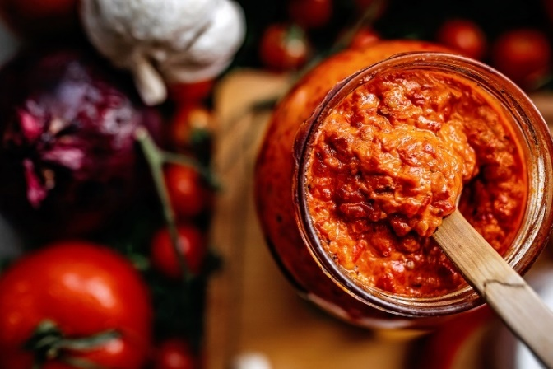
- 1 green chili (adjust to taste)
- 2 cloves garlic (optional)
- 1/4 cup roasted chana dal (split chickpeas) or peanuts (optional, for creaminess)
- 1/4 teaspoon salt (or to taste)
- 2 tablespoons water (adjust for desired consistency)

For Tempering:
- 1 teaspoon oil (coconut or neutral oil)
- 1/2 teaspoon mustard seeds
- 1/4 teaspoon cumin seeds
- 1–2 dried red chilies
- 6–8 curry leaves

Prepare the Chutney Base: In a blender, combine grated coconut, chopped tomato (or substitute), onion, green chili, garlic, roasted chana dal or peanuts, and salt. Add 2 tablespoons of water and blend into a smooth paste. Adjust the water for the desired consistency.
Tempering the Chutney: Heat 1 teaspoon of oil in a small pan over medium heat. Add mustard seeds and allow them to splutter. Stir in cumin seeds, dried red chilies, and curry leaves. Fry for 30 seconds until aromatic. Pour the tempering over the blended chutney and mix well. Serve fresh with dosa, idli, or other South Indian dishes.
Substitution For Tomatoes and Peppers:
Carrot: Use 1/4 cup grated carrot, which provides natural sweetness and some texture.
Tamarind: Use 1 tablespoon tamarind pulp (adjust to taste) for tanginess to balance the sweetness of the carrot.
Adding carrot provides vitamin A, fiber, and natural sweetness, while tamarind adds antioxidants, aids digestion and helps regulate blood sugar.

Nutritional Highlights

- Coconut provides healthy fats that support brain health and energy.
- Tomatoes are rich in lycopene, a powerful antioxidant that promotes heart health.
- Substitutes like tamarind or beetroot add vitamin C and anti-inflammatory benefits.
- Roasted chana dal or peanuts add fiber and plant-based protein.
- Mustard seeds and cumin in the tempering improve digestion and reduce bloating.
- Curry leaves and chilies provide antioxidants and antimicrobial properties.

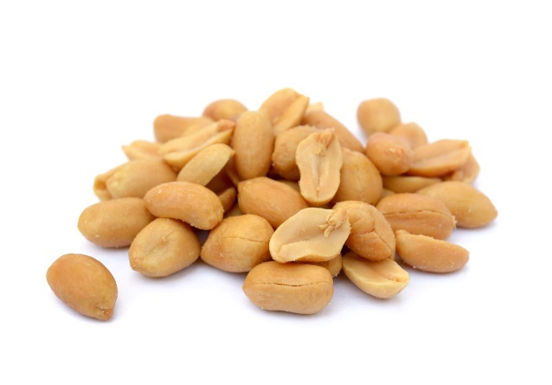
Food Combinations and Benefits

1. Coconut + Tomato (or Substitute)
Combination: Coconut contains healthy fats that help absorb fat-soluble nutrients like lycopene (from tomatoes) or carotenoids (from roasted red bell peppers).
Health Benefit: Boosts antioxidant intake, supports heart health and reduces inflammation.
2. Coconut + Peanuts/Chana Dal
Combination: The fats and protein from both ingredients create a creamy base that balances the tanginess and heat of the chutney.
Health Benefit: Provides sustained energy and enhances nutrient absorption.
3. Mustard Seeds + Cumin in Tempering
Combination: Mustard seeds add a nutty, pungent flavor, while cumin provides an earthy aroma. Both are known for their digestive benefits.
Health Benefit: Improves digestion and reduces bloating.
4. Chilies + Curry Leaves in Tempering
Combination: Chilies contribute capsaicin for circulation support, while curry leaves add antioxidants and a citrusy aroma.
Health Benefit: Supports metabolism and enhances immune health.

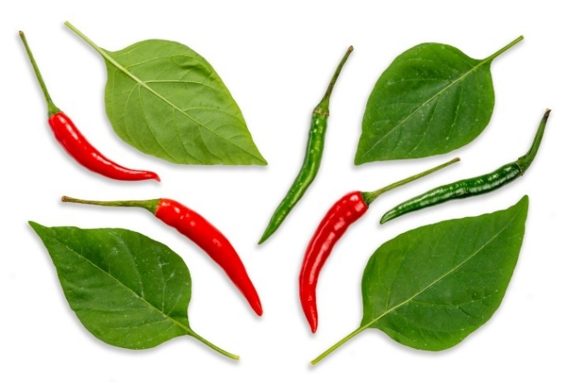

Why Tempering Matters
Tempering is a traditional cooking technique that enhances flavor and nutritional value. Spices are fried in hot oil to release their essential oils, infusing the dish with rich aroma and depth of flavor.
Health Benefits of Tempering:
- Improves digestion with mustard seeds and cumin.
- Adds antioxidants from curry leaves and chilies.
- Enhances absorption of fat-soluble nutrients in the chutney.
- Tempering transforms a simple chutney into a vibrant and health-supporting dish, making it both delicious and nourishing.

Traditional Indian Palak Paneer Recipe
Serves 4

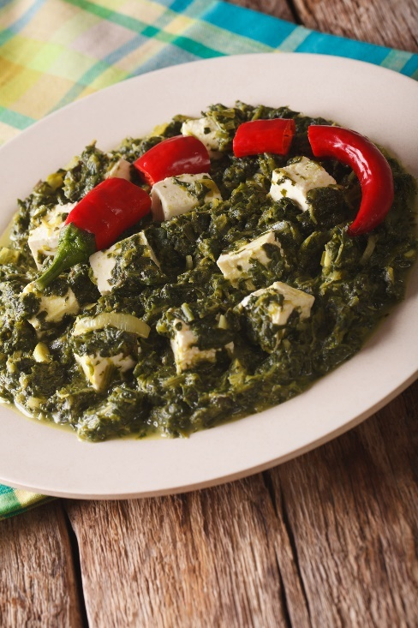
- 200g paneer (Indian cottage cheese), cubed
- 4 cups fresh spinach leaves (palak), washed and chopped
- 1 medium onion, finely chopped
- 3 garlic cloves, minced
- 1-inch piece of ginger, grated
- 1 green chili, finely chopped (optional, adjust to taste)
- 1/2 tsp turmeric powder
- 1 tsp cumin seeds
- 1/2 tsp garam masala
- 1/2 tsp ground coriander
- 2 tbsp ghee (clarified butter) or vegetable oil
- 1/2 cup yogurt curds or cashew cheese (for a vegan option)
- Salt to taste
- Lemon wedges (optional, for garnish)

Bring water to a boil in a large pot and blanch the spinach leaves for 1–2 minutes until wilted. Drain and immediately transfer to ice water to preserve the green color. Blend the spinach into a smooth puree and set aside.

Heat ghee or oil in a pan over medium heat. Add cumin seeds and let them splutter. Add onions, garlic, ginger, and green chili. Sauté until the onions are translucent and fragrant. Stir in turmeric powder, ground coriander, and garam masala. Cook for 1 minute to release the flavors of the spices.

Pour the spinach puree into the pan, mix well, and simmer for 5–7 minutes. Adjust salt as needed. Gently fold in the paneer cubes and yogurt (or cashew cream). Simmer for 2–3 minutes until the paneer is warmed through. Garnish with a drizzle of cream or a squeeze of lemon juice, and serve hot with roti, naan, or basmati rice.

Nutritional Highlights

- Rich in Iron and Calcium: Spinach and paneer provide essential minerals for bone health and energy production.
- Protein-Packed: Paneer offers high-quality protein, making this dish ideal for vegetarians.
- Gut-Friendly: The yogurt or cashew cream adds probiotics (or prebiotics) and enhances digestion.
- Anti-Inflammatory Spices: Turmeric and ginger help reduce inflammation and support immunity.

Food Combinations and Their Benefits

1. Spinach + Paneer (Calcium and Iron)

Combination: Spinach provides iron, while paneer offers calcium. Together, they balance each other and prevent nutrient absorption interference.

Health Benefit: Supports bone density, energy levels, and muscle health.

Science: Calcium in paneer offsets the oxalates in spinach, enhancing overall mineral absorption.

2. Garlic + Spinach (Antioxidant Synergy)

Combination: Garlic contains allicin, which complements spinach's lutein and beta-carotene.

Health Benefit: Promotes cardiovascular health, reduces oxidative stress, and supports the immune system.

Science: Garlic's sulfur compounds enhance spinach's bioavailability of fat-soluble antioxidants.

3. Ghee + Turmeric (Enhanced Curcumin Absorption)

Combination: Ghee is a carrier for turmeric's curcumin, enhancing its bioavailability.

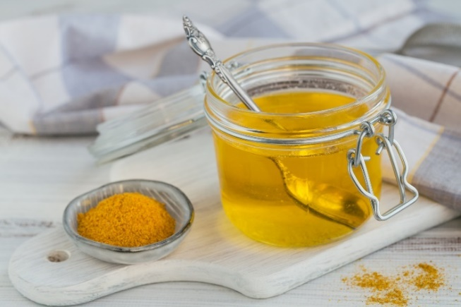
Health Benefit: Supports anti-inflammatory pathways and improves nutrient absorption.

Science: Curcumin is fat-soluble, requiring healthy fats like ghee for optimal absorption.

4. Yogurt + Spinach (Gut Health Synergy)

Combination: Yogurt's probiotics pair with spinach's fiber to nourish gut microbiota.

Health Benefit: Improves digestion, supports immune health and enhances nutrient absorption.

Science: Studies show that probiotics and prebiotics create a synergistic effect, promoting gut health.

Cooking Method and Its Benefits

- Blanching for Nutrient Retention

Process: Quick blanching preserves spinach's bright color and nutrients while removing excess oxalates.

Taste Perspective: Retains a fresh, vibrant flavor without bitterness.

Health Perspective:

- Reduces oxalate content in spinach, enhancing calcium absorption.
- Maintains water-soluble vitamins like vitamin C and B vitamins.

- Low-Heat Cooking for Dairy

Process: Cooking yogurt or paneer at low heat prevents curdling and preserves their delicate flavors and textures.

Taste Perspective: Creamy and smooth without overpowering other flavors.

Health Perspective:

- Preserves probiotics in yogurt (if used) for gut health.
- Maintains protein integrity in paneer for optimal nutrition.

West African Peanut Stew Recipe

This hearty and flavorful stew combines nutrient-dense ingredients like peanuts, sweet potatoes, and spinach for a comforting, health-boosting meal.

- 2 tbsp vegetable oil (e.g., coconut or peanut oil)
- 1 medium onion, diced
- 3 cloves garlic, minced
- 1-inch piece of ginger, minced or grated
- 1-2 tsp red chili flakes or cayenne pepper (adjust to taste)
- 1 large sweet potato, peeled and cubed
- 1 can (14 oz) diced tomatoes (or 4 fresh tomatoes, diced)
- 1/2 cup natural peanut butter (unsweetened, unsalted)
- 4 cups vegetable or chicken broth
- 2 cups fresh spinach or kale, chopped
- Salt and black pepper, to taste
- Optional: 1 can (14 oz) chickpeas or cooked lentils for extra protein
- Fresh cilantro, chopped, for garnish
- Cooked rice, quinoa, or flatbread for serving

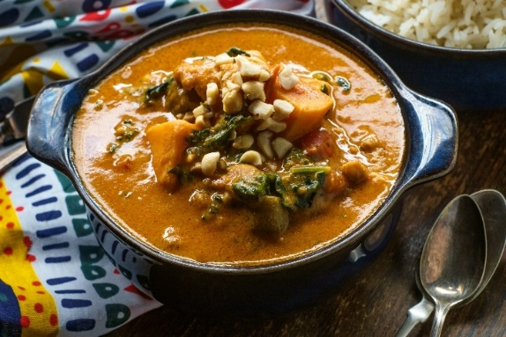
Heat the vegetable oil in a large pot over medium heat. Add the onion and cook until soft and translucent (about 5 minutes). Stir in the garlic, ginger, and chili flakes. Cook for another minute until fragrant.

Add the cubed sweet potatoes and diced tomatoes to the pot. Stir and cook for 5 minutes, letting the tomatoes break down slightly. Stir in the peanut butter until well combined. Pour in the vegetable or chicken broth, stirring to ensure the peanut butter dissolves. Bring the stew to a simmer, cover, and cook for 20-25 minutes or until the sweet potatoes are tender.

Stir in the chopped spinach or kale, allowing it to wilt. If using chickpeas or lentils, add them now and cook for an additional 5 minutes. Season with salt and black pepper to taste. Ladle the stew into bowls.

Nutritional Highlights

- Rich in Plant-Based Protein: Peanut butter and optional chickpeas/lentils contribute high-quality plant protein, which is ideal for vegetarians or those seeking nutrient-dense meals.
- High in Fiber: Sweet potatoes, spinach, and optional legumes offer dietary fiber, which promotes digestive health and stabilizes blood sugar levels.
- Packed with Micronutrients: Sweet potatoes are rich in beta-carotene (a vitamin A precursor), spinach provides iron and calcium, and peanuts contribute vitamin E and magnesium.
- Anti-Inflammatory Properties: Ginger and chili flakes contain bioactive compounds like gingerol and capsaicin, which help reduce inflammation and support immune health.
- Heart-Healthy Fats: Peanut butter and vegetable oil provide unsaturated fats that support cardiovascular health and aid nutrient absorption.

Food Combinations and Their Benefits

1. Peanuts + Sweet Potatoes (Energy and Nutrient Boost)

Combination: Peanuts provide fats and protein, complementing the sweet potato's complex carbohydrates and beta-carotene.

Health Benefit: Supports sustained energy release, immune function, and eye health.

Science: Beta-carotene in sweet potatoes is fat-soluble, and peanuts enhance its bioavailability for optimal absorption.

2. Spinach + Peanut Butter (Iron Absorption and Fat-Soluble Vitamins)

Combination: Spinach offers plant-based iron and calcium, while peanut butter provides fats that enhance absorption.

Health Benefit: Promotes red blood cell production, bone health, and overall energy levels.

Science: Dietary fats improve the bioavailability of spinach fat-soluble vitamins like vitamins A, K, and E.

3. Ginger + Chili Flakes (Anti-Inflammatory Synergy)
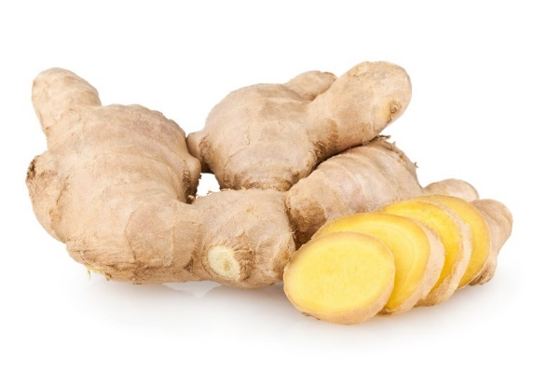
Combination: Gingerol in ginger and capsaicin in chili flakes work together to combat inflammation and boost metabolism.

Health Benefit: Reduces oxidative stress, supports digestion, and enhances circulation.

Science: Capsaicin improves blood flow, while gingerol enhances gut motility and anti-inflammatory pathways.

4. Tomatoes + Peanut Butter (Lycopene Absorption)

Combination: Tomatoes are rich in lycopene, an antioxidant; peanut butter's fats enhance its absorption.

Health Benefit: Protects against oxidative stress, supports heart health, and may reduce cancer risk.

Science: Studies show that consuming lycopene with dietary fats significantly increases its bioavailability.

Cooking Method and Its Benefits

- Sautéing Aromatics for Flavor Development

Process: Cooking onions, garlic, and ginger in oil releases their natural flavors and enhances the depth of the dish.

Taste Perspective: This creates a robust and aromatic base for the stew.

Health Perspective:
- Garlic and ginger release sulfur compounds that boost immunity and fight inflammation.
- Onions provide quercetin, an antioxidant that supports heart health.

- Simmering for Nutrient Blending

Process: Cooking the stew slowly allows flavors to meld and soften the sweet potatoes.

Taste Perspective: Results in a creamy, cohesive stew balanced with sweet, savory, and spicy flavors.
Health Perspective:

- Preserves water-soluble vitamins like vitamin C in sweet potatoes.
- Softens fiber for easier digestion.

- Adding Greens at the End

Process: Adding spinach or kale before serving retains their vibrant color and nutrients.

Taste Perspective: Adds freshness and mild bitterness to balance the stew's richness.

Health Perspective:

- Minimizes heat exposure to preserve delicate antioxidants and vitamins like vitamin C and folate.

- Cultural and Health Insights

Traditional Element: Peanuts as a base reflects West African culinary traditions, where groundnut-based stews are a staple.

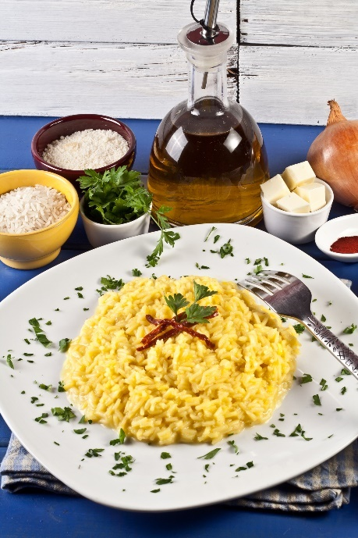
Traditional Italian Risotto alla Milanese
Serves 4

- 2 tbsp butter (or olive oil for a lighter version)
- 1 small onion, finely chopped
- 1 1/2 cups Arborio rice
- 1/2 cup dry white wine
- 4 cups chicken or vegetable stock, warmed
- 1/4 tsp saffron threads
- 1/2 cup grated Parmesan cheese
- Salt and black pepper, to taste
Optional: 2 tbsp chopped fresh parsley for garnish

Melt 1 tbsp of butter in a large skillet or pot over medium heat. Add the chopped onion and sauté until soft and translucent (about 5 minutes). Add the Arborio rice to the pot and stir for 2–3 minutes until the rice is lightly toasted and coated with butter. Pour in the white wine and stir until it is mainly absorbed, enhancing its flavor.

Gradually add warm stock, one ladle at a time, stirring continuously. Allow the rice to absorb each addition of stock before adding the next. After 15 minutes, dissolve the saffron threads in a small amount of warm stock and add to the risotto. Once the rice is al dente and creamy (about 20–25 minutes total), stir in the Parmesan cheese and the remaining butter. Adjust seasoning with salt and black pepper to taste. Garnish with fresh parsley, if desired, and serve immediately.

Nutritional Highlights

- Energy-Rich Carbohydrates: Arborio rice provides sustained energy and is gentle on the digestive system, making it ideal for a comforting meal.
- Anti-Inflammatory Saffron: Saffron contains crocin and safranal, antioxidants known for their mood-boosting and anti-inflammatory properties.
- High-Quality Protein and Calcium: Parmesan cheese adds protein, calcium, and phosphorus, supporting bone health.
- Rich in Healthy Fats: Butter or olive oil provides essential fats, aiding nutrient absorption and adding a luxurious texture.
- Gut-Friendly: Onions serve as a prebiotic, nourishing, beneficial gut bacteria.

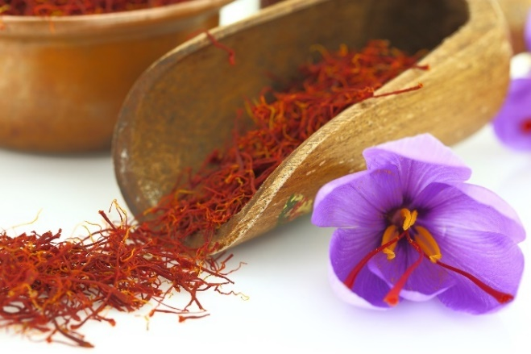
Food Combinations and Their Benefits

1. Saffron + Butter (Antioxidant Boost and Absorption)

Combination: Saffron's antioxidants are better absorbed by fat from butter or olive oil.

Health Benefit: Combats oxidative stress, supports brain function, and enhances nutrient uptake.

Science: Studies show fat-soluble antioxidants like saffron's crocin are more bioavailable when paired with healthy fats.

2. Arborio Rice + Parmesan (Energy and Satiety)

Combination: The rice provides quick-digesting carbs, while Parmesan offers protein and fat for satiety.

Health Benefit: A balanced combination of sustained energy and muscle maintenance.

Science: Protein in Parmesan slows the digestion of carbs, stabilizing blood sugar levels.

3. Onions + Stock (Flavor and Gut Health)

Combination: Onions release prebiotic fibers and natural sweetness when cooked in stock.

Health Benefit: Supports gut microbiota diversity and boosts immune function.

Science: Prebiotic compounds in onions enhance the growth of beneficial gut bacteria, while stock contributes collagen for gut lining support.

4. Wine + Saffron (Heart Health and Antioxidants)

Combination: White wine brings polyphenols that complement saffron's antioxidant properties.

Health Benefit: Protects against oxidative damage and supports cardiovascular health.

Science: Polyphenols in wine enhance blood vessel function and reduce inflammation.

Cooking Method and Its Benefits

- Slow Stock Absorption

Process: Gradually adding stock and stirring allows the rice to release its starch, creating a creamy texture.

Taste Perspective: The slow absorption enhances flavor depth, allowing the stock's richness to infuse the rice.

Health Perspective:

- Preserves nutrients in the stock.
- Creates a creamy texture without added cream, making it lighter while satisfying.

- Saffron Infusion

Process: Dissolving saffron in warm liquid ensures even color, flavor, and nutrient distribution.

Taste Perspective: Adds subtle floral notes and a golden hue to the dish.
Health Perspective:

- Preserves the bioactive compounds in saffron, like crocin and safranal, which degrade at high heat.
- Enhances the dish's visual appeal, boosting its sensory impact.

- Cultural and Health Insights

Traditional Element: Risotto alla Milanese is a classic Milanese dish often served as a luxurious accompaniment to meats like osso buco.

Why Garlic and Onions Are Staples Across Cultures

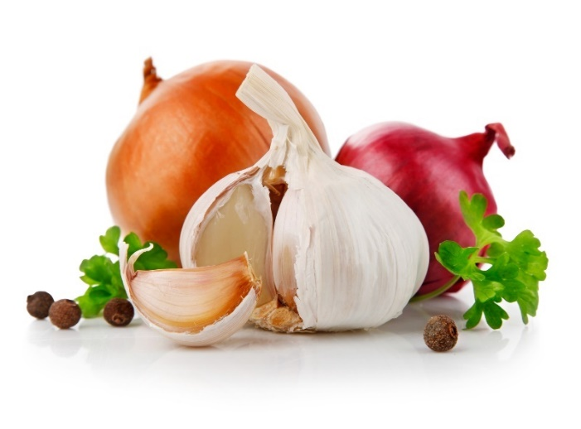
Flavor Enhancers:

Garlic and onions form the aromatic base of countless dishes, adding depth, umami, and complexity. Onions bring natural sweetness as they caramelize, while garlic contributes pungency and savory richness.

Their complementary profiles balance and amplify the flavors of spices, herbs, and other ingredients.

Cultural Significance and Accessibility:

Garlic and onions are easy to grow, store, and use, making them staples in kitchens worldwide. Many cultures attribute them to have protective properties; for instance, garlic has been used in folklore to ward off illness and evil spirits. It's the antimicrobial properties of garlic and onions that ward off illness.

Health-Promoting Properties: Rich in sulfur compounds and antioxidants, garlic and onions enhance food flavor and contribute to its medicinal value, supporting holistic well-being.

Health Benefits of Garlic and Onions

Rich in Sulfur Compounds: Garlic contains allicin, formed when chopped or crushed, offering antimicrobial and immune-boosting effects.

Onions contain sulfur compounds like thiosulfinates, which aid in detoxification and reduce inflammation.

Gut Health: Both are excellent sources of prebiotic fibers, like inulin, which feed beneficial gut bacteria, promoting better digestion and immune function.

Cardiovascular Support: Garlic and onions help regulate blood pressure and cholesterol levels while improving circulation through compounds like allicin and quercetin (an antioxidant found in onions).

Anti-Inflammatory and Antioxidant Properties: Quercetin in onions and sulfur compounds in garlic reduce inflammation and oxidative stress, lowering the risk of chronic diseases like arthritis, diabetes, and heart disease.

Detoxification: The sulfur compounds boost liver detoxification pathways, enhancing the body's ability to eliminate toxins.

Antimicrobial and Immune Boosting: Garlic is a natural antibiotic; onions bolster immune defenses through their antioxidant content.

How Garlic and Onions Enhance the Nutrients in Other Foods

Improved Mineral Absorption: Garlic and onions enhance the bioavailability of iron and zinc from plant and animal sources, making them particularly valuable in recipes featuring legumes, grains, or meats.

Example: Adding garlic and onions to lentil soups or bean stews increases the absorption of essential minerals, combating anemia.

Enhanced Antioxidant Activity: When paired with vitamin C-rich foods (e.g., citrus and bell peppers), the antioxidants in garlic and onions boost each other's effects, improving immune support.

Example: Garlic and onions in salads or dressings with lemon juice amplify the antioxidant profile.

Fat-Soluble Nutrient Bioavailability: Their sulfur compounds improve the absorption of fat-soluble vitamins (A, D, E, and K) from vegetables like leafy greens and carrots.

Example: Sautéing spinach or kale with onions and garlic enhances vitamin A and K absorption.

Synergistic Effects with Anti-Inflammatory Foods: Garlic and onions enhance the bioavailability of curcumin (in turmeric) and sulforaphane (in cruciferous vegetables), amplifying their anti-inflammatory and anticancer properties. This may be true for other phytonutrients, but research is not complete.

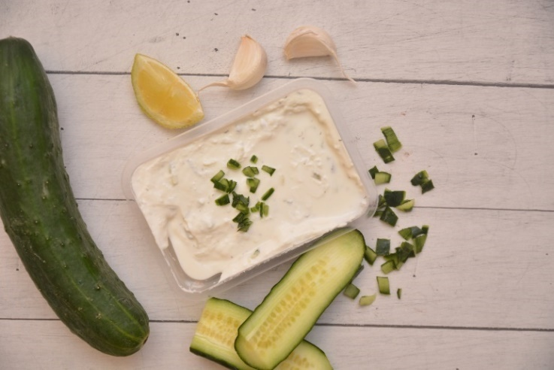
Example: Indian curries with turmeric, garlic, and onions create a powerful anti-inflammatory dish.

Gut Microbiota Support: Garlic and onions' prebiotic fibers nourish gut bacteria, complementing probiotics in foods like yogurt, miso, or kimchi.

Example: Dishes like tzatziki (yogurt with garlic) support gut health through prebiotic-probiotic synergy.

Amplified Protein Digestion: The sulfur compounds help break down proteins during cooking, improving digestibility and nutrient assimilation.

Example: Garlic-marinated chicken or tofu with onions enhances protein utilization.

Increased Antioxidant Potential in Cooking: Garlic and onions release sulfur compounds during cooking, enhancing the nutrient profiles of dishes with antioxidant-rich vegetables like tomatoes or peppers.

Example: Stir-fried vegetables with onions and garlic deliver a higher antioxidant load.

Examples of Classic Pairings and Their Nutritional Benefits

- Garlic + Leafy Greens: Boosts fat-soluble vitamins and lutein bioavailability, supporting eye health.
- Onions + Lentils: Enhances iron and zinc absorption, combating deficiencies.
- Garlic + Olive Oil: Creates a heart-healthy combination with enhanced anti-inflammatory effects.
- Onions + Potatoes: Reduces the glycemic load, stabilizing blood sugar levels.
- Garlic + Tomatoes: Improves lycopene absorption, offering antioxidant protection.

French Coq au Vin Recipe

This traditional French dish marries the deep flavors of wine, garlic, and herbs to create a hearty, comforting meal perfect for cool evenings.

- 2 tbsp olive oil
- 1 small onion, diced
- 3 cloves garlic, minced
- 4 oz pancetta or smoked bacon, diced
- 1 whole chicken (cut into 8 pieces) or 4 chicken thighs/drumsticks
- 2 cups red wine (e.g., Burgundy or Pinot Noir)
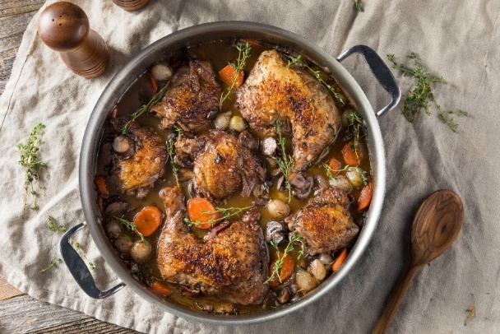
- 1 cup chicken stock
- 2 tbsp tomato paste
- 1 tbsp all-purpose flour (optional for thickening)
- 2 large carrots, sliced
- 8 pearl onions, peeled (or 1 medium onion, quartered)
- 8 oz cremini mushrooms, quartered
- 2 sprigs fresh thyme
- 1 bay leaf
- 1 tbsp fresh parsley, chopped, for garnish
- Salt and black pepper, to taste

Heat olive oil in a large Dutch oven or heavy-bottomed pot over medium heat. Add the pancetta and cook until crisp. Remove with a slotted spoon and set aside. Season the chicken pieces with salt and pepper. Brown them in the same pot in batches, ensuring they get a nice golden crust. Remove and set aside. Add the diced onion and garlic to the pot. Sauté for 2–3 minutes, scraping up the browned bits.

Stir in the tomato paste and flour (if using), cooking for 1 minute. Return the chicken and pancetta to the pot. Pour in the wine and chicken stock. Add the thyme, bay leaf, carrots, and pearl onions. Bring to a simmer. Cover and cook on low heat for 25–30 minutes. Add the mushrooms during the last 10 minutes of cooking. Adjust the seasoning with salt and pepper. Garnish with fresh parsley. Serve with crusty bread, mashed potatoes, or buttered noodles.

Nutritional Highlights

- Protein-Rich: Chicken provides high-quality protein essential for muscle repair and growth.
- Rich in Antioxidants: Red wine contains resveratrol and flavonoids with antioxidant and anti-inflammatory properties.
- Micronutrient Boost: Carrots, onions, and mushrooms provide vitamins A, C, potassium, and selenium, which support immune and cardiovascular health.
- Heart-Healthy Fats: Olive oil offers monounsaturated fats that support heart health.
- Gut-Friendly Garlic: Garlic contains prebiotic compounds that nourish beneficial gut bacteria.

Food Combinations and Their Benefits

1. Wine + Garlic (Antioxidant and Cardiovascular Boost)

Combination: The antioxidants in red wine enhance the cardiovascular benefits of allicin in garlic.

Health Benefit: Promotes healthy blood flow and reduces oxidative stress.

Science: Studies suggest resveratrol in wine improves endothelial function, while garlic lowers blood pressure and cholesterol.

2. Chicken + Mushrooms (Immune and Protein Synergy)

Combination: Selenium in mushrooms complements the protein in chicken.

Health Benefit: Boosts immune function and aids in muscle recovery.

Science: Selenium supports thyroid health and acts as an antioxidant.

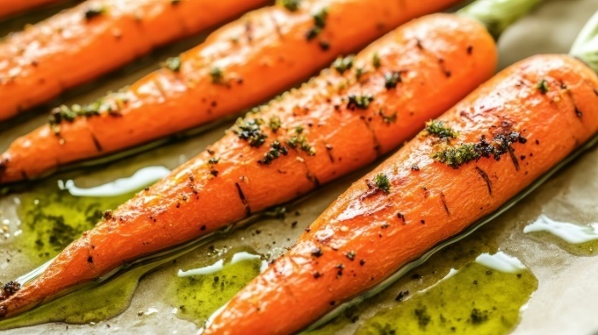
3. Carrots + Olive Oil (Vitamin Absorption)

Combination: Olive oil enhances the absorption of beta-carotene in carrots.

Health Benefit: Supports eye health, immune function, and skin health.

Science: Beta-carotene is fat-soluble, and healthy fats improve its bioavailability.

Cooking Method and Its Benefits

- Browning Meat for Flavor Development

Process: Searing chicken and pancetta creates a caramelized surface, enhancing the dish's depth of flavor.
Taste Perspective: Adds a savory umami element.

Health Perspective: It locks in moisture, reduces nutrient loss during cooking, and increases antioxidants when caramelized.

- Simmering for Layered Flavors

Process: Slow cooking melds wine, garlic, and herbs, infusing the chicken with rich flavor.

Taste Perspective: Creates a harmonious balance of savory, sweet, and earthy notes.

Health Perspective: Preserves vitamins and minerals while softening vegetables for easier digestion.

- Adding Mushrooms Late

Process: Adding mushrooms near the end retains their texture and nutrients.

Taste Perspective: Adds an earthy, meaty note.

Health Perspective: It preserves some nutrients. However, caramelizing the mushrooms by cooking them at the beginning with onions and garlic increases these antioxidants: ergothioneine, glutathione, melanoidins, phenolic compounds, and polyphenols.

Vegan Version

Mushroom and White Bean Coq au Vin

- 2 tbsp olive oil
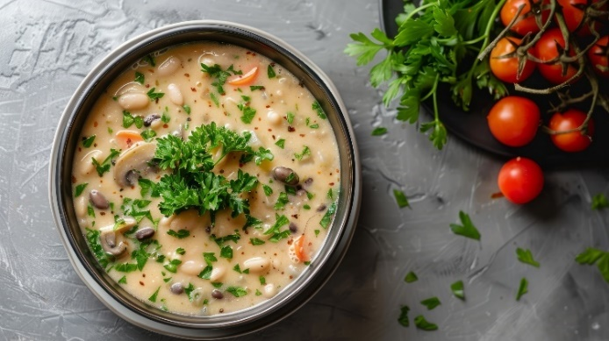
- 1 small onion, diced
- 3 cloves garlic, minced
- 12 oz cremini mushrooms, halved or quartered
- 2 cups red wine (e.g., Burgundy or Pinot Noir)
- 1 cup vegetable stock
- 2 tbsp tomato paste
- 1 tbsp all-purpose flour (optional for thickening)
- 2 large carrots, sliced
- 8 pearl onions, peeled (or 1 medium onion, quartered)
- 1 ½ cups cooked cannellini beans (or 1 can, drained and rinsed)
- 2 sprigs fresh thyme
- 1 bay leaf
- 1 tbsp fresh parsley, chopped, for garnish
- Salt and black pepper, to taste

Heat olive oil in a large Dutch oven or heavy-bottomed pot over medium heat. Add the diced onion, garlic, and mushrooms, and cook until soft and fragrant. Sprinkle with sea salt to help caramelize (5-10 minutes). Stir frequently. Stir in the tomato paste and flour (if using), cooking for 1 minute. Pour in the wine and vegetable stock, scraping up any browned bits. Add the carrots, pearl onions, thyme, and bay leaf. Simmer for 15–20 minutes until the vegetables are tender. Stir in the cooked cannellini beans. Simmer for 5 more minutes to heat through. Adjust seasoning with salt and pepper. Garnish with fresh parsley. Serve with crusty bread, mashed potatoes, or buttered noodles.

Antioxidants and the Maillard Reaction

The Maillard reaction, which occurs when proteins and sugars in food react at high heat, is responsible for the browning and the development of complex flavors. This reaction also produces unique compounds, some of which have antioxidant properties:

Formation of Antioxidant Compounds:

Melanoidins: These brown pigments formed during the Maillard reaction have been shown to exhibit antioxidant activity, including the ability to scavenge free radicals and chelate metal ions.

Intermediate Compounds: During browning, intermediate molecules such as certain amino acid-sugar derivatives demonstrate antioxidant effects.

Effect on Food's Nutritional Profile: While some heat-sensitive antioxidants (e.g., vitamin C) may degrade during high-heat cooking, creating new antioxidant compounds can offset this loss. Browning adds to the dish's overall antioxidant capacity, which helps combat oxidative stress when consumed.

Traditional Hummus Recipe

- 1 ½ cups cooked chickpeas (or 1 can, drained and rinsed)
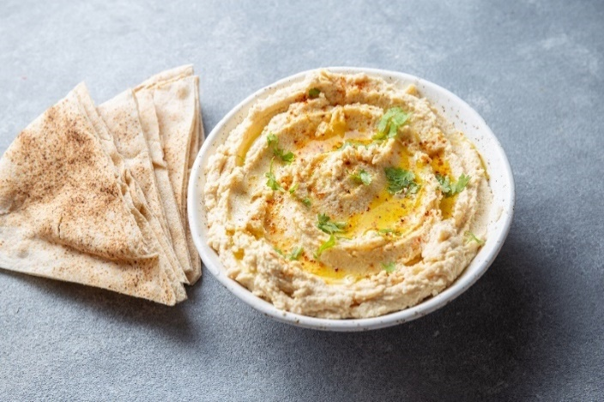
- 3 tbsp tahini (sesame seed paste)
- 2 tbsp extra virgin olive oil
- 2 cloves garlic, minced
- Juice of 1 lemon
- ½ tsp ground cumin
- ½ tsp salt (adjust to taste)
- 3–4 tbsp cold water (adjust for desired consistency)
Optional garnish: paprika, olive oil drizzle, and chopped parsley

Combine chickpeas, tahini, olive oil, garlic, lemon juice, cumin, and salt in a food processor. Blend until smooth, slowly adding cold water until the hummus reaches your desired consistency. Transfer to a bowl, drizzle with olive oil, and sprinkle with paprika and parsley. Serve with pita bread, fresh vegetables, or crackers.

Nutritional Highlights

- Rich in Plant-Based Protein: Chickpeas and tahini provide high-quality plant protein, supporting muscle repair and maintenance.
- Heart-Healthy Fats: Olive oil and tahini contribute to monounsaturated fats and omega-6 fatty acids, promoting cardiovascular health.
- High in Fiber: Chickpeas offer soluble fiber, aiding digestion and supporting gut health.
- Vitamin and Mineral Boost: Lemon juice adds vitamin C, while tahini provides calcium, magnesium, and zinc.
- Anti-Inflammatory Properties: Garlic contains allicin, and cumin provides bioactive compounds that help reduce inflammation and support immunity.

Food Combinations and Their Benefits

1. Chickpeas + Tahini (Protein and Nutrient Synergy)

Combination: Chickpeas provide lysine, and tahini is rich in methionine, creating a complete protein profile.

Health Benefit: Supports muscle repair, tissue growth, and energy production.

Science: Combining plant-based proteins ensures all essential amino acids are present for optimal absorption.
2. Garlic + Olive Oil (Anti-Inflammatory Power)

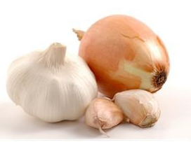
Combination: Garlic's sulfur compounds synergize with olive oil's monounsaturated fats.

Health Benefit: Reduces inflammation, supports cardiovascular health and enhances immune response.

Science: Allicin in garlic is better absorbed when paired with fats like olive oil.

3. Lemon Juice + Tahini (Calcium and Iron Absorption)

Combination: Lemon juice's vitamin C enhances the absorption of iron from tahini and chickpeas.

Health Benefit: Supports energy levels, bone health, and immune function.

Science: Vitamin C increases non-heme iron bioavailability by converting it to a more absorbable form.

4. Cumin + Garlic (Digestive and Anti-Inflammatory Synergy)

Combination: Cumin's antioxidants and digestive enzymes pair with garlic's sulfur compounds to enhance gut health and reduce inflammation.

Health Benefit: Improves digestion, supports liver detoxification, and boosts antioxidant activity.

Science: Sulfur compounds in garlic enhance the bioavailability of cumin's antioxidants, amplifying their effects.

Cooking Method and Its Benefits

- Blending for Maximum Nutrient Preservation

Process: The ingredients are blended raw (except for chickpeas) to retain their natural nutrients.

Taste Perspective: Creates a creamy, flavorful dip with a balance of savory, nutty, tangy, and warm flavors.

Health Perspective: Preserves heat-sensitive vitamins like vitamin C in lemon juice and antioxidants in olive oil and cumin.

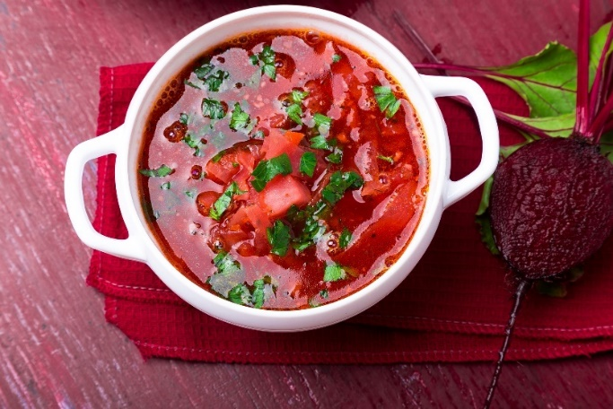
Traditional Russian Borscht Recipe
Serves 2-4

- 1 tbsp sunflower oil (or other neutral oil)
- 1 medium onion, diced
- 2 cloves garlic, minced
- 2 medium beets, peeled and grated
- 2 medium carrots, peeled and grated
- 2 medium potatoes, peeled and diced
- 1 small head of cabbage, finely shredded
- 1 large tomato, diced (or 2 tbsp tomato paste)
- 6 cups vegetable or beef broth
- 1 bay leaf
- Salt and black pepper, to taste
- Fresh dill, chopped, for garnish
- 1 cup cooked kidney beans or meat (e.g., beef or pork), optional for additional protein
- Smetana (traditional sour cream) or plain yogurt for serving

Heat sunflower oil in a large pot over medium heat. Add the onion and garlic, cooking until soft and fragrant (about 3–4 minutes). Stir in the grated beets and carrots. Cook for 5 minutes, then add the diced tomato or tomato paste and cook for another 2–3 minutes. Pour in the broth, add the potatoes and bay leaf, and bring to a boil. Reduce to a simmer and cook for 10 minutes.

Stir in the shredded cabbage and optional kidney beans or meat. Simmer for another 10–15 minutes until all vegetables are tender. Season with salt and pepper. Ladle the borscht into bowls, garnish with fresh dill, and top with a dollop of smetana or yogurt. Serve with rye bread or crackers.

Nutritional Highlights

- Rich in Antioxidants: Beets contain betalains, which have anti-inflammatory and antioxidant properties.
- Gut-Healthy Fiber: Cabbage, carrots, and potatoes provide dietary fiber, supporting digestion and gut health.
- Immune Support: Garlic and dill contribute antimicrobial and anti-inflammatory compounds.
- Heart-Healthy: Beets and dill promote healthy blood pressure and circulation.
- Probiotic Boost: Smetana and yogurt are fermented, providing beneficial bacteria that support gut health and immunity.

Food Combinations and Their Benefits

1. Beets + Cabbage (Anti-Inflammatory and Digestive Support)

Combination: Beets offer betalains, and cabbage provides glucosinolates, both known for their detoxifying properties.

Health Benefit: Reduces oxidative stress and supports liver detoxification.

Science: Betalains in beets and sulfur compounds in cabbage enhance antioxidant enzyme activity.

2. Garlic + Dill (Immune and Cardiovascular Support)

Combination: Garlic's allicin pairs with dill's monoterpenes and flavonoids to boost immunity and reduce inflammation.

Health Benefit: Protects against infections, supports circulation, and reduces cholesterol levels.

Science: Allicin in garlic is a potent antimicrobial, while dill aids digestion and has lipid-lowering properties.

3. Potatoes + Smetana or Yogurt (Energy and Nutrient Absorption)

Combination: Potatoes provide complex carbohydrates, while smetana or yogurt offers fats or proteins that enhance the absorption of fat-soluble vitamins.

Health Benefit: It supports sustained energy levels and improves the bioavailability of vitamins A, D, E, and K.
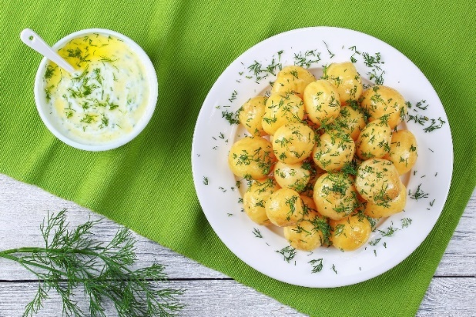
Science: The fats in smetana or the proteins in yogurt increase the bioavailability of these nutrients from other ingredients.

4. Beets + Smetana or Yogurt (Flavor and Digestive Harmony)

Combination: The earthy sweetness of beets balances the tangy creaminess of smetana or yogurt.

Health Benefit: Enhances digestive comfort through probiotics while balancing the dish's acidity.

Science: Fermented dairy products like smetana and yogurt contain live cultures that support gut health and aid digestion.

Cooking Method and Its Benefits

- Sautéing Aromatics for Depth of Flavor

Process: Cooking onions, garlic, and vegetables in oil enhances their natural sweetness and creates a flavorful base.
Taste Perspective: Adds richness and aroma to the borscht.

Health Perspective: Releases sulfur compounds in garlic and onions, boosting immune and heart health.
Simmering for Nutrient Integration

- Slow Cooking

Process: Slow cooking allows the flavors of vegetables and broth to meld while retaining most of their nutrients.

Taste Perspective: Creates a rich, well-balanced flavor.

Health Perspective: Preserves water-soluble nutrients like vitamin C in cabbage and carrots.

- Adding Smetana or Yogurt at the End

Process: Serving smetana or yogurt as a topping retains its probiotic content and enhances the dish's creaminess and tanginess.

Taste Perspective: Balances the earthiness of the beets and cabbage while adding a cooling contrast.

Health Perspective: Preserves probiotics and adds digestive and immune-boosting properties.

Traditional Chocolate Nut Clusters Recipe

- 8 oz dark chocolate (70% cocoa or higher), chopped
- 1 cup mixed nuts (e.g., almonds, walnuts, hazelnuts, or pecans)
- 1/2 cup dried fruits (optional, e.g., raisins, cranberries, or chopped apricots)
- 1 tsp vanilla extract (optional)
- Pinch of sea salt

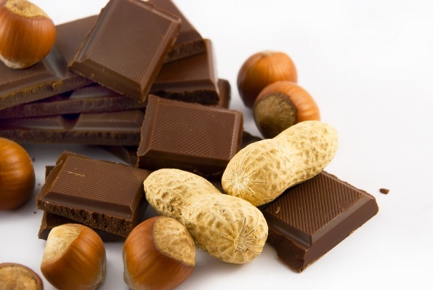
Preheat the oven to 300°F (175°C). Spread the nuts on a baking sheet and toast for 10-12 minutes until fragrant. Let them cool slightly. Place the chopped dark chocolate in a heatproof bowl and melt it using a double boiler, or place the bowl in a pot with about 1 inch of water in the bottom. Remove the bowl from the pot. Stir the toasted nuts (and dried fruits into the melted chocolate. Add the vanilla extract and a pinch of sea salt, mixing until everything is evenly coated.

Line a baking sheet with parchment paper. Drop spoonfuls of the chocolate-nut mixture onto the sheet, forming small clusters. Refrigerate for 30 minutes or until the chocolate is firm. Enjoy immediately, or store in an airtight container in the fridge for up to 2 weeks.

Nutritional Highlights

- Rich in Antioxidants: Dark chocolate and nuts contain flavonoids and polyphenols that combat oxidative stress and reduce inflammation.
- Heart-Healthy Fats: Nuts provide monounsaturated fats and omega-3 fatty acids, which lower cholesterol and support cardiovascular health.
- Reduces Advanced Glycation End Products (AGEs): Nuts and dried fruits contain compounds that lower the formation of AGEs, which are harmful compounds formed when proteins or fats combine with sugars.
- High in Fiber: Nuts and dried fruits contribute to dietary fiber, improving digestion and stabilizing blood sugar levels.
- Energy Boost: The combination of chocolate, nuts, and dried fruits offers sustained energy and supports overall vitality.

What Are AGEs?

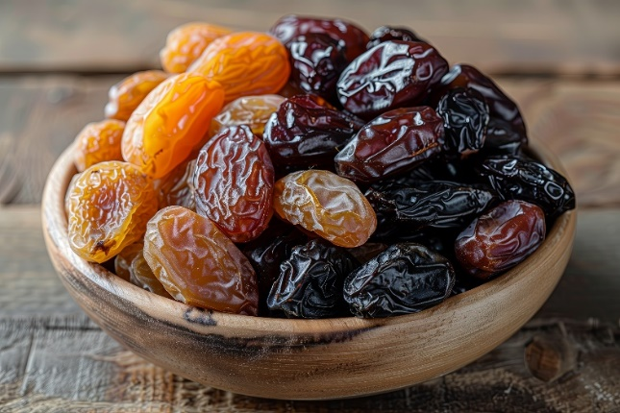
Advanced Glycation End Products (AGEs) are harmful compounds formed when sugars bind to proteins or fats through glycation. This can occur naturally in the body or be accelerated by high-heat cooking methods and diets high in processed foods. AGEs contribute to oxidative stress and inflammation, which are linked to aging and chronic diseases like diabetes, heart disease, and neurodegenerative disorders.

How Nuts and Fruits Help Lower AGEs

Antioxidant Content:
Nuts (e.g., almonds, walnuts, hazelnuts) and dried fruits (e.g., raisins, apricots) are rich in antioxidants like vitamin E, flavonoids, and polyphenols.
These antioxidants neutralize free radicals and reduce oxidative stress, which helps prevent AGE formation.

Fiber:
The fiber in nuts and dried fruits slows the absorption of sugars, reducing blood sugar spikes that can lead to the formation of AGEs.

Natural Anti-Glycation Compounds:
Nuts and dried fruits contain natural compounds, such as phenolic acids, that inhibit glycation processes, reducing AGE accumulation in the body.

Low Glycemic Impact:
Compared to refined sugars, the natural sugars in dried fruits have a lower glycemic impact when paired with fiber and healthy fats, further minimizing AGE production.

Food Combinations and Their Benefits

1. Dark Chocolate + Nuts (Antioxidant and Anti-Glycation Synergy)

Combination: Flavonoids in chocolate pair with antioxidants and healthy fats in nuts to combat oxidative stress and glycation.

Health Benefit: Reduces AGE formation, supports cardiovascular health, and protects cells from damage.

2. Dried Fruits + Nuts (Glycemic Balance and AGE Reduction)

Combination: Dried fruits offer natural sweetness and vitamins, while nuts provide fats and fiber to regulate blood sugar.

Health Benefit: Lowers the glycemic load, minimizing AGE production and inflammation.

3. Chocolate + Sea Salt (Flavor Enhancement)

Combination: Sea salt highlights the sweetness of chocolate while providing trace minerals.

Health Benefit: Adds flavor balance, helping to satisfy cravings with smaller portions and less sugar. The salt complements chocolate's sweetness, balances dark chocolate's bitter edge, and brings out the natural flavors of nuts, making the treat more satisfying and reducing overindulgence.

Here are other seasonings that can also be added and enhance flavor and benefits:

- Cinnamon: Amplifies dark chocolate's antioxidant properties and complements the healthy fats in nuts, supporting overall cardiovascular and metabolic health.
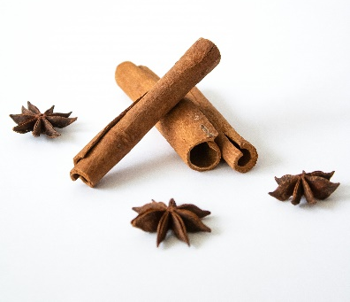
- Paprika: Pairs with chocolate's richness and the healthy fats in nuts, enhancing both taste and the anti-inflammatory benefits.

- Vanilla: Enhances the natural sweetness of chocolate, highlights the nuttiness of the nuts, and works synergistically with their antioxidants for a flavorful and health-boosting treat.

- Chili: Capsaicin from chili enhances the body's absorption of flavonoids and alkaloids in cocoa, amplifying their antioxidant and anti-inflammatory effects. This combination also promotes endorphin release, giving it mood-boosting properties.

Cooking Method and Its Benefits
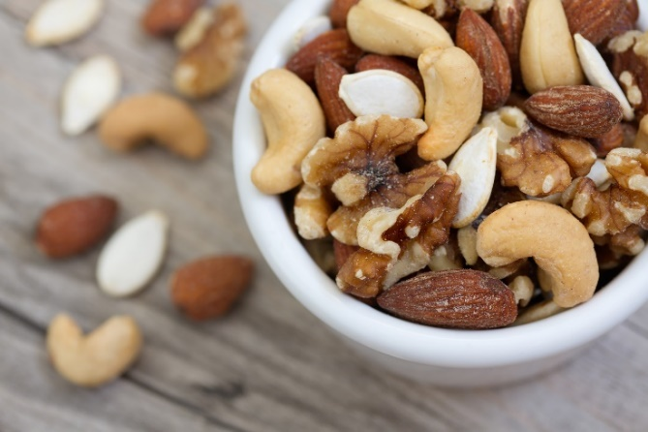
- Roasting Nuts

Process: Light toasting releases the nuts' natural oils, enhancing flavor while maintaining nutrient content. It also increases the nuts' antioxidants.

Health Perspective: Improves digestibility and retains anti-glycation properties.

- Low-Heat Chocolate Melting

Process: Melting chocolate gently at low heat preserves its antioxidants.

Health Perspective: Maintains the flavonoid content, which combats oxidative stress and AGE formation.

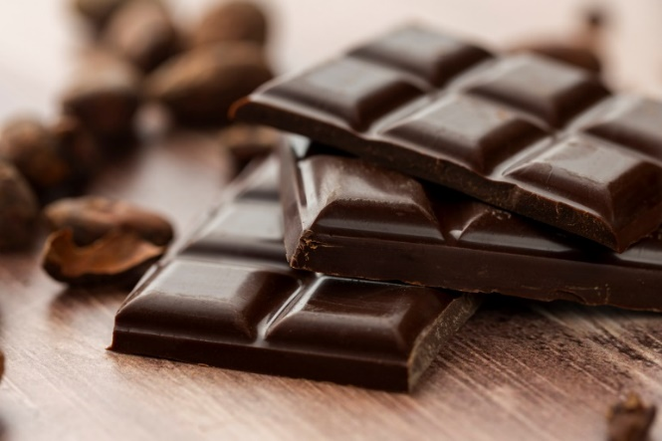

Why Use Vanilla in Recipes Like Chocolate Nut Clusters?

Enhances Flavor Balance: Vanilla complements dark chocolate's bitterness and toasted nuts' nuttiness, creating a harmonious and satisfying flavor profile.

Boosts Antioxidant Levels: Vanilla contains vanillin, an antioxidant that works synergistically with flavonoids in dark chocolate and polyphenols in nuts to combat oxidative stress and promote overall health.

Supports Mood: Vanilla's calming effects promote relaxation and satisfaction, enhancing the sensory enjoyment of indulgent treats and potentially reducing stress-induced cravings.

Natural Appetite Suppressant:

Role: Vanilla's naturally sweet aroma and flavor can be a natural appetite suppressant. The sensory experience of vanilla is thought to help curb cravings by stimulating satiety signals in the brain.

Science: Studies indicate that aromatic compounds like vanillin may reduce the desire for high-sugar or calorie-dense foods, promoting mindful eating and portion control.

Practical Effect: Incorporating vanilla into recipes can make treats feel more indulgent, reducing the urge to overeat while satisfying sweet cravings.



