
Eating
For
Epigenetics

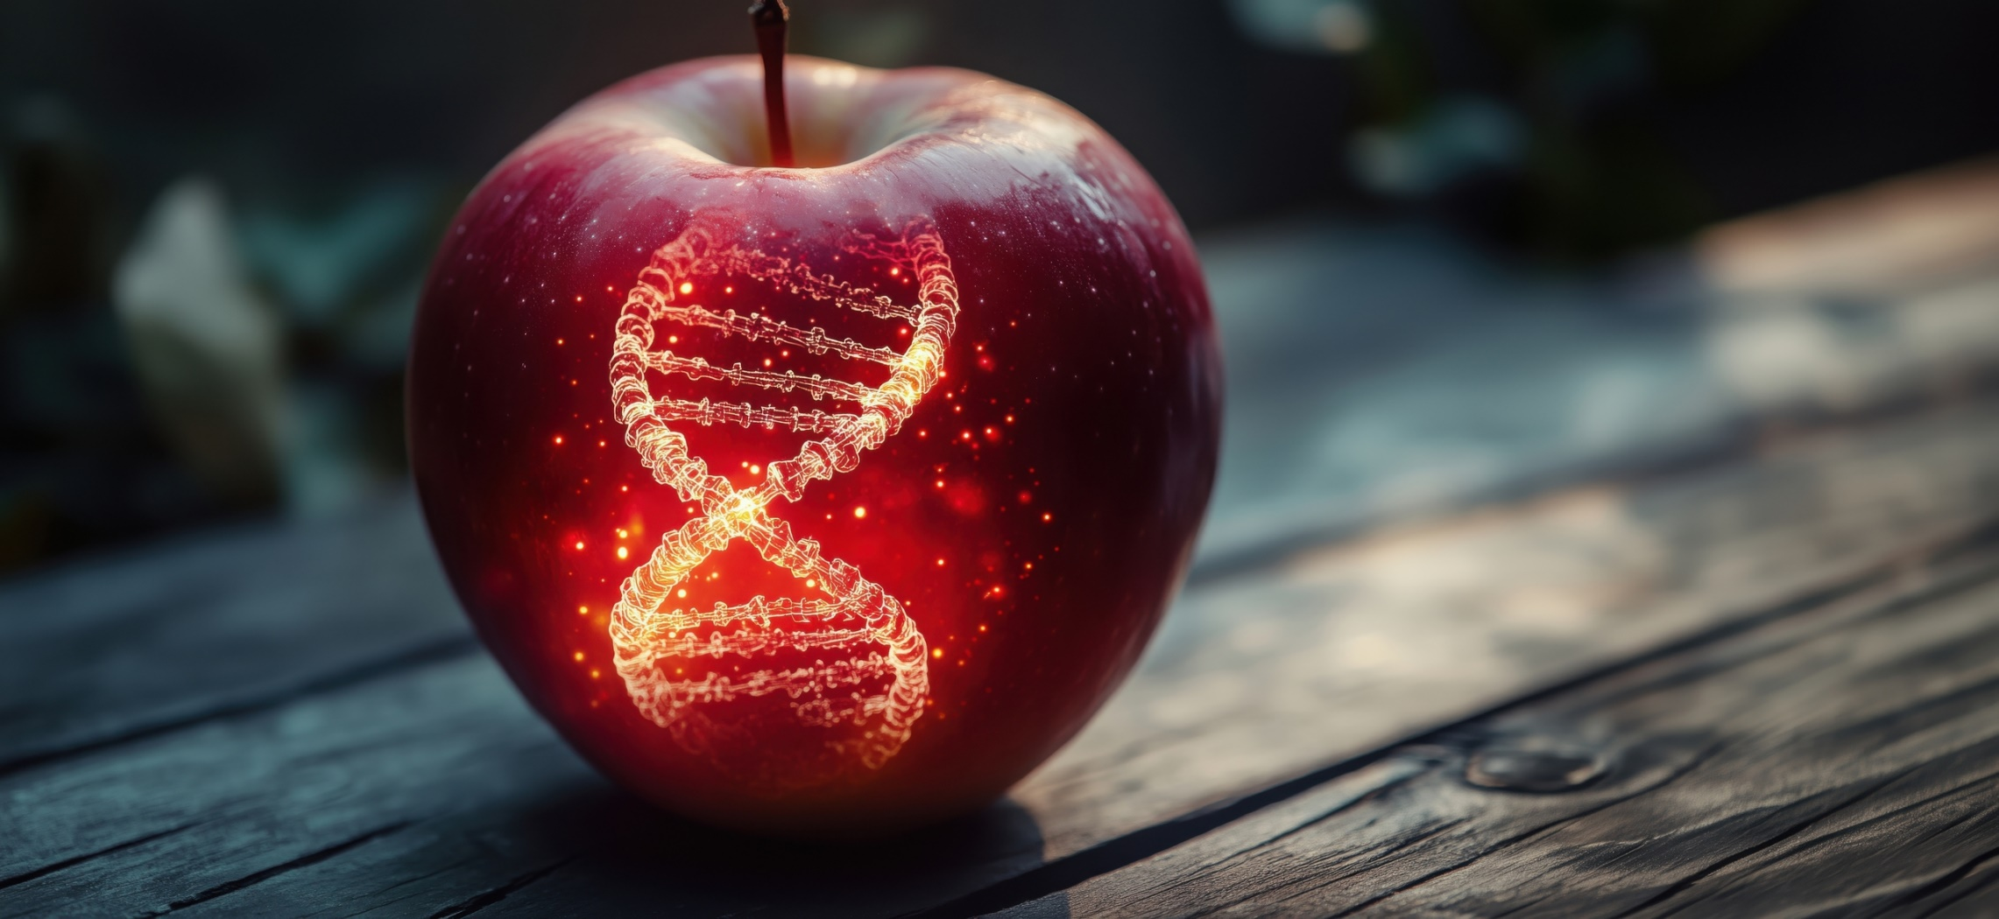
Hello,
Welcome to the Eating For Epigenetics
Your daily food choices have the power to influence gene expression, shaping your health at the molecular level. Epigenetics shows us how specific nutrients affect DNA methylation, histone modifications, and non-coding RNA activity, ultimately impacting metabolism, inflammation, and longevity.
This guide provides carefully curated recipes and meal ideas to support epigenetic pathways through targeted foods, herbs, and spices. Whether you want to enhance detoxification, cognitive function, or cellular repair, these nutrient-dense meals will help you optimize gene expression and overall well-being.
If you have any questions, feel free to reach out at (PHONE NUMBER) or (EMAIL).
Let’s nourish your genes for lifelong health!

Signature
 (Place HEADSHOT)
Contact info (optional)
(Place LOGO)

Medical Disclaimer
All information contained in this document is for informational purposes only. It is not intended to diagnose, treat, cure, or prevent health problems. For all serious health issues, please contact a medical or nutrition practitioner. The information provided in this program is based on the best knowledge of the author at the time of writing, and we do not assume liability for the information within this program, be it direct or indirect, consequential, special, exemplary, or other damages. In all circumstances, it is always wise to consult your physician before changing your diet, taking supplements, or starting any exercise or health program.
Table of Contents
Fermented Beet Beverage For Epigenetics 4
Recipe 5
Ways to Use the Strained Ingredients from the Fermented Beet Beverage 6
5 Recipes for DNA Methylation Support 7
1. Methylation Power Salad 7
2. Beet & Lentil Soup 8
3. Choline-Rich Scramble 9
4. Salmon with Roasted Asparagus and Sweet Potato 9
5. Turmeric Golden Milk with Almonds 10
5 Recipes for Histone Modification Support 10
1. Kale & Broccoli Stir-Fry with Brown Rice 10
2. Berry & Walnut Overnight Oats 10
3. Curried Roasted Cauliflower with Garlic Chicken 11
4. Green Tea & Dark Chocolate Smoothie 11
5. Wild Blueberry Chia Pudding 12
5 Recipes for Non-Coding RNA Support 12
Fermented Grain Bowl 12
2. Flaxseed & Walnut Energy Bites 13
3. Sardine & Avocado Toast 13
4. Garlic & Leek Soup 14
5. Kefir Berry Smoothie 14
Extra Recipes to Complete the Meals 15
1. Sourdough Toast with Avocado 15
2. Green Tea 15
3. Sautéed Spinach & Mushrooms 15
4. Steamed Edamame 15
5. Apple with Almond Butter 16
6. Brown Rice 16
7. Side of Roasted Brussels Sprouts 16
Meal Ideas 17

Epigenetics—the study of how lifestyle and environmental factors influence gene expression—plays a crucial role in long-term health. Diet is a key component of this process, impacting DNA methylation, histone modifications, and non-coding RNA regulation, all of which help control gene activity. By incorporating nutrient-dense foods that support these functions, we can optimize our body's ability to maintain genetic balance and reduce the risk of chronic diseases.

This guide provides targeted recipes and meal ideas to enhance three key processes that help balance gene expression: DNA methylation, histone modification, and non-coding RNA regulation. Specific foods, herbs, and spices can be used to accomplish this.

Each section highlights essential nutrients and food pairings contributing to epigenetic health, making integrating science-backed nutrition into daily meals easier. Whether you're looking to support detoxification, cognitive function, or cellular repair, these recipes offer practical and delicious ways to nourish your body at the genetic level.

Fermented Beet Beverage For Epigenetics

Fermenting key foods needed for balancing epigenetics provides a simple way to consume the nutrients in one beverage. Fermenting increases the bioavailability of nutrients, making it a powerful way to support the body.

Ingredients & Benefits
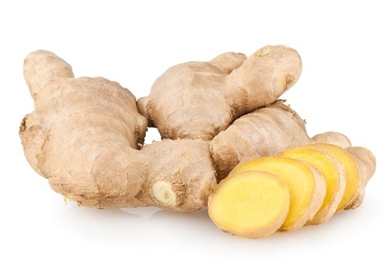
- Beets – Supports DNA methylation with betaine and promotes gut microbiota for non-coding RNA regulation.
- Radish: Supports DNA methylation, histone modification, and non-coding RNA regulation through its folate, glucosinolates, and antioxidant compounds.
- Red Onion, White Onion, or Shallots: Provide quercetin, which influences DNA methylation and detox-related non-coding RNA expression.
- Non-Chlorinate Water: Provides a clean base for fermentation. Spring water is best.
- Himalayan Sea Salt – Controls microbial balance and encourages beneficial fermentation.
- Sauerkraut Brine or Whey: Provides probiotics that influence histone modification and non-coding RNA activity via gut-brain interactions.
- Mustard Seeds: Contain sulforaphane, which modulates histone modification and detox-related non-coding RNA expression.

- Fresh Ginger: Contains gingerol, which regulates non-coding RNA expression related to inflammation and oxidative stress.
- Turmeric: Curcumin affects histone modification and non-coding RNA activity.
- Black Pepper – enhances the absorption of turmeric and other nutrients.
- Garlic: Supports DNA methylation, histone modification, and non-coding RNA through sulfur compounds that influence gene expression and inflammation.
- Fresh Lemon Juice: Contains flavonoids that regulate non-coding RNA expression and support histone modification.
- Pomegranate Juice: Supports histone modification through ellagic acid and urolithins, regulating gene expression and inflammation.

Recipe
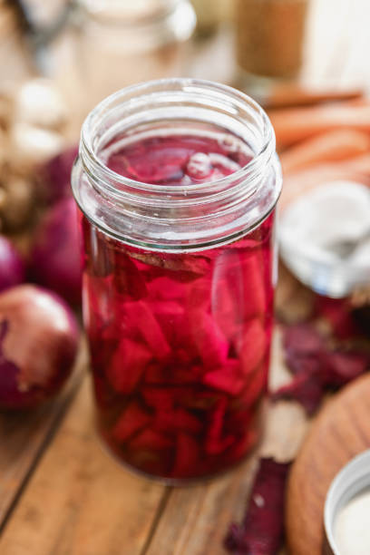
- 4 cups filtered water
- 1 tbsp Himalayan sea salt
- 2 tbsp sauerkraut brine or yogurt whey
- 2 medium beets, cubed
- 2 small radishes – black, purple, or daikon (about 1/4 cup)
- 2 tbsp finely chopped red onion, white onion or shallots
- 1 tbsp mustard seeds or 1 tsp mustard powder
- 2 tsp grated fresh ginger
- 1 tsp turmeric
- Pinch of black pepper
- 1/2 tsp cinnamon
- 1 small clove garlic, sliced (optional)
- 1/2 tsp fresh lemon juice (added post-fermentation)
- 1 tbsp pomegranate juice (added post-fermentation)

Mix the water and sea salt in a measuring cup to make the brine and set aside. Wash and scrub the beets (peeling is optional*), and cut into 1-inch cubes. Put the beets, radish, onions, mustard seed, ginger, turmeric, black pepper, cinnamon, and garlic, if using, in a Mason jar. Add the whey or sauerkraut juice.

Pour the brine over the ingredients, leaving about 1 inch of space at the top. Cover with a lid. Let ferment at room temperature (65-70°F) for 5 days. It can ferment for up to two weeks. Turn the jar upside down at least once daily for the first three days to ensure the brine covers the ingredients.

After 3 days, enough gas will have built up in the empty space in the jar to create a vacuum; therefore, if any ingredients poke up above the brine, they won't mold.

Once the fermentation is complete, strain out the ingredients and return the liquid to the jar. Cover and store in the refrigerator. Will keep for several weeks.

To serve: Pour 1/4 cup into a glass and add 1 tbsp of pomegranate juice. You can also add 1/2 tsp lemon juice, but make it to your taste. Some raw honey can be added when drinking if the beverage tastes too salty or sour.

*If you choose not to peel beets, they taste slightly musty. If you're planning to eat the fermented food after

✔ Supports All Three Epigenetic Pathways – Carefully selected ingredients enhance DNA methylation, histone modification, and ncRNA regulation.
✔ Balanced Flavor – Earthy beets, warm ginger and cinnamon, mild onion depth, and bright lemon create a pleasant, complex taste.
✔ Low Alcohol Risk – Controlled fermentation time, moderate salt levels, and post-fermentation lemon addition keep alcohol formation minimal.

Ways to Use the Strained Ingredients from the Fermented Beet Beverage
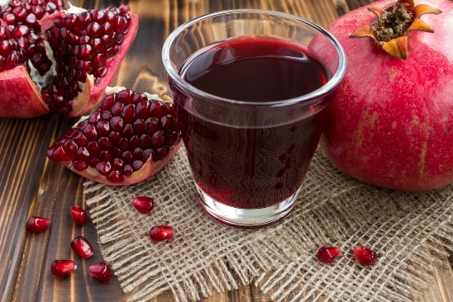
1. Eat as a Probiotic-Rich Side Dish

The fermented beets and other ingredients are tangy and full of gut-friendly probiotics.
Serve them as a salad with shredded carrots or cabbage, a drizzle of olive oil, a splash of lemon juice, and fresh herbs.

2. Blend into a Smoothie or Soup

Toss the fermented beets into a smoothie for a tangy, nutrient-dense boost. Blend into soups or borscht to add fermented flavors.

3. Mash into a Spread or Dip

Mash the strained beets with tahini, garlic, and lemon for fermented beet hummus. Puree and add full-fat yogurt or coconut yogurt for a probiotic-rich beet dip.

4. Add to Grain Bowls or Wraps

Chop them and toss them into grain bowls (quinoa, rice, or farro). For a tangy, umami flavor, use them in wraps or sandwiches.

5. Reuse in the Next Batch of the Fermented Beet Beverage

Some live probiotics remain in the strained beets, so you can use a small portion as a starter for your next batch.

6. Pickle Further for Extended Fermentation
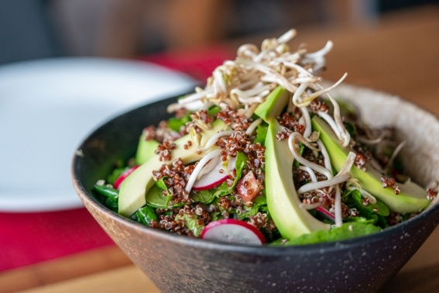
Store the strained beets in a jar with extra brine from the kvass and let them pickle further for more probiotic development.

7. Compost for Soil Health

If you don't want to eat them, use the nutrient-rich remains in your compost to improve soil microbiota and garden health.

5 Recipes for DNA Methylation Support

Foods that support DNA methylation include folate-rich foods (leafy greens, legumes), B vitamins (B6, B12), choline (eggs, liver), and betaine (beets, quinoa).

1. Methylation Power Salad

- 1 cup baby spinach (folate)
- 1 cup Romaine lettuce
- 1/2 cup cooked quinoa (betaine)
- 1/2 cup cooked chickpeas (folate, B6)
- 1 boiled egg (choline, B12)
- 1/4 avocado (healthy fats)

Put all the ingredients in a bowl. Make the dressing and drizzle it over the salad ingredients. Toss. Season with sea salt and pepper to taste.

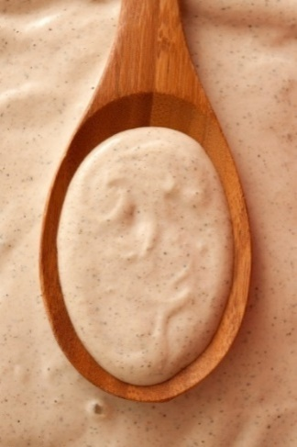
Lemon-Tahini Dressing

- 1/4 tahini
- 1 tbsp fresh lemon juice
- 1 tbsp extra virgin olive oil
- 1 tbsp apple cider vinegar
- 1 tsp maple syrup or raw honey
- 1 small garlic clove, chopped
- 1 tbsp chopped cilantro
- 1/4 teaspoon turmeric (optional, for extra benefits)
- Sea salt and pepper to taste
- 1 tbsp water, to thin, if needed (optional)

Whisk together tahini, lemon juice, olive oil, apple cider vinegar, and maple syrup in a small bowl.
Add chopped garlic, cilantro, and turmeric (if using). Slowly add water (if using), whisking until the desired consistency is reached. Season with sea salt and pepper to taste. The recipe makes more dressing than needed. Store excess in the refrigerator. It can be kept for 1 week.

2. Beet & Lentil Soup
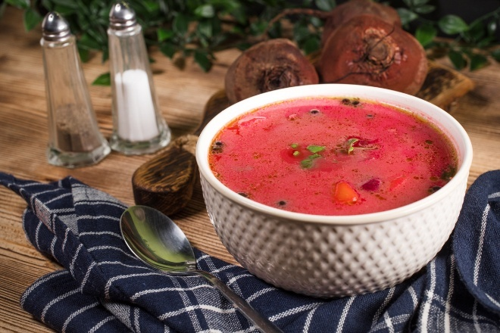
- 1 tbsp olive oil
- 2 tbsp chopped onions
- 2 medium beets, peeled, diced (betaine)
- 1 carrot, sliced (B6)
- 1 clove garlic, chopped
- 12 cup lentils (folate)
- 4 cups vegetable broth
- 1/2 tsp turmeric
- 1 tsp cumin
- Sea salt and pepper to taste

Put the olive oil and onion in a pot on medium-high heat. Sauté for two minutes. Add the carrots, beets, turmeric, and cumin. Continue to sauté for another 3 minutes, stirring frequently. Add the garlic, lentils, and broth. Bring to a boil and lower to a simmer. Continue to cook until the lentils are cooked and the carrots and beets are tender. Season with sea salt and pepper to taste

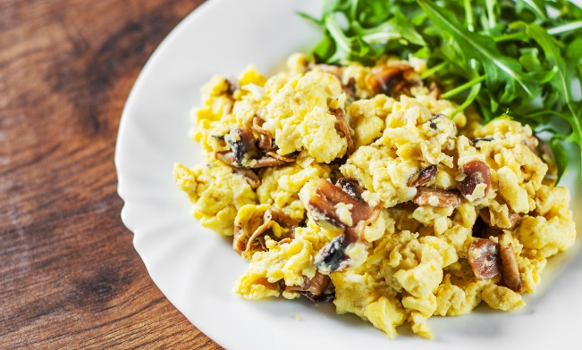
3. Choline-Rich Scramble

- 2 tsp chopped white onion
- 1 tbsp butter, ghee, or coconut oil
- 1/4 cup chopped Cremini or shitake mushrooms (B vitamins)
- 2 eggs (choline, B12)
- 1 handful spinach (folate)
- 1 tbsp chopped parsley

Heat a skillet on medium-high. Add the mushrooms and onions. Sauté for 3-4 minutes, stirring frequently. Add spinach until wilted. Beat the eggs and parsley in a small bowl and add. Scramble until the eggs are cooked—season with sea salt and pepper to taste.

4. Salmon with Roasted Asparagus and Sweet Potato

- 1 fillet salmon (B12, omega-3s)
- 1 tsp garlic, chopped
- 1 1/2 tbsp olive oil
- 1 tsp smoked paprika
- 1 medium sweet potato, cubed (betaine)
- 5 asparagus spears, roasted (folate)
- 2 tsp lemon juice
- Sea salt and pepper

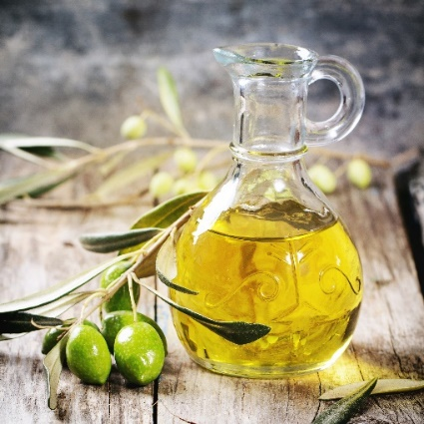
Preheat the oven to 375 degrees F. Mix the garlic, 1/4 tsp smoked paprika, and 1/2 tbsp olive oil in a small dish and mix. Put the salmon in a small baking dish with a piece of parchment paper lining the bottom. Brush the olive oil mixture over the salmon. Put the sweet potatoes and the rest of the smoked paprika in another baking dish. Add the rest of the olive oil and toss it all together. Put in the oven with the salmon and bake for 20 minutes. The salmon should be done at this point. Add the asparagus to the sweet potatoes and mix. Bake for another 15 minutes. Season both the salmon and vegetables with sea salt and pepper to taste. Transfer to a plate and drizzle with lemon juice.


5. Turmeric Golden Milk with Almonds

- 1 cup almond milk or whole dairy milk
- 1/2 tsp turmeric
- 1/2 tsp cinnamon
- 1 tsp honey
- 5 crushed almonds (B vitamins)

Warm milk, stir in turmeric, cinnamon, and honey, and top with almonds.

5 Recipes for Histone Modification Support

Histone modifications rely on polyphenols, sulforaphane, curcumin, resveratrol, and omega-3s.

1. Kale & Broccoli Stir-Fry with Brown Rice

- 1 tbsp olive oil
- 1 garlic clove, chopped
- 1 cup kale (polyphenols)
- 1 cup broccoli (sulforaphane)
- 1 tsp tamari sauce, ponzu, or coconut aminos
- 1/2 cup cooked brown rice
- Sea salt and pepper to taste

Sauté garlic with olive oil in a skillet on medium-high heat. Add broccoli and kale. Sauté until vegetables are tender, stirring frequently. Add tamari, ponzu, or coconut aminos as the vegetables are cooking. If vegetables start to stick, add a little water. Toss in the brown rice to warm it up—season with sea salt and pepper to taste.

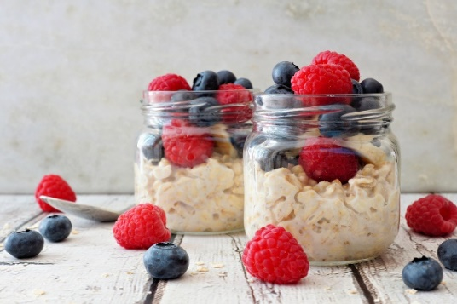
2. Berry & Walnut Overnight Oats

- 1/2 cup rolled oats
- 1 tbsp chia seeds (polyphenols)
- 1/2 cup mixed berries (resveratrol)
- 1/2 cup almond milk or dairy
- 1 tbsp maple syrup or raw honey
- 1 tbsp walnuts (omega-3s)
- 1/8 tsp cinnamon
- 1/8 tsp sea salt

Mix all ingredients in a bowl. Cover and refrigerate overnight.

3. Curried Roasted Cauliflower with Garlic Chicken

Serves 2

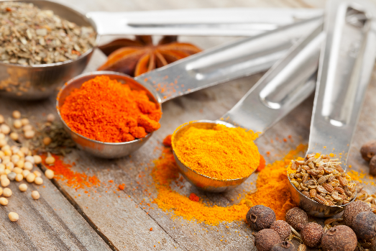
- 2 boneless, skinless chicken thighs
- 1 garlic clove, minced
- 2 tsp lemon juice
- 1 tbsp chopped white onions
- 2 tbsp olive oil
- 1/2 tsp cumin
- 4 cups chopped cauliflower (sulforaphane)
- 1 tsp turmeric (curcumin)
- 1 tsp curry powder
- 1 tbsp olive oil
- Sea salt and pepper to taste

Cut the chicken thighs into pieces and place in a bowl. Add the garlic, lemon juice, onions, 2 tbsp olive oil, cumin, curry powder, sea salt, and pepper to taste. Cover and marinate for 2 hours. Roast cauliflower with turmeric, curry powder, and 1 tbsp olive oil at 375°F for 25 minutes. Heat a skillet on medium-high heat when there are about 10 minutes left for the cauliflower. Add the chicken mixture and sauté for about 5-7 minutes, or until the chicken is cooked. Mix the chicken with the cauliflower. Season with sea salt and pepper to taste.

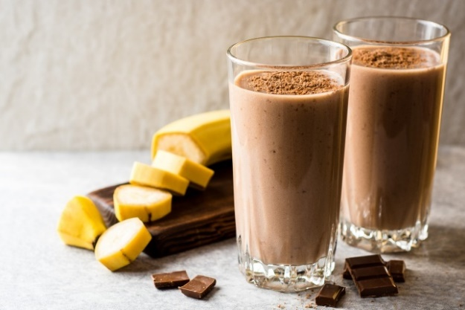
4. Green Tea & Dark Chocolate Smoothie

Serves 1

- 1 cup brewed green tea (polyphenols)
- 1/2 banana
- 1 tbsp cacao powder (resveratrol)
- 2 tsp maple syrup or raw honey
- 1/2 cup almond milk, full-fat dairy milk, or coconut milk

Blend all ingredients in a blender until smooth. Freezing the banana ahead of time makes it refreshingly cold.

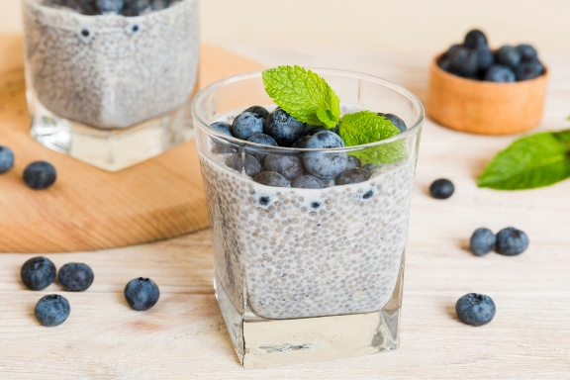
5. Wild Blueberry Chia Pudding

Serves 1

- 1 cup almond milk, full-fat dairy milk, or coconut milk
- 3 tbsp chia seeds
- 1/2 cup wild blueberries (resveratrol)
- 2 raw tsp honey
- 1 tbsp yogurt or kefir (dairy or coconut)

Mix the chia seeds, milk, and honey in a bowl or glass. Add the blueberries on top. Cover and refrigerate overnight. Add the yogurt or kefir when serving.

5 Recipes for Non-Coding RNA Support

Foods that influence non-coding RNA include omega-3s, polyphenols, prebiotics, and fermented foods.

Fermented Grain Bowl

Serves 1

- 1 cup cooked brown rice
- 1/4 cup fermented veggies (kimchi or sauerkraut)
- 1/4 cup chopped, roasted cashews
- 1 tbsp yogurt
- 1 tsp miso paste
- 1 tsp lime juice
- 1 tsp fresh basil
- 1/2 tsp raw honey or maple syrup
- Sea salt and pepper to taste

Mix the yogurt, miso, lime juice, basil, and honey or maple syrup in a bowl. Add the brown rice, fermented veggies, and cashews. Mix. Season with sea salt and pepper to taste. The fermented vegetables and miso are salty, so extra sea salt may not be needed.

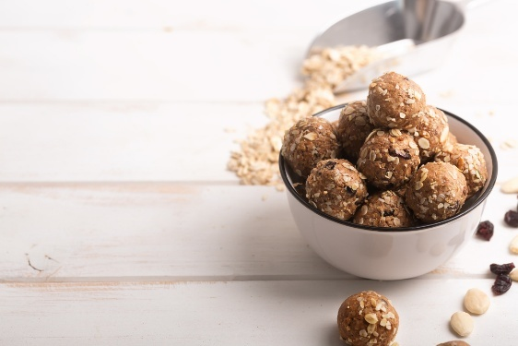
2. Flaxseed & Walnut Energy Bites

Makes 8-12

- 1 cup rolled oats
- 2 tbsp flaxseeds (omega-3s)
- 3/4 cup walnuts (polyphenols)
- 1/2 cup almond butter
- 2 tbsp raw honey
- 1/8 tsp cinnamon
- 1/8 tsp sea salt
- 1 tbsp water (if needed to mix)

Mix the ingredients together in a food processor. Roll into balls and place in a container with a lid. Refrigerate.

3. Sardine & Avocado Toast

Serves 1

- 1 slice whole-grain sourdough (prebiotic fiber)
- 1/2 avocado, mashed
- 1/2 can sardines (omega-3s)*
- 1 tsp lemon juice
- Sea salt and pepper to taste

Mash the avocado with lemon juice, sea salt, and pepper to taste. Toast the bread. Spread the avocado on the toast and top with sardines.

For those who do not like sardines, replace with good quality canned tuna or salmon.

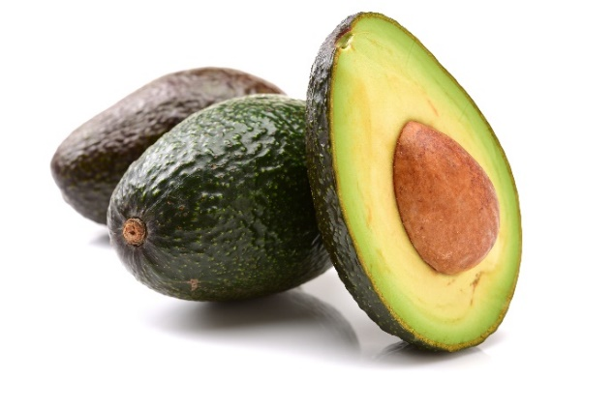

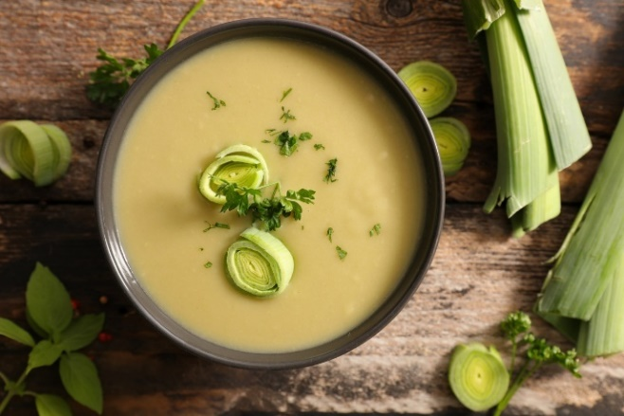
4. Garlic & Leek Soup

Serves 4

- 1 head of garlic, roasted
- 2 tbsp olive oil (supports absorption of bioactive compounds)
- 2 large leeks, sliced (white and light green parts)
- 4 cups vegetable or bone broth
- 1 cup cabbage pieces (for extra sulfur compounds)
- 1 tsp turmeric (modulates non-coding RNA and inflammation)
- 1 tsp thyme (rich in polyphenols)
- 1/4 tsp cayenne pepper (optional for anti-inflammatory effects)
- Sea salt and pepper (enhances absorption of nutrients) to taste
- Juice of 1/2 lemon (for antioxidant support)

Roast the garlic: Preheat oven to 375°F (190°C). Cut the tops off the garlic heads, drizzle with 1 tbsp olive oil, wrap in foil, and roast for 30-40 minutes until soft. In a pot, heat the remaining olive oil over medium heat. Add leeks and a pinch of sea salt. Sauté until soft (5 minutes).

Add cabbage and stir in turmeric, thyme, and cayenne. Cook for another 2 minutes. Add the broth. Add the roasted garlic (squeezed from the skins). Simmer for 10 minutes, then blend in a blender until smooth. Add the lemon juice and season with sea salt and pepper to taste.
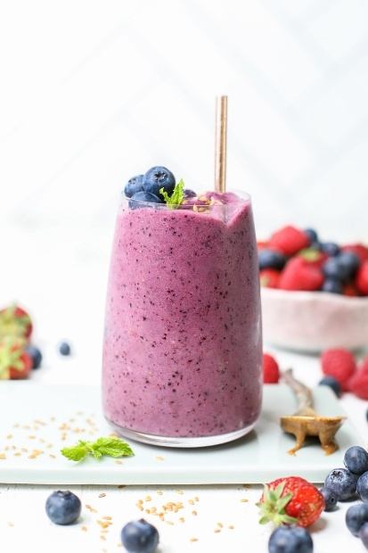

5. Kefir Berry Smoothie

- 1/2 cup kefir (probiotics)
- 1/2 cup full-fat dairy milk, almond milk, or coconut milk
- 1 cup frozen mixed berries (polyphenols)
- 1 tbsp flaxseeds (omega-3s)
- 2 tsp maple syrup or raw honey

Put all the ingredients in a blender. Blend until smooth.

Extra Recipes to Complete the Meals

1. Sourdough Toast with Avocado

- 1 slice of whole-grain sourdough bread (or white sourdough)
- 1/2 avocado, mashed
- 1 tsp lemon juice
- Optional: 1/2 tsp chili flakes
- Sea salt and pepper to taste

Toast the sourdough. Mash the avocado with lemon juice and chili flakes. Season with sea salt and pepper to taste, and spread over the toast.

2. Green Tea

- 1 cup hot water
- 1 green tea bag

Boil the water and pour over the tea bag. Steep the tea bag in hot water for 5 minutes.

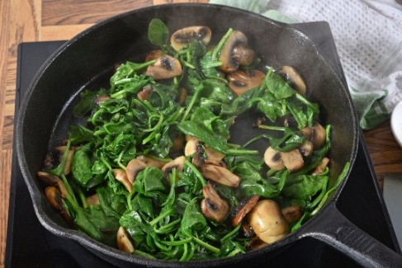
3. Sautéed Spinach & Mushrooms

- 1 cup Cremini or shitake mushrooms, chopped
- 2 tsp olive oil
- 1 clove garlic, chopped
- 1 cup baby spinach
- Sea salt and pepper to taste

Sauté mushrooms in the olive oil for 5 minutes, stirring frequently. Add extra water if the mushrooms start to stick. Add garlic and spinach, and cook until the spinach is wilted. Season with sea salt and pepper to taste.

4. Steamed Edamame

- 1/2 cup shelled edamame (or snap peas)
- Sea salt and pepper to taste

Put the edamame in a colander resting in a pot with 1 inch of water in the bottom. Add the edamame to the colander and cover with a lid. Bring the water to a boil and steam for 5 minutes. Remove from the colander and season with sea salt and pepper to taste.

5. Apple with Almond Butter

- 1 apple, sliced
- 1 tbsp almond butter

Serve apple slices with almond butter for dipping.

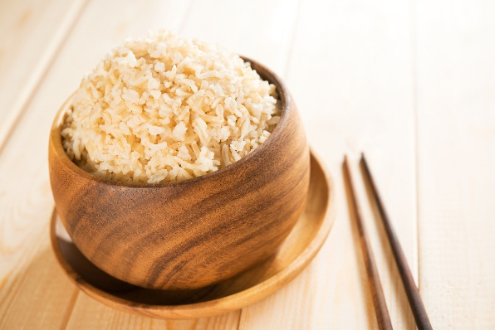
6. Brown Rice

- 1/2 cup uncooked brown rice
- 1 cup water
- Pinch of sea salt
- 1 tsp olive oil or ghee or coconut oil
- Sea salt and pepper to taste

Rinse the rice, bring to a boil with water in a pot, and add the salt. Cover with a lid and lower to simmer for 30-35 minutes or until the rice has the desired texture. Be sure that the water does not completely evaporate, or the rice will burn. Extra water can be added. Rinse with hot water when cooked. Add the oil or ghee. Mix. Season with sea salt and pepper to taste.

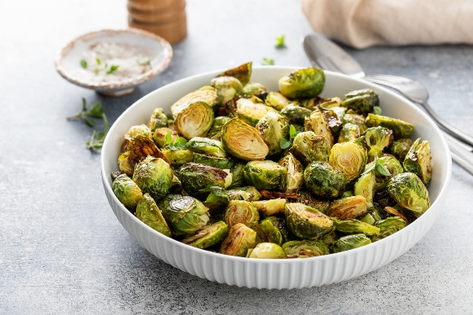
7. Side of Roasted Brussels Sprouts

- 1 cup Brussels sprouts, halved
- 1 tbsp olive oil
- Sea salt and pepper to taste
- 1 tsp lemon juice

Preheat the oven to 400 degrees F. Toss Brussels sprouts with oil, sea salt, and pepper. Put in a baking dish and roast at 400°F for 20 minutes. Remove from the oven and drizzle with lemon juice.

Meal Ideas

Breakfast: Scrambled eggs with mushrooms + overnight oats

Lunch: Beet & lentil soup + sourdough toast with avocado

Dinner: Salmon with roasted asparagus and sweet potato

Snack: Flaxseed & walnut energy bites + green tea

Breakfast: Sardine & avocado toast + sautéed spinach & mushrooms + turmeric golden milk

Lunch: Miso-tahini fermented veggie bowl + brown rice

Dinner: Kale & broccoli stir-fry + brown rice + steamed edamame

Snack: Wild blueberry chia pudding + apple with almond butter

Lunch: Garlic & leek soup + seed cracker or sourdough crackers or nut crackers

Dinner: Curried Roasted Cauliflower with Garlic Chicken + Roasted Brussels Sprouts

Your daily food choices profoundly impact your gene expression and long-term health. By incorporating nutrient-dense foods that support DNA methylation, histone modification, and non-coding RNA regulation, you are actively shaping your body's ability to function optimally.

This guide has provided you with practical, science-backed meal ideas and recipes designed to nourish your genes and enhance key epigenetic pathways. Whether you're focusing on detoxification, cognitive function, or cellular repair, these strategies can help you take control of your health at the molecular level.

