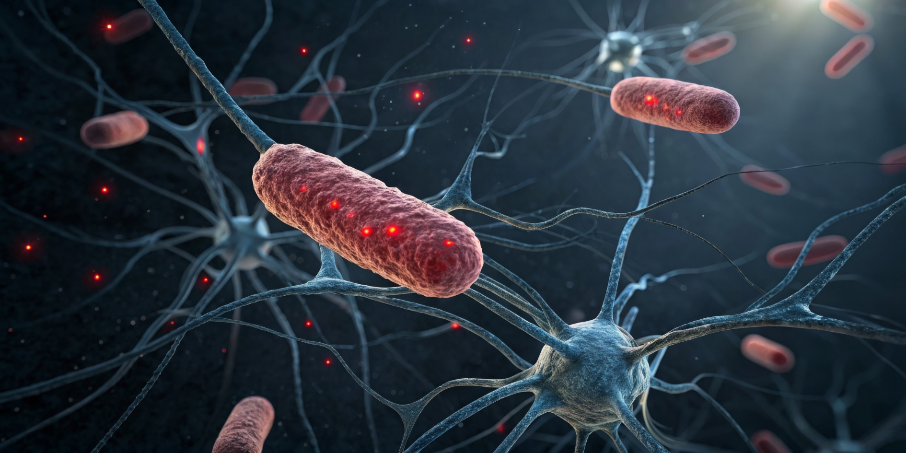
Epigenetic

Food & Lifestyle Guide


Hello,
Welcome to the Epigenetic Food & Lifestyle Guide
Your genes don’t dictate your destiny—your daily choices play a powerful role in shaping your health. Epigenetics reveals how nutrition, movement, sleep, and stress influence gene expression, impacting everything from metabolism to longevity. This guide will help you make informed choices that support optimal gene function and overall well-being.
As a [Insert Title], I help clients use epigenetic principles to take control of their health. Inside, you’ll find key foods and lifestyle strategies that can positively influence your genetic expression.
If you have any questions, feel free to reach out at (PHONE NUMBER) or (EMAIL).
Let’s get started!

Signature
 (Place HEADSHOT)
Contact info (optional)
(Place LOGO)

Medical Disclaimer
All information contained in this document is for informational purposes only. It is not intended to diagnose, treat, cure, or prevent health problems. For all serious health issues, please contact a medical or nutrition practitioner. The information provided in this program is based on the best knowledge of the author at the time of writing, and we do not assume liability for the information within this program, be it direct or indirect, consequential, special, exemplary, or other damages. In all circumstances, it is always wise to consult your physician before changing your diet, taking supplements, or starting any exercise or health program.
Table of Contents
Epigenetic Food & Lifestyle Guide for Optimal Gene Expression 4
Epigenetic Foods: Nutrients That Influence Gene Expression 4
Epigenetic Lifestyle Strategies 6
Epigenetic Action Plan 8

Epigenetic Food & Lifestyle Guide for Optimal Gene Expression

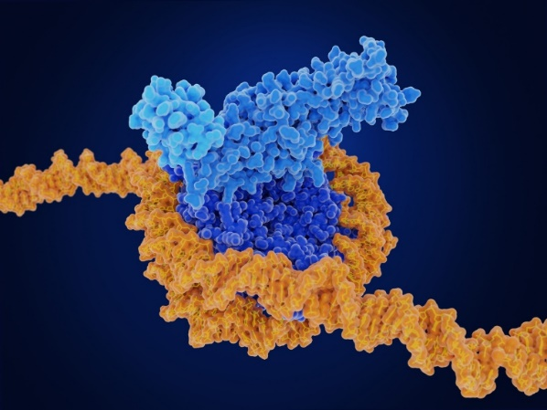
The Power of Epigenetics
Epigenetics explores how lifestyle and environmental factors influence gene expression without altering DNA sequences. How genes are turned on or off affects metabolism, hormone balance, immune function, and overall health.
Three primary mechanisms regulate gene expression:
DNA Methylation – The process of adding methyl groups to DNA, silencing or activating specific genes.
Histone Modification – Alters how tightly DNA is wrapped around proteins, controlling gene accessibility.
Non-Coding RNA (ncRNA) Regulation – Small RNA molecules that fine-tune genetic activity, particularly in metabolic and inflammatory pathways.
By selecting nutrient-dense foods and engaging in targeted lifestyle habits, gene expression can be optimized to promote hormonal balance, longevity, cognitive function, and disease prevention.

Epigenetic Foods: Nutrients That Influence Gene Expression

Foods That Support DNA Methylation
Methylation-supportive foods provide essential nutrients that help activate or silence genes involved in detoxification, inflammation, and cellular repair.
Methylation-Boosting Foods:
B vitamins (B6, B9, B12): Dark leafy greens, liver, eggs, salmon, lentils, asparagus, sunflower seeds
Choline: Eggs, fish, turkey, shiitake mushrooms, cruciferous vegetables such as broccoli, Brussels sprouts, and cabbage
Betaine: Beets, quinoa, spinach, whole wheat, rye
Zinc and magnesium: Pumpkin seeds, cashews, almonds, chickpeas, cacao, avocados
Methionine-rich proteins: Wild-caught fish, pasture-raised poultry, grass-fed beef, shellfish

Polyphenols for methylation balance: Green tea, berries, turmeric, olive oil, pomegranates
Methylation Disruptors:
- Processed foods high in refined sugars
- Excessive alcohol, interfering with methylation pathways
- Heavy metals, pesticides, and environmental toxins
Foods That Enhance Histone Modification
Histone-modifying nutrients help genes remain accessible, supporting anti-inflammatory pathways and metabolic function.
Histone-Modifying Foods:
Polyphenols that enhance histone acetylation: Green tea, dark chocolate, berries, turmeric, red wine (resveratrol), olives, artichokes, cocoa

Sulforaphane for detox and histone modulation: Broccoli, Brussels sprouts, cauliflower, cabbage, bok choy, arugula, radishes
Curcumin for histone-modifying properties: Turmeric, mustard seeds, curry powder
Resveratrol, a cardioprotective histone modifier: Red grapes, blueberries, peanuts, cranberries, mulberries
Butyrate, which supports histone acetylation and gut health: Grass-fed butter, ghee, resistant starches such as green bananas, cooked and cooled potatoes, and legumes
Histone Disruptors:
- Processed vegetable oils that increase inflammation and disrupt histone modification
- Artificial trans fats that negatively impact histone function

Foods That Regulate Non-Coding RNA

Non-coding RNAs influence inflammation and metabolism. Certain nutrients help maintain balance in these pathways.
Non-Coding RNA-Regulating Foods:
Omega-3 fatty acids that reduce inflammatory ncRNA expression: Wild-caught salmon, sardines, flaxseeds, chia seeds, walnuts, hemp seeds, anchovies
Curcumin to modulate inflammatory gene expression: Turmeric, curry powder, ginger
Quercetin to influence metabolic pathways: Onions, garlic, apples, citrus, capers, dark cherries

EGCG, a green tea compound for cellular repair: Green tea, matcha, oolong tea
Fermented foods that influence gut microbiome-linked ncRNA: Kimchi, sauerkraut, yogurt, kefir, miso, tempeh, natto
Prebiotic-rich foods that support gut bacteria influencing ncRNA: Leeks, asparagus, onions, bananas, dandelion greens, Jerusalem artichokes
Non-Coding RNA Disruptors:
- Excessive refined sugar, which upregulates inflammatory ncRNA
- Artificial additives and preservatives, which negatively impact gene regulation

Epigenetic Lifestyle Strategies

Exercise and Movement
- Moderate aerobic exercise for 30 to 45 minutes, four to five times per week, enhances DNA methylation and regulates inflammation-related genes.
- Strength training two to three times per week modulates insulin sensitivity and improves muscle-related gene expression.
- Yoga and breathwork help balance stress-induced epigenetic changes and support hormonal function.

Disruptors:
A sedentary lifestyle is linked to imbalances in DNA methylation patterns and chronic disease risk.

Sleep and Circadian Rhythms
- Seven to nine hours of uninterrupted sleep prevents epigenetic dysregulation.
- A consistent sleep schedule supports healthy gene activation patterns.
- Reducing blue light exposure at night improves melatonin-regulated gene activity.
Disruptors:
Chronic sleep deprivation leads to methylation imbalances and increased disease risk.
Stress Management
- Meditation, breathwork, and mindfulness reduce stress-induced epigenetic modifications.
- Social connection and strong relationships positively influence gene pathways related to resilience.
- Nature exposure through outdoor activities and forest walks reduces inflammation and supports non-coding RNA balance.
Disruptors:
Chronic stress activates inflammatory genes and disrupts methylation stability.
Detoxification and Toxin Reduction
- Sweating through exercise or sauna therapy helps remove heavy metals and endocrine disruptors.
- Liver-supportive foods, including cruciferous vegetables, garlic, beets, and dandelion tea, enhance detoxification.
- Drinking filtered water and reducing plastic use minimizes exposure to hormone-disrupting chemicals such as BPA and phthalates.
Disruptors:
Pesticides, heavy metals, and industrial pollutants damage DNA methylation and histone function.

Conclusion: Small Changes, Big Genetic Impact
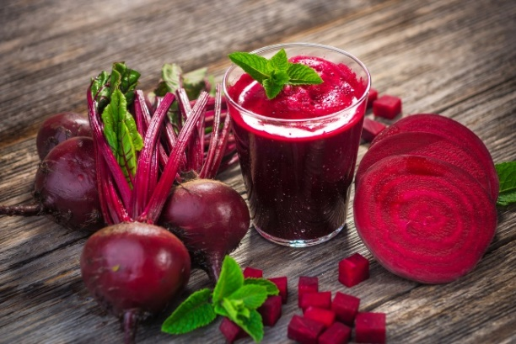
Genes respond to nutritional intake, movement, sleep, and stress management. By implementing targeted foods and lifestyle habits, gene function can be optimized for hormonal balance, metabolic health, cognitive function, and longevity.

Epigenetic Action Plan
- Eat a variety of whole, nutrient-dense foods that support DNA methylation, histone function, and ncRNA balance.
- Engage in regular movement and exercise to enhance positive gene expression.
- Prioritize sleep and manage stress to avoid harmful epigenetic changes.
- Minimize toxins that disrupt gene regulation and hormonal health.
- Consistent, small changes can create profound epigenetic benefits, promoting health at the cellular level.

Start today and harness the power of epigenetics for long-term well-being.



